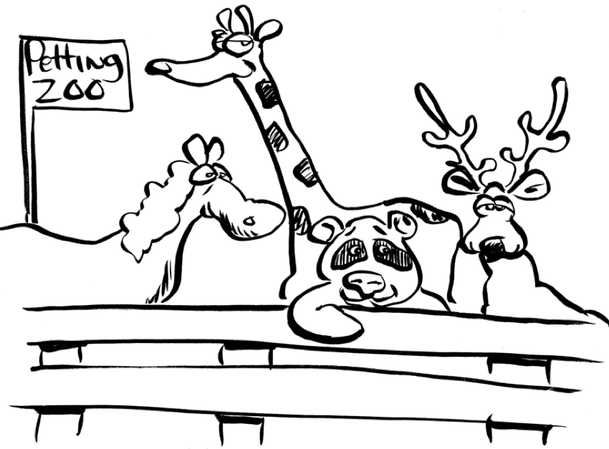
You have been hired by a nearby town to plan a new petting zoo for the community park.

The town councillors would like 3 to 5 different rectangular animal enclosures, each designed for a different kind of animal.

They have purchased 40 m of fencing for each enclosure.

When you recommend animals, remember:
- Large animals like llamas need an area of at least 15 m² for each animal.
- Medium animals like goats need at least 8 m² each.
- Small animals like ducks need at least 4 m² each.

Use grid paper for your plan. One square on the paper represents 1 m² in the park. Be prepared to present your plan to the council!

As you prepare your plan, you will…
- create a labeled map of the petting zoo, with 3 to 5 animal enclosures;
- find the perimeter and area for each animal enclosure;
- explain your recommendation for an animal for each enclosure, using mathematical reasoning; and
- find the maximum number of animals for each enclosure.

Challenge: Research to determine the approximate cost of animals for your petting zoo.

Student _____________________________________ Date _____________________
Before I submit my plan to the council: | Check
My name is on each page.
My plan is complete, with 3 to 5 animal enclosures.
My plan is clearly labeled, including areas and perimeters.
My work is organized in a way that makes it easy to read and understand.

Criteria | Specific Requirements | Yes | Not Yet | Teacher Comment
Designs rectangles  (Shape and Space 2)  [PS, R, V] | - Designs rectangles with accurate perimeters
 | - Determines accurate areas.

Level  Criteria | 4  Excellent | 3  Proficient | 2  Adequate | 1  Limited * | Insufficient/ Blank *
Make generalizations  (Shape and Space 2)  [C, CN, R] | Justifies choices by using explicit mathematical reasoning. | Justifies choices by using relevant mathematical reasoning. | Justifies choices by using simplistic mathematical reasoning. | Justifies fence choices by using weak mathematical reasoning. | No score is awarded because there is insufficient evidence of student performance based on the requirements of the assessment task.
Apply multiplication strategies  [ME, R] | Uses efficient strategies to determine the maximum number of animals for each enclosure. | Uses effective strategies to determine the maximum number of animals for each enclosure. | Uses workable strategies to determine the maximum number of animals for each enclosure. | Uses ineffective strategies to determine the maximum number of animals for each enclosure.
* When work is judged to be limited or insufficient, the teacher makes decisions about appropriate intervention to help the student improve.

Name ___________________________________ Date ________________

Summarize your plan:

Enclosure | Animal | Area | Perimeter | Maximum Number
A
B
C

Explain, using mathematical reasoning, why you recommend each animal for each enclosure.

How did you find the maximum number of animals for each enclosure?
Use 40 m of fence for each rectangle. Make each rectangle different. 1 square = 1m²
Large animals: 15 m² Medium animals: 8 m² Small animals: 4 m²

