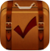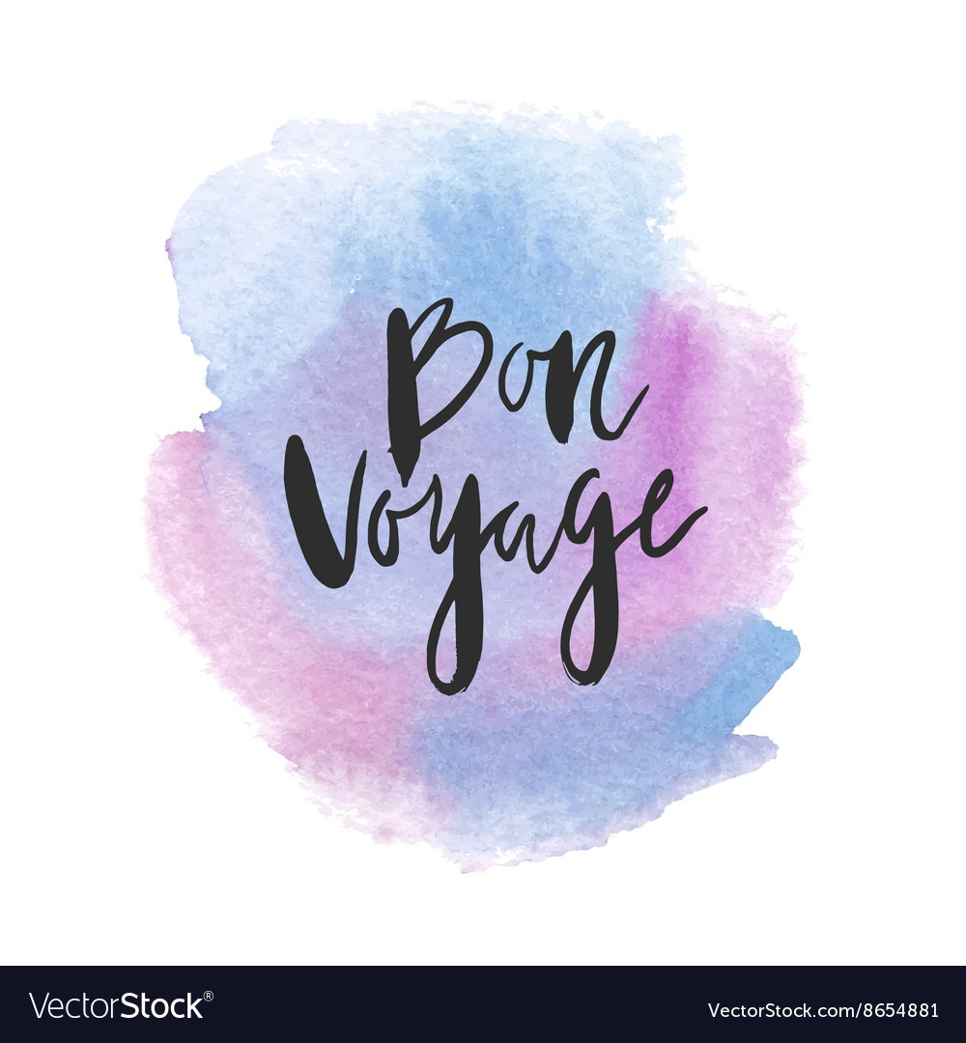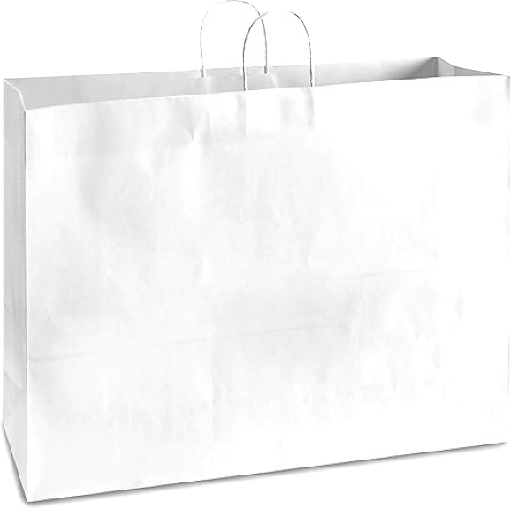

**J’apporte aussi….**

**(I am also bringing…)**

**1.**

**2.**

**3.**

**4.**

**5.**

**6.**

**7.**

**8.**

**9.**

**10.**

**11.**

**12.**

**13.  
14.**

**15.**

**Je fais mes bagages. I pack my bags.**

Qu’est-ce que tu apportes? What are you bringing?

**Il faut faire tes bagages. Cependant, tu n’as pas assez de vêtements. Tu fais du shopping en ligne avant de partir pour ton voyage. You must pack your bags. However, you do not have enough clothing. You are shopping online before leaving for your trip.**

1. Achètes 2 ensembles (articles de la tête aux pieds). Buy 2 outfits (items head to toe)
2. Décris chaque article (couleurs -adj. , prix -$/#, style - adj) Describe each article (colours - adjectives /price and style - practice $ and #, style - describe your style/why do you like your outfit?)
3. Apportes 15 articles en dehors de vêtements. Bring 15 items besides/outside of clothing.

___________________________________________________________

___________________________________________________________

___________________________________________________________

___________________________________________________________

___________________________________________________________

___________________________________________________________

___________________________________________________________

**Ensemble #1 (Outfit #1)**

___________________________________________________________

___________________________________________________________

___________________________________________________________

___________________________________________________________

___________________________________________________________

___________________________________________________________

___________________________________________________________

**Ensemble #2 (Outfit #2)**

[**www.lexception.com/fr**](http://www.lexception.com/fr)

[**www.balzac-paris.fr**](http://www.balzac-paris.fr)

[**shop.kitsune.fr**](http://shop.kitsune.fr)

**https://www.simons.ca/fr**

[**https://www.jeancoutu.com/magasiner**](https://www.jeancoutu.com/magasiner)

**La Redoute**