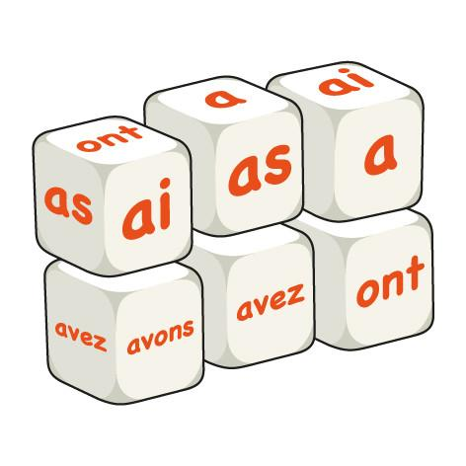

Le verbe Avoir **(The verb Avoir - To have)**

| **Avoir** | **To have** |
| --- | --- |
|  | I have |
|  | You have (Informal/Singular) |
|  | He has (Masculine Singular) |
|  | She has (Feminine Singular) |
|  | One, The individual, It, The collective has |
|  | We have |
|  | You all/You guys, You have (Plural/Formal) |
|  | They are (Masculine Plural) |
|  | They are (Feminine Plural) |

Pourquoi nous utilisons le verbe Avoir? Why do we use the verb Avoir/To have?

A

E

P

**TENER = ________________________**

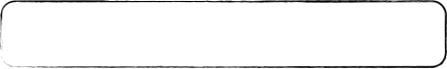

**Les exemples (Examples):**

1. Do you have a pencil? ____________________________________________________________

2. Do you have French class? __________________________________________________________

3. How old are you? ________________________________________________________________

I am (have) 16 years old. ___________________________________________________________

