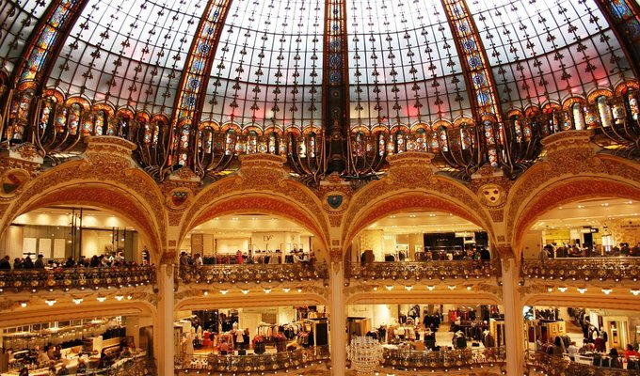

**In the 19th century, it was a time of big changes in Paris:**serious change in social connections, morals, mind states, but also architecture, aspiring to be renewed and women wanted to work and manage their own money. But all this became possible thanks to the birth of the department stores.  With an Art Nouveau architectural style, the glass, iron, and cement were honored in lavish decorations that attract as many customers as museums or palaces attract daily visitors. With the creation of Aristide Boucicaut’s store “Au Bon Marché” in 1852, the notion of shopping arrived in France.

**\*Make sure to use the French language option not English!**

**https://www.simons.ca/fr**

**https://www.balzac-paris.fr/**

You need to write a paragraph in French about an outfit you will buy on the online clothing shops above. Your outfit must be at least 5 items.

1. **You need to write the items that you will need to buy. Start your sentence with (Choose one verb):**
2. I buy, I am buying a/some....
3. I need a/some......
4. I am looking for a/some.....

**2. Describe the sizes that you need. “I need a shirt in small size”** J’ai besoin de (d’) une chemise de taille petit.

**3. Describe each article of clothing, use adjectives (beautiful, fantastic, comfortable, etc...), the verb Être, Colours**

**4. How much does each article of clothing cost? Use the verb Coûter (Ça coûte, Coutent ). Start your sentence with “The pants cost....”. Le pantalon coûte cent dollars. Les souliers coûtent soixante-dix dollars. Write out the dollar value. For example for $70, write soixante-dix dollars.**

**5. Name 10 new words that you learned by browsing this website.**