i

il ETait une fois .. .. .. **(Once upon a time)**

Vous allez écrire/creer une histoire, un conte pour enfant, un LIVRE d’Enfant . Le livre doit avoir moins de 10 pages et il doit être illustré 10 images . Consultez certains de vos livres préférés (pour enfants ou non) pour vous inspirer . Choisissez une histoire qui recoupe vos intérêts et vos talents, que ce soit une aventure, du merveilleux, ou une énigme.

**You will write/create a children's story book. The children’s book must have at least 10 pages and be illustrated, 10 images. Refer to some of your favourite books growing up (for children or not for children) for inspiration. Choose a story that catches your interests and brings out your talents, may it be an adventure, magic/supernatural or mystery/riddle.**

**Story Writing Curricular Ob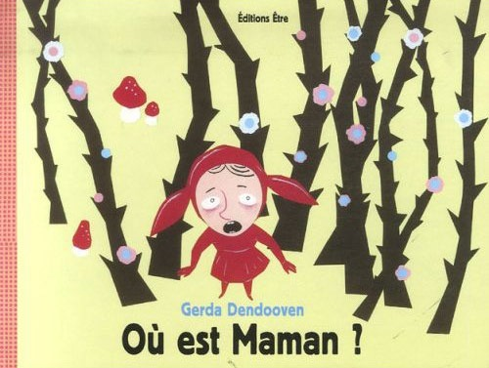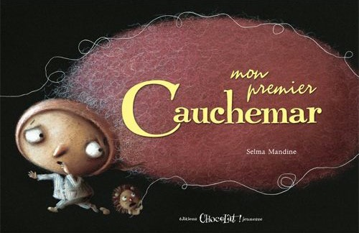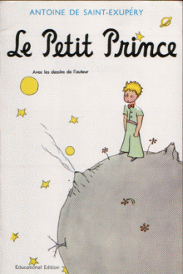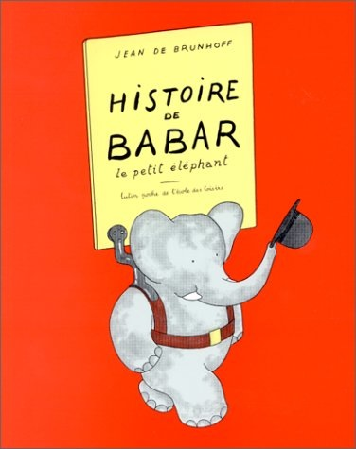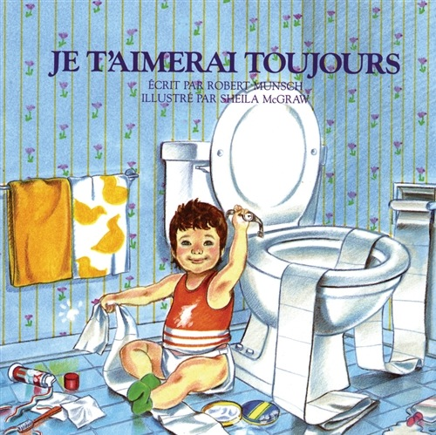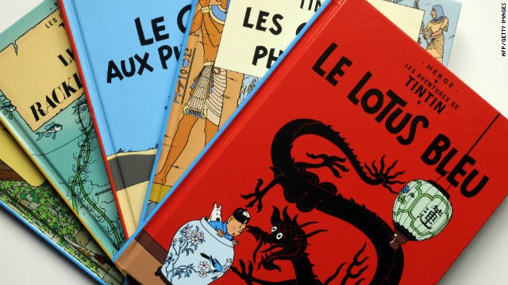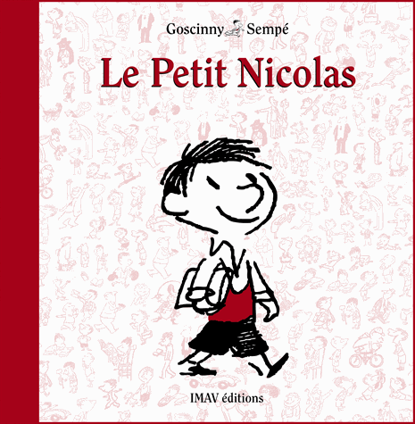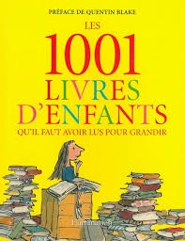jectives** (I will be able to……)

* comprehend and express oral or written messages involving a variety of language functions related to various contexts and communicative purposes.
* use time clues to determine if the message is being expressed in the past, present, future,
* as part of the editing process, work with a peer to read aloud a prepared production to determine if the message is clear
* apply knowledge of conjugation patterns in the **present tense** with frequently-used regular verbs
* apply knowledge of the formation of **le passé composé**  and **l’imparfait** for frequently-used regular verbs
* understand the formation of **the conditional** twith frequently-used verbs
* apply knowledge of l**e futur proche** and  **le futur simple** and including aller, avoir, être and faire, e.g., j’irai, tu auras, il sera, elle fera



**Un rappel/ A Reminder:**  The use of of translators is **prohibited** considered plagiarism and cheating. The end result is not your own work. Translators often give inappropriate or deceptive translations. I know when you use one! If you use a translator, you will earn a 0% and must redo and rewrite your story. The writing and editing of your story will take place in class. Please use appropriate resources to write your book (Use you notes from class, Peer to peer editing, Dictionaries/Thesaurus, Ask your teacher)

**LA rubrique :**

| **Les critères** | **Niveau 1**  **Remarkable (9 - 10 points)** | **Niveau 2**  **Well Done (7 - 8 points)** | **Niveaul 3**  **Sufficient (6 points)** | **Niveau 4**  **Insufficient (0 - 5 points)** | **Teacher Comments and Final Grade** |
| --- | --- | --- | --- | --- | --- |
| **Content:**  **1. Vocabulary**  **2. Cover**  **3. Plot/Setting:**  Characters  Location/Theme  Time  Conflict  Resolution  **4. Use Passé Composé**  **5. Use Imparfait** | Rich use of vocabulary. Remarkably Able to include idiomatic expressions. All required information/content is included | Well and accurate use of vocabulary for this level. Able to include a few idiomatic expressions. Most required information/content is included. | Adequate abut sometimes inaccurate use of vocabulary. Able to adequately include idiomatic expressions. Some required information/content is included | Inadequate and/or inaccurate use of vocabulary. Often relies on English when unsure of vocabulary. Limited or missing information/content. | **/50** |
| **Storyboard/Draft Copy Mapped Out:**  **10 Main Ideas**  **10 Main Images**  **3 Peer Editing of First Draft** | Storyboard/Draft and Peer Editing required process/information/content is included . | Storyboard/Draft and Peer Editing required process/information/content is mostly included . | Storyboard/Draft and Peer Editing required process/information/content is somewhat included . | Storyboard/Draft and Peer Editing required process/information/content is limited, lacking or missing | **/10** |
| **Mechanics** | Student’s verbal presentation is clear, concise, and well organized with remarkable sentence/paragraph construction. Thoughts are expressed in a coherent and logical manner. There are minimal spelling, grammar, or syntax errors. | Student’s verbal and written presentation is mostly clear, concise, and well organized with good sentence/ paragraph construction. Thoughts are expressed in a coherent and logical manner. There are no more than five spelling, grammar, or syntax errors. | Student’s verbal presentation is sometimes unclear and/or disorganized. Thoughts are adequately expressed in a logical manner. There are more than five spelling, grammar, or syntax errors. | Student’s verbal and written presentation is unclear and disorganized. Thoughts ramble and make little sense. There are numerous spelling, grammar, or syntax errors throughout the presentation. | **/25** |
| **Verbal (Presentation/Reading of Book)**  **Preparedness** | Student is completely prepared and has obviously rehearsed. Oral presentation content has been memorized with no reliance on notes. | Student seems mostly prepared but might have needed a couple more rehearsals. Oral presentation content has been mostly memorized with no or little reliance on notes. | The student is somewhat prepared, but it is clear that rehearsal was lacking. Oral presentation content has not been memorized with extensive reliance on notes. | Student does not seem at all prepared to present. Oral presentation content has not been memorized with complete reliance on notes. | **/10** |
| **Art work/ Creativity** | Student’s presentation/work is remarkably, original, unique  and is visually engaging for the  audience. | Student’s presentation/work is well done  and visually engaging for the  audience. | Student’s presentation/work  is adequate and  shows some  evidence of original  thinking. The presentation/work  is adequately visually engaging | Student’s presentatioon/work  lacks creativeness and does not visually engage the  audience. | **/5** |

**Les ress**ources:

|  |  |
| --- | --- |
| **You can create a book…..**   1. **The old fashioned way.** Making and putting together pieces of card stock/paper and Illustrating your own images (Google “Book Binding” or “Make your own book”) You can print out pictures from your computer. If you have taken a Communication Technology Course, you can also use Adobe Photoshop or Illustrator to illustrate your work.   2. You can use **Animoto** - an online video/animation presentation webiste  3. You can use **Powtoon** - an online video/animation presentation  4. You can use **Pixton** - an online comic maker  5. If you find a different resource or know of another great resource to make your book, please let your teacher know about it! |  |
|  |
|  |
|  |

1. What is a storyboard?: <http://accad.osu.edu/womenandtech/Storyboard%20Resource/>

2. Story Telling Resource: <http://www.schrockguide.net/digital-storytelling.html>

3. How to write Stories for Children: <http://fr.wikihow.com/%C3%A9crire-une-histoire-pour-enfants>

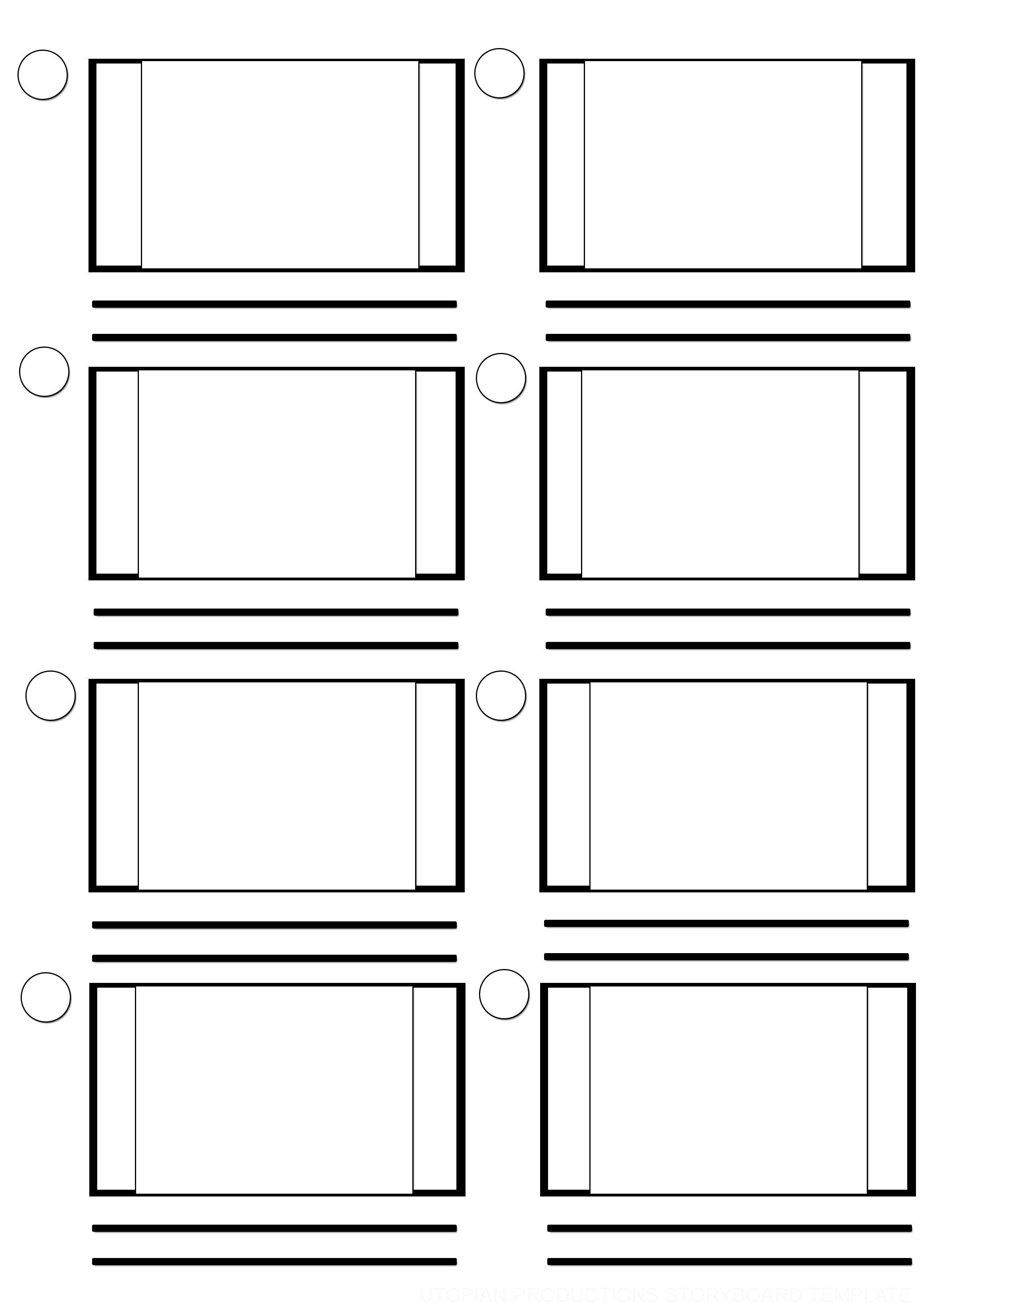

**Storyboard**

