Fête Fridays

- Vous allez faire une enquête sur un pays francophone. You are going to do a research on a French speaking country.
- Sélectionnez un pays francophone. Choose a French speaking country.
- Vous pouvez travailler seul ou avec un partenaire. You can work alone or work in partners (2 max).
- Créez un site web. Create a Website (wix.com weebly.com site123)
- Préparez un repas/un collation. You must cook a traditional meal/snack/dessert and...
You must include a recipe. The ingredients must be written in French. The instructions can remain
in English. Please photocopy your recipe 30 times to hand out to the class. *If you need help purchasing ingredients. Please come see me after school.
- Sélectionnez une activité de TIC TAC TOE (Try to make it engaging for the class to do/participate in)
7. Sélectionnez le jour de présentation . Choose a date to present your project.

Tic tac Toe Activités

traditional dance  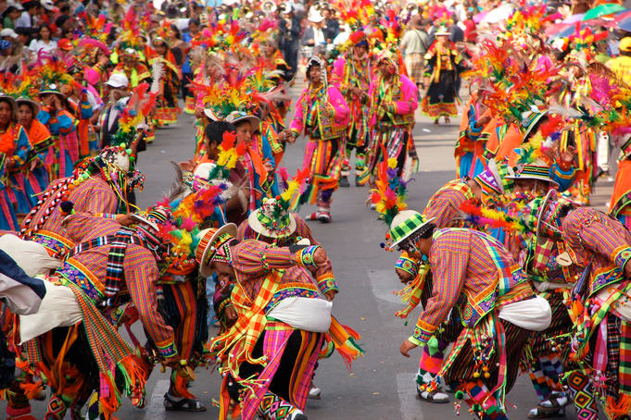 | pop culture  (television shows, fashion)   | traditional games  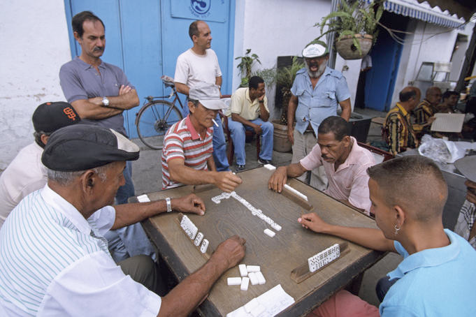
festivals   | traditional stories/legends  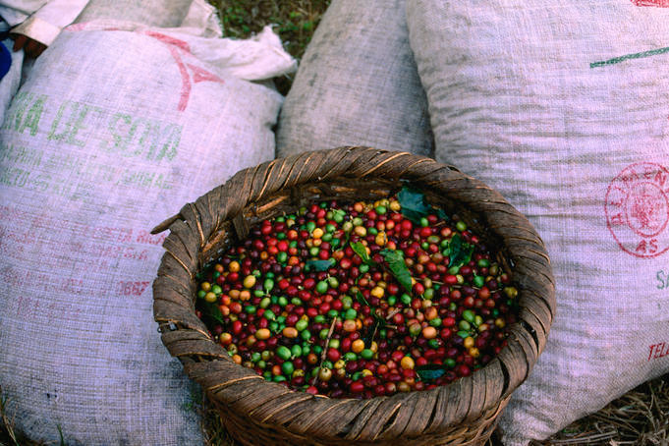 | song/music  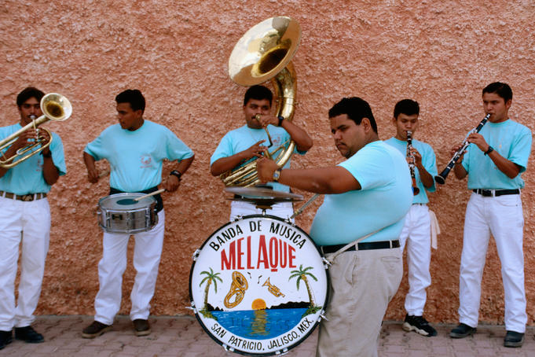
arts/crafts   | traditional sports  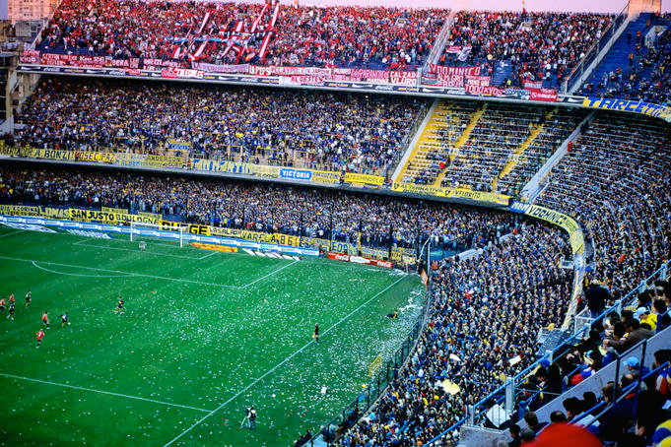 | ?

La Fête Project Components and Rubric

Étudiante(s):
Teacher Comments: FINAL MARK:

Components | Evaluation
- Build Website  Research Requirements:  - country’s flag  - pictures/photos  - videos  - maps  - capital city  - important facts/history  - bibliographie  - other engaging material! | 0 - 5 Limited required information. Lack of completeness. The presentation is not thoughtful and meaningful and/or incomplete. The Student’s presentation lack of comprehension of the material. Viewpoints and interpretations are missing and unsupported. | 6 Some required information has been included. presentation is adequately thoughtful and meaningful. The Student adequately demonstrates comprehension of the material. Viewpoints and interpretations are adequately insightful and supported. | 7- 8 Most of the required information has been included. presentation is thoughtful and meaningful. The Student demonstrates thorough comprehension of the material. Viewpoints and interpretations are remarkably insightful and well supported. | 9 - 10 All the required information has been included. The presentation is remarkably thoughtful and meaningful. The Student remarkably demonstrates thorough comprehension of the material. Viewpoints and interpretations are remarkably insightful and well supported. | 30%  /30
- TIC TAC TOE  Actividad #1  La comida (The Food)  - explain the history and why this important to the culture and country  - Include a recipe with ingredients in French.  Recipe Handout is included | 0 -5 Limited required information. Lack of completeness. | 6 Some required information has been included | 7- 8 Most of the required information has been included | 9 - 10 All the required information has been included | 20%  /20
- TIC TAC TOE  Actividad #2  ?  _______________________________________________________________  a. explain the history and why this important to the culture and country | 0 -5 Limited required information. Lack of completeness. | 6 Some required information has been included | 7- 8 Most of the required information has been included | 9 - 10 All the required information has been included | 20%  /20
4. Mechanics | 0 -5 Student’s verbal and written presentation is sometimes unclear and/or disorganized. Thoughts are adequately expressed in a logical manner. There are more than five spelling, grammar, or syntax errors per page of writing. Presentation lacks  engagement and does not  draws the attention of  audience. Rare eye  contact/ poor speaking  voice. Relies on and reads  présentation | 6 Student’s verbal and written presentation is sometimes unclear and/or disorganized. Thoughts are adequately expressed in a logical manner. There are more than five spelling, grammar, or syntax errors per page of writing.  Presentation lacks some  engagement and  sometimes draws the  attention of thé audience.  Some eye contact/  speaking voice. Often,  relies on and reads  présentation. | 7- 8 Student’s verbal and written presentation is mostly clear, concise, and well organized with good sentence/paragraph construction. Thoughts are expressed in a coherent and logical manner. There are no more than five spelling, grammar, or syntax errors per page of writing. Presentation  is sufficiently engaging and  draws the audience. Sufficient  eye contact and speaking  voice. | 9 - 10 Student’s verbal and written presentation is clear, concise, and well organized with remarkable sentence/paragraph construction. Thoughts are expressed in a coherent and logical manner. There are minimal spelling, grammar, or syntax errors. Presentation is  remarkably engaging and draws  the audience. Remarkable eye  contact and speaking voice. | 10%  /10
5. Peer Evaluation | Evaluation Rubric |  |  |  | 10%  /10
6. Self/Group Evaluation | Evaluation Rubric |  |  |  | 10%  /10

