Electrochemistry review Section 2

Use the following information to answer the next _ questions.
In 1936, an object of unknown purpose was discovered near Baghdad. The object was determined to be approximately 2 000 years old. This object had several similarities to modern dry cells, and as a result, was named the “Battery of Baghdad.”
(see picture before)
It is possible, using materials known to be available 2 000 years ago, to construct a model cell that produces a voltage.
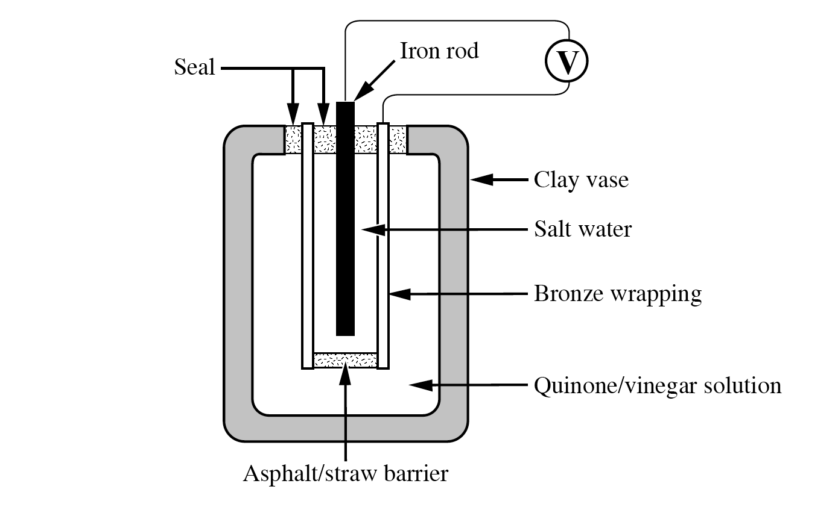
The reaction that occurs in this model cell is
Fe(s) + OC₆H₄O(aq) + 2 H⁺(aq) → HOC₆H₄OH(aq) + Fe²⁺(aq) E°_{net} = +1.25 V

____ 150. The oxidizing agent in the model cell is
a. | Fe(s)
b. | Fe²⁺(aq)
c. | OC₆H₄O(aq)
d. | HOC₆H₄OH(aq)

____ 151. The substance acting as the “salt bridge” in the model cell is

a. | iron
b. | clay
c. | bronze
d. | asphalt/straw

____ 152. As the model cell operates, one would predict that the quinone/vinegar solution would

a. | remain unchanged
b. | become less acidic
c. | become less basic
d. | decrease in pH

____ 153. The predicted E° under standard conditions for the quinone/vinegar solution half-reaction, OC₆H₄O(aq) + 2 H⁺(aq) + 2 e⁻ → HOC₆H₄OH(aq), is

a. | +0.80 V
b. | +1.70 V
c. | - 0.80 V
d. | - 1.70 V

Use the following information to answer the next two questions.
This simplified diagram shows the cell used in the Chlor-Alkali process at the Dow Chemical Plant in Fort Saskatchewan, Alberta.
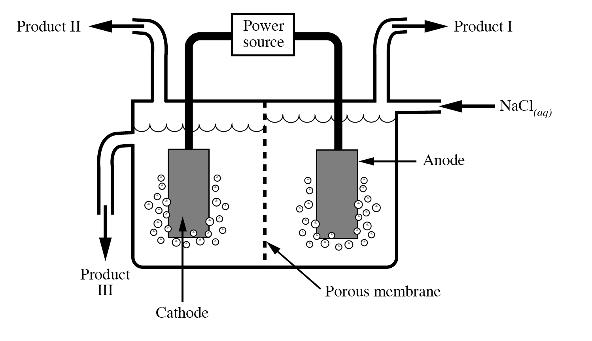

____ 154. The cell shown in the diagram is

a. | electrolytic
b. | voltaic
c. | galvanic
d. | acid-base

____ 155. Products I, II, and III from this cell, respectively, are

a. | Cl₂(g), H₂(g), and HCl(aq)
b. | H₂(g), Cl₂(g), and NaOH(aq)
c. | HCl(g), Cl₂(g), and NaOH(aq)
d. | Cl₂(g), H₂(g), and NaOH(aq)

Use the following information to answer the next _ questions.
The chlor-alkali process used by Dow Chemical in Fort Saskatchewan uses sodium chloride from underground deposits. The sodium chloride is dissolved in water and then pumped into electrolytic cells where a current is passed through the solution to form yellow chlorine gas, colourless hydrogen gas, and aqueous sodium hydroxide.
The net ionic equation is 2 H₂O(l) + Cl⁻(aq) → Cl₂(g) + 2 OH⁻(aq) + H₂(g)

____ 156. In the electrolysis of NaCl(aq), the cathode half-reaction is
a. | Na⁺(aq) + e⁻ → Na(s)
b. | 2 Cl⁻(aq) → Cl₂(g) + 2 e⁻
c. | 2 H₂O(l) → O₂(g) + 4 H⁺(aq) + 4 e⁻
d. | 2 H₂O(l) + 2e⁻ → H₂(g) + 2 OH⁻(aq)

____ 157. When the electric current is switched off, the
a. | pH stops decreasing
b. | concentration of the Na⁺(aq) stops changing
c. | concentration of the Cl⁻(aq) stops decreasing
d. | concentration of the H₂O(l) stops decreasing

____ 158. It is estimated that up to 25% of the iron produced annually in North America is used to replace iron objects that have been damaged by rust. The corroded iron is often expensive or difficult to replace and is often disposed of in landfills. Corrosion is a concern from both
a. | a political and a scientific perspective
b. | an ecological and an ethical perspective
c. | a technological and a scientific perspective
d. | an economic and an ecological perspective

____ 159. Which of the following characteristics is associated with a voltaic cell consisting of standard half-cells of nickel and zinc?
a. | The E°net is +1.02 V.
b. | Cations migrate to the zinc electrode.
c. | Oxidation occurs at the nickel electrode.
d. | The net ionic equation is Ni²⁺(aq) + Zn(s) → Ni(s) + Zn²⁺(aq)

____ 160. A student constructed a standard electrochemical cell by using copper metal and a copper(II) nitrate solution in one half-cell and an unlabelled metal and a nitrate solution of the metal ion in the other half-cell. The two half-cells were connected by a voltmeter, which then registered +0.79 V. If the copper electrode was the cathode, then the unlabelled metal electrode was likely
a. | tin
b. | iron
c. | silver
d. | chromium

Use the following information to answer the next question.
A student set up the following electrochemical cell and allowed it to operate for a
few minutes.
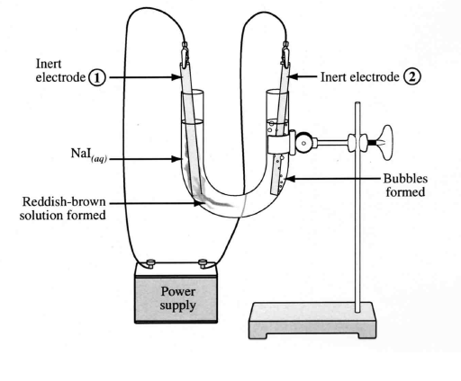

____ 161. The gas formed near electrode 2 is most likely
a. | I₂(g)
b. | Na(g)
c. | O₂(g)
d. | H₂(g)
Use the following information to answer the next two questions.
In order to refinish a car bumper, the first step is to clean the bumper and repair any damaged areas. The second step is the electroplating of nickel on the bumper as shown below.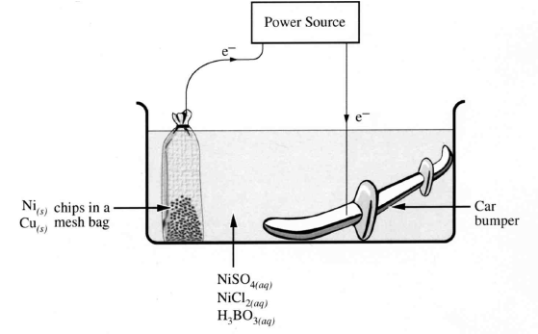

____ 162. The reaction that would occur at the anode in the electroplating cell above is
a. | Ni(s) → Ni²⁺(aq) + 2 e⁻
b. | Ni²⁺(aq) + 2 e⁻ → Ni(s)
c. | Cu(s) → Cu²⁺(aq) + 2 e⁻
d. | SO₄²⁻(aq) + H₂O(l) + 2 e⁻ → SO₃²⁻(aq) + 2 OH⁻(aq)

____ 163. In the third step of the electroplating process, the bumper is transferred to a tank that contains CrSO₄(aq). A current of 3 750 A is used to plate a thin layer of chromium over the nickel. If the mass of the chromium layer is 125 g, then the time required for this plating process to occur is

a. | 0.515 min
b. | 1.03 min
c. | 2.06 min
d. | 124 min

Numeric Response
164. The oxidation numbers of sulfur in SO₂(g), SO₃(g), H₂SO₃(aq), and H₂SO₄(aq), respectively, are __, __, __, __.
(Record your four digit answer in the numeric response section.)

165. Using the Table of Standard Electrode Potentials, the numbered oxidizing agents listed from strongest to weakest are __, __, __, __.
1 Sn²⁺(aq)
2 Cu²⁺(aq)
3 Zn²⁺(aq)
4 Pb²⁺(aq)
(Record your four digit answer in the numerical response section.)

Use the following information to answer the next question.
__NH₃(g) + __O₂(g) → __NO₂(g) + __H₂O(g)

166. When balanced in terms of lowest whole numbers, the coefficients for this equation are, respectively, __, __, __, and __.
(Record your four digit answer in the numeric response section.)

Use the following information to answer the next _ questions.
A student titrated samples of sulfurous acid with a potassium permanganate solution. He obtained the following results:
Table 1. Volumes of 0.0310 mol/L KMnO₄(aq) required to completely react with 100.0 mL samples of sulfurous acid.
Trial 1 2 3 4
Final buret reading (mL) 9.50 18.15 26.75 34.75
Initial buret reading (mL) 1.00 9.50 18.15 26.75
Final colour of mixture pink pink pink colourless

167. To determine the concentration of sulfurous acid, the average volume of potassium permanganate use is ________ mL.
(Record your three digit answer in the numeric response section.)

168. The concentration of sulfurous acid in the sample is _____ mmol/L.
(Record your three digit answer in the numeric response section.)

169. When the redox reaction __H₂O(l) + __NO₂⁻(aq) + __Al(s) → __NH₃(g) + __AlO₂⁻(aq) + __H⁺(aq)
is balanced using lowest whole number coefficients, the coefficient of
H₂O(l) is _______ (Record in the first column)
NO₂⁻(aq) is _____ (Record in the second column)
Al(s) is _________ (Record in the third column)
H⁺(aq) is _______ (Record in the fourth column)
(Record your four digit response in the numeric response section.)

Use the following information to answer the next question.
ICCP (Impressed Current Cathodic Protection) is a corrosion prevention technique that is used to protect buried metal structures. A low-voltage current (electron flow) is applied to the buried metal structure such that only reduction reactions can occur at its surface.

170. The ground water surrounding the buried metal structure may contain the following ions.
1 Pb²⁺(aq)
2 Fe²⁺(aq)
3 Fe³⁺(aq)
4 Cd²⁺(aq)
The order in which these ions are reduced on the surface of the metal structure is __, __, __ and __.
(Record your three digit number in the numeric response section.)

Use the following information to answer the next question.
1 Fe²⁺(aq) + Cr³⁺(aq) → Fe³⁺(aq) + Cr²⁺(aq)
2 NH₃(aq) + H₂O(l) → NH₄⁺(aq) + OH⁻(aq)
3 2 NH₃(g) + O₂(g) → 2 NO₂(g) + 3 H₂O(g)
4 Mg²⁺(aq) + 2 OH⁻(aq) → Mg(OH)₂(s)
5 Sn²⁺(aq) + 2 NO₃⁻(aq) + 4 H⁺(aq) → Sn⁴⁺(aq) + 2 NO₂(g) + 2 H₂O(l)
6 PbSO₄(s) + SO₃²⁻(aq) + 2 OH⁻(aq) → H₂O(l) + Pb(s) + 2 SO₄²⁻(aq)

171. The equations that represent oxidation-reduction reactions, listed in any order, are __, __, __, and __.
(Record your four digit answer in the numeric response section.)
Use the following information to answer the next _ questions.
Titration of 20.0 mL Samples of Acidified H₂O₂(l) with 0.15 mL KMnO₄(aq)
Trial I II III IV
Final Buret volume (mL) 18.3 34.6 17.4 33.8
Initial Buret volume (mL) 0.4 18.3 0.9 17.4
Colour at endpoint purple pink pink pink

172. The volume of potassium permanganate that should be used in subsequent calculations is ________ mL.
(Record your three digit answer in the numeric response section.)

173. The hydrogen peroxide concentration is _______ mol/L.
(Record your three digit answer in the numeric response section.)

Use the following information to answer the next _ questions.
To determine the concentration of Sn²⁺(aq) solution, a student titrated a 50.00 mL sample of acidified Sn²⁺(aq) with 1.44 mmol/L KMnO₄(aq). The titration required 24.83 mL of KMnO₄(aq) in order to reach a pale pink endpoint.

174. The concentration of Sn²⁺(aq) in the sample is _______ mmol/L.
(Record your three digit answer in the numeric response section.)

Use the following information to answer the next _ questions.
The beautiful patterns of butterfly wings, the stripes on zebra pelts and the myriad of colours of tropical fish all result from oscillating chemical reactions. These chemcial reactions can be studied in a much simpler form in the laboratory. In 1958, the Russian chemist B.P. Belousoz discovered a complete reaction sequence in which the concentration of reactants and products oscillated over time.
Unbalanced Reaction Equations
I __H⁺(aq) + __BrO₂⁻(aq) + __ BrO₃⁻(aq) ↔ __BrO₂(aq) + __H₂O(l)
II __Ce³⁺(aq) + __BrO₂(aq) ↔__ Ce⁴⁺(aq) + __BrO₂⁻(aq)
III __BrO₂⁻(aq) ↔ __BrO₃⁻(aq) + __BrO⁻(aq)

175. When reaction equation I is balanced with lowest whole number coefficients, the coefficient of
H⁺(aq) is ___________ (Record in the first column)
BrO₂⁻(aq) is ___________ (Record in the second column)
BrO₃⁻(aq) is ___________ (Record in the third column)
BrO₂(aq) is ___________ (Record in the fourth column)
(Record your four digit answer in the numeric response section.)

Use the following information to answer the next question.
A 0.532 mol/L solution of Ce⁴⁺(aq) was used to titrate a 25.0 mL sample of Sn²⁺(aq).
Volume Used
Final Buret reading (mL) 43.5
Initial Buret reading (mL) 12.6
The half-reaction for cerium(IV) can be represented by
Ce⁴⁺(aq) + e- → Ce³⁺(aq) E° = +1.61 V

176. The [Sn²⁺(aq)] of the sample, expressed in scientific notation, is _______ x 10⁻¹ mol/L.
(Record your three digit answer in the numeric response section.)
Use the following information to answer the next _ questions.
At one time, an aqueous solution of formaldehyde called formalin(CH₂O(aq)) was used as a disinfectant and as a tissue preservative. Today, formalin is commonly used in the industrial preparation of plastics and resins.
Formalin can be produced by reacting methanol with acidified potassium dichromate, as represented by the following unbalanced equation.

__CH₃OH(l) + __Cr₂O₇²⁻(aq) __H⁺(aq) →__ CH₂O(aq) + __Cr³⁺(aq) + __H₂O(l)

177. When 39.5 kg of methanol is reacted, the mass of formalin produced is _______ kg.
(Record your three digit answer in the numeric response section.)

Use the following information to answer the next question.

An acidic solution of nickel(II) nitrate is poured into a tin container.
Chemical Changes
1 does not react
2 is oxidized
3 is reduced
4 reacts but there is no change in its oxidation number

178. Match each of the chemical changes listed above with the reaction species given below.
tin __________ (Record in first column)
nitrate ion __________ (Record in second column)
nickel(II) ion __________ (Record in third column)
hydrogen ion __________ (Record in fourth column)
(Record your four digit answer in the numeric response section.)

Use the following equations to answer the next question.
1 HSO₃⁻(aq) + HCO₃⁻(aq) → H₂CO₃(aq) + SO₃²⁻(aq)
2 C₆H₁₂O₆(aq) + 6 O₂(g) → 6 CO₂(g) + 6 H₂O(l)
3 Ni²⁺(aq) + Fe(s) → Fe²⁺(aq) + Ni(s)
4 Co²⁺(aq) + 2 Fe²⁺(aq) → 2 Fe³⁺(aq) + Co(s)
5 6 CO₂(g) + 6 H₂O(l) → C₆H₁₂O₆(aq) + 6 O₂(g)

179. Match the equations, as numbered above, with the corresponding description below.

A biological redox reaction carried out
in a plant cell but not in an animal cell _____ (Record in the first column)
A biological redox reaction carried out
in both animal and plant cells _____ (Record in the second column)
A spontaneous, non-biological redox
reaction _____ (Record in the third column)
A non-spontaneous, non-biological
redox reaction _____ (Record in the fourth column)
(Record your four digit answer in the numeric response section.)

180. When the equation V₂O₅(s) + Mn(s) → VO(s) + MnO₂(s) is balanced using the lowest whole number coefficients, the coefficient of
V₂O₅(s) is _________ (Record in the first column)
Mn(s) is _________ (Record in the second column)
VO(s) is _________ (Record in the third column)
MnO₂(s) is _________ (Record in the fourth column)
(Record your four digit answer in the numeric response section.)

181. Nitrogen forms a number of oxides. Examples include NO(g), NO₂(g), N₂O(g), and N₂O₅(g). The oxidation of number of nitrogen in each compound listed above is, respectively, ___, ___, ___, and ___.
(Record your four digit number in the numeric response section).

Use the following information to answer the next question.
A student dipped 12.50 g strips of four different metals, Ag(s), Cu(s), Pb(s), and Mg(s), into a beaker containing 250 mL of 1.00 mol/L HCl(aq) in order to determine an activity series. One of the metals reacted immediately and vigorously with the acid.

182. The mass of metal that reacted with the hydrochloric acid is _______g.
(Record your three digit answer in the numeric response section.)

183. The volume of 0.160 mol/L K₂Cr₂O₂(aq) required to completely react with 10.0 mL of acidic 0.0881 mol/L H₂O₂(aq) is _____ mL.
(Record your three digit answer in the numeric response section.)

184. The oxidation numbers of carbon in HCOOH(aq), C₆H₁₂O₆(s), CO₂(g), and CHCl₃(g), respectively, are ___, ___, ___, and ___.
(Record your four digit answer in the numeric response section.)

185. When 1.20 mol of H₂PO₄⁻(aq) react according to the equation
12 H₂PO₄⁻(aq) + 12 H⁺(aq) + 10 Br⁻(aq)→ 3 P₄(s) + 18 H₂O(l) + 10 BrO₃⁻(aq),
the number of moles of electrons transferred is ______ mol.
(Record your three digit answer in the numeric response section.)

Use the following information to answer the next _ questions.
A thermite reaction is a highly exothermic process that is used in welding massive objects such as ship propellers and train rails. The reaction can be represented by the equation
2 Al(s) + Fe₂O₃(s) → Al₂O₃(s) + Fe(l)

186. The value of the oxidation number for
aluminium in Al(s) is _____ (Record in the first column)
iron in Fe₂O₃(s) is _____ (Record in the second column)
aluminium in Al₂O₃(s) is _____ (Record in the third column)
iron in Fe(l) is _____ (Record in the fourth column)
(Record your four digit answer in the numeric response section.)

Use the following information to answer the next question.
Four Reaction Equations  In(s) + La³⁺(aq) → no reaction  Np(s) + La³⁺(aq) → Np³⁺(aq) + La(s)  Np(s) + Nd³⁺(aq) → Np³⁺(aq) + Nd(s)  La(s) + Nd³⁺(aq) → no reaction | Key  1 In(s) 5 In³⁺(aq)  2 Np(s) 6 Np³⁺(aq)  3 Nd(s) 7 Nd³⁺(aq)  4 La(s) 8 La³⁺(aq)

187. Arranged in order form strongest to weakest, the oxidizing agents above are_____, _____, _____, and _____.
(Record your four digit answer in the numeric response section.)

188. In a standard aluminium-silver cell, the mass of the anode decreases by 0.270 g. The increase in the mass of the cathode is ________g.
(Record your three digit response in the numerical response section.)

Use the following information to answer the next question.

Cell I E°_{net} = +1.33 V anode: Ni(s) → Ni²⁺(aq) + 2 e⁻
cathode: X₂(s) + 2 e⁻ → 2 X⁻(aq)
Cell II E°_{net} = +0.23 V anode: A(s) → A²⁺(aq) + 2 e⁻
cathode: Ni²⁺(aq) + 2 e⁻ → Ni(s)
189. The predicted cell potential for the spontaneous reaction that occurs by combining the half-cells X₂(s)|X⁻(aq) and A(s)|A²⁺(aq) is _____ V.
(Record your three digit answer in the numeric response section.)

Use the following information to answer the next _ questions.
Corrosion of iron causes billions of dollars in damage every year. A reaction that occurs during corrosion is
4 Fe(s) + 3 O₂(g) + 6 H₂O(l) → 4 Fe(OH)₃(s) + energy

190. If 6.98 g of iron corroded, then the volume of oxygen gas consumed at SATP is _________ L. (Note: 1 mol of oxygen at SATP occupies 24.8 L)
(Record your three digit answer in the numeric response section.)

191. In an electrolytic cell, 61.0 g of Zn(s) was plated in 10.0 min. The mass of Cr(s) that could be plated in the same time using the same current from a solution of Cr³⁺(aq) is _________ g.
(Record your three digit answer in the numeric response section.)

Use the following information to answer the next question.
The diagram represents the voltaic cell Ni(s)|Ni²⁺(aq)||MnO₄(aq), Mn²⁺(aq), H⁺(aq)|C(s)
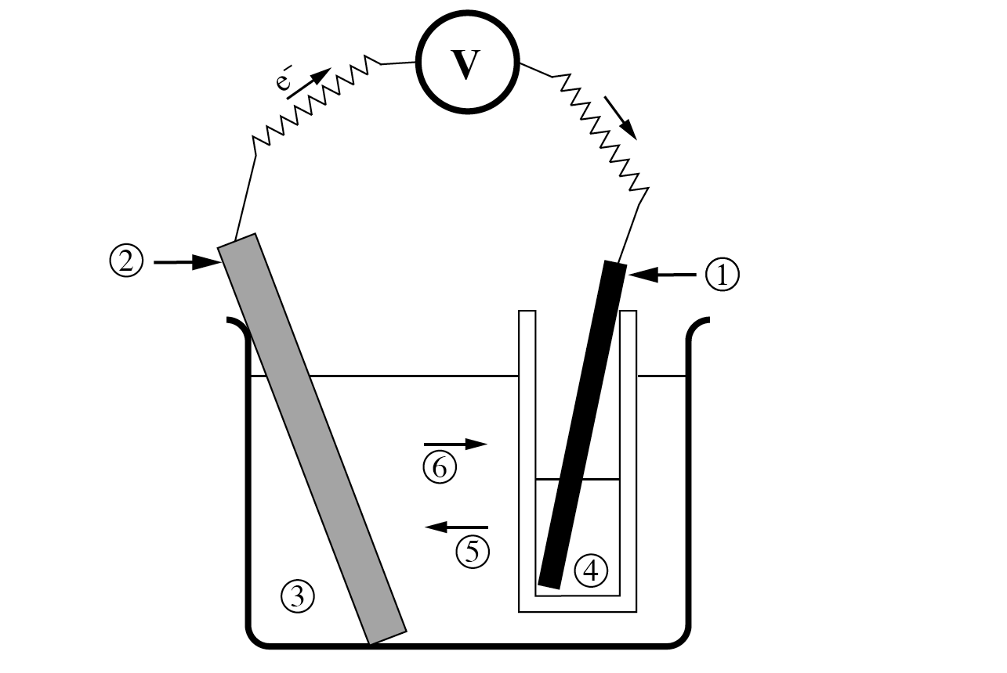

192. The nickel electrode is represented by number ___ (Record in first column)
The acidic MnO₄(aq) solution is represented by number ___ (Record in second column)
The cation migration is represented by number ___ (Record in third column)
The cathode is represented by number ___ (Record in fourth column)
(Record your four digit answer in the numeric response section.)

Use the following information to answer the next question.
Reagents
1 Ag(s) 5 1.0 mol/L Fe²⁺(aq)
2 Cd(s) 6 1.0 mol/L Hg²⁺(aq)
3 Hg(l) 7 1.0 mol/L Cd²⁺(aq)
4 Fe(s) 8 1.0 mol/L Ag⁺(aq)

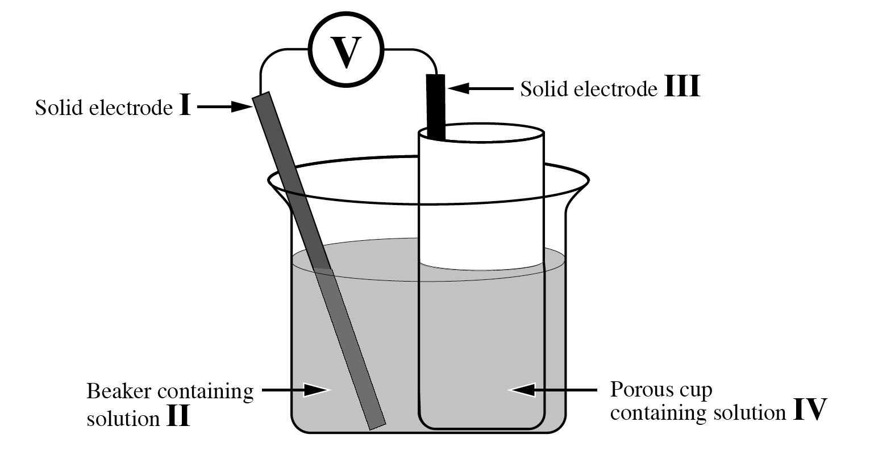

193. What reagents are required in order for the cell to produce a voltage of 1.25 V?

Electrode I ________ (Record in first column)
Solution II ________ (Record in second column)
Electrode III ________ (Record in third column)
Solution IV ________ (Record in fourth column)
(Record your four digit answer in the numeric response secetion.)
194. Under standard conditions, hydrogen gas reacts with Au³⁺(aq) ions to produce Au(s). The net cell potential for the reaction is +/- ___ V.
(Record your three digit answer in the numeric response section.)

Use the following information to answer the next question.
The sodium metal in television picture tubes reacts with oxygen that would otherwise oxidize the tungsten and phosphorus found in the tubes. Tungsten and phosphorus are vital to the function of the picture tubes.

195. The mass of sodium that will react when 0.350 mol of electrons is transferred is ________ g.
(Record your three digit answer in the numeric response section.)

Use the following information to answer the next question.
An Electrochemical Cell
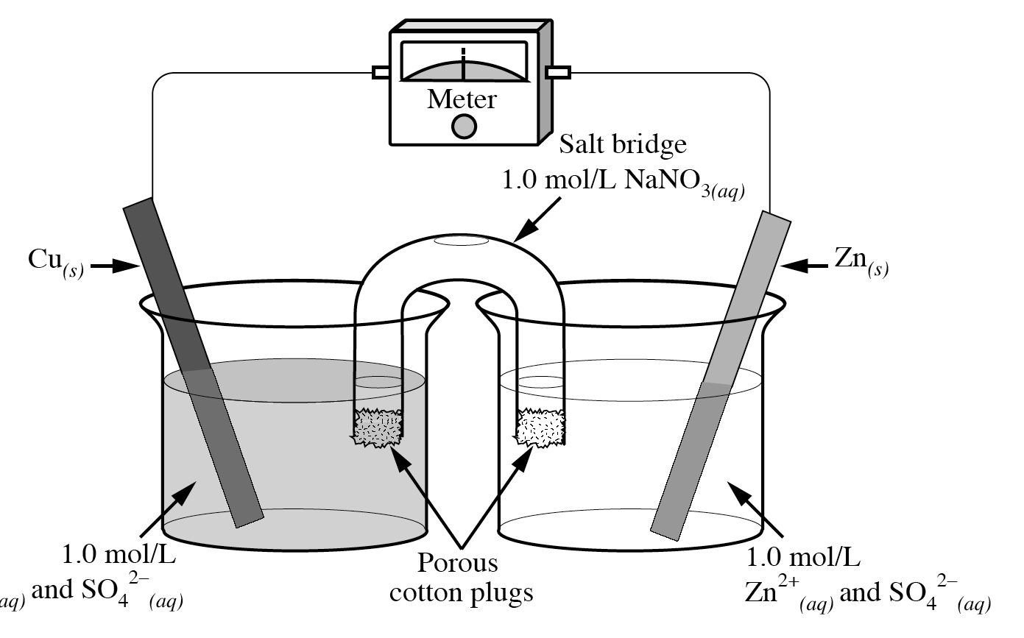

196. A student attempted to replicate a traditional Daniell Cell by setting up the electrochemical cell shown above. Under standard conditions, the electrical potential of the cell should be +/- _______V.
(Record your three digit answer in the numeric response section.)

Use the following diagram to answer the next question.
Voltaic Cell
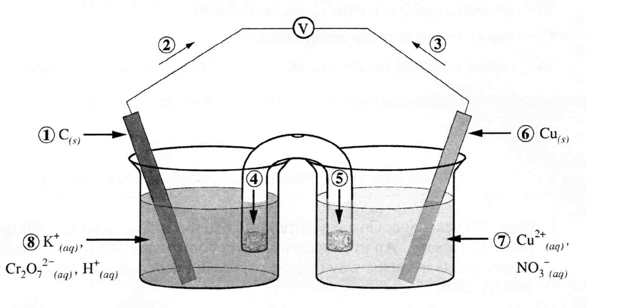

197. In the diagram above, the number that represents the
anode is __________ (Record in the first column)
cathode is __________ (Record in the second column)
cation flow is __________ (Record in the third column)
electron flow is __________ (Record in the fourth column)
(Record your four digit answer in the numeric response section.)
Use the following information to answer the next question.
In vehicles, hydrogen fuel cells are about twice as efficient as gasoline engines. One method used to produce the hydrogen for the fuel cell is the electrolysis of water, as represented by the diagram below.
Electrolysis of Water
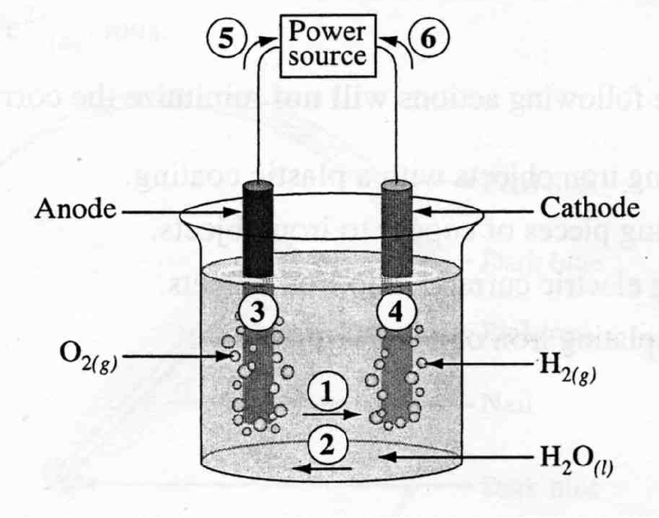

198. Match four of the numbers in the diagram above with their appropriate labels given below
The direction of cation flow _____ (Record in the first column)
The direction of electron flow _____ (Record in the second column)
The site where oxidation occurs _____ (Record in the third column)
The site where electrons are gained _____ (Record in the fourth column)
(Record your four digit answer in the numeric response section.)

Use the following information to answer the next _ questions.
Solid-state lithium batteries are being developed as miniature, rechargeable energy sources. Different sizes and shapes of batteries are possible because the electrolyte is a very thin polymer layer. A simplified diagram of the battery is drawn below.
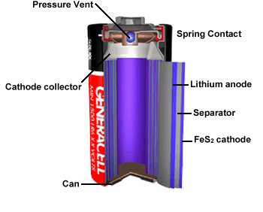
Relevant Equations
Li(s) → Li⁺(s) + e⁻
FeS₂(s) + e⁻→ FeS₂⁻(s)

199. If a solid-state lithium battery produced 5.00 mA in 8.25 h, then the mass of lithium consumed would be _______ mg.
(Record your three digit answer in the numeric response section.)
Use the following information to answer the next question.
A voltaic cell capable of lighting a small light bulb can be made by placing copper and zinc strips in a lemon.
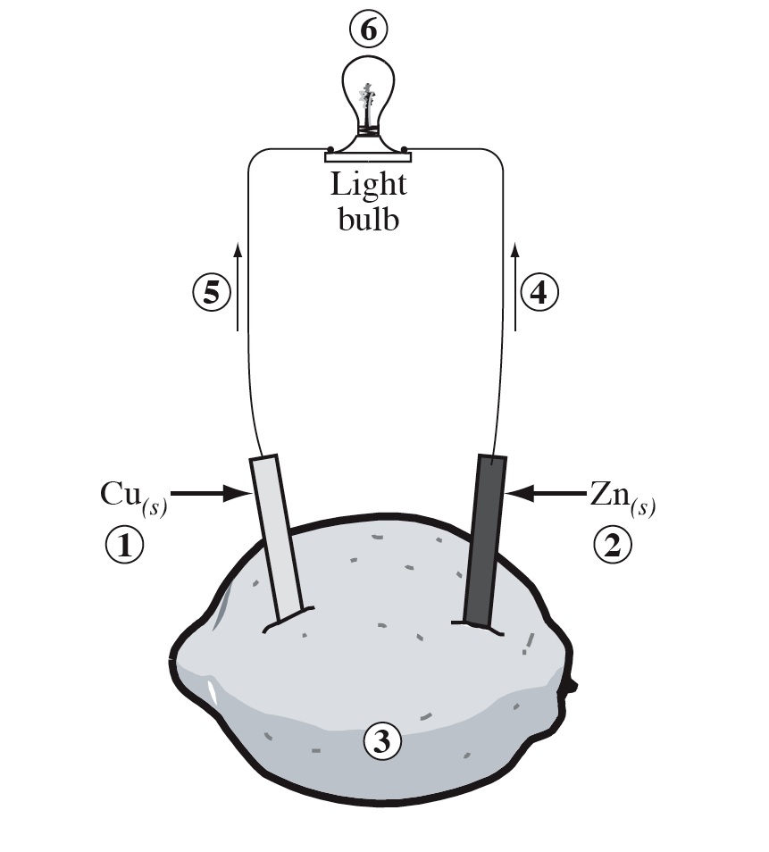

200. Identify the part of the voltaic cell, as numbered above, that corresponds to each of the descriptors listed below.
Anode ___________ (Record in the first column)
Cathode ___________ (Record in the second column)
Electron flow ___________ (Record in the third column)
Electrolyte ___________ (Record in the fourth column)
(Record your four digit answer in the numeric response section.)

Use the following information to answer the next _ questions.
To determine the identity of an unknown metallic ion in a solution, a student designed the voltaic cell shown below.
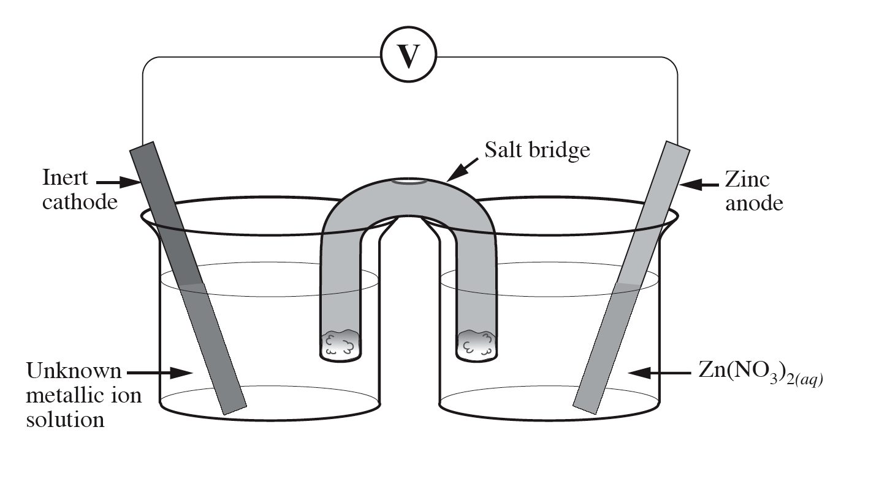

201. If the charge on the unidentified metal ion is 3+, then the number of moles of the metal produced when the zinc anode decreases in mass by 200 g is _______ mol.
(Record your three digit answer in the numeric response section.)

Use the following information to answer the next question.
Hydrogen-oxygen fuel cells have been used for years in spacecraft and more recently in small-scale power plants to generate electricity. Now, some governments and companies are working together to perfect this type of fuel cell for automobile use, and experiments are currently being conducted with operational prototypes. A diagram of a hydrogen-oxygen fuel cell is shown below.
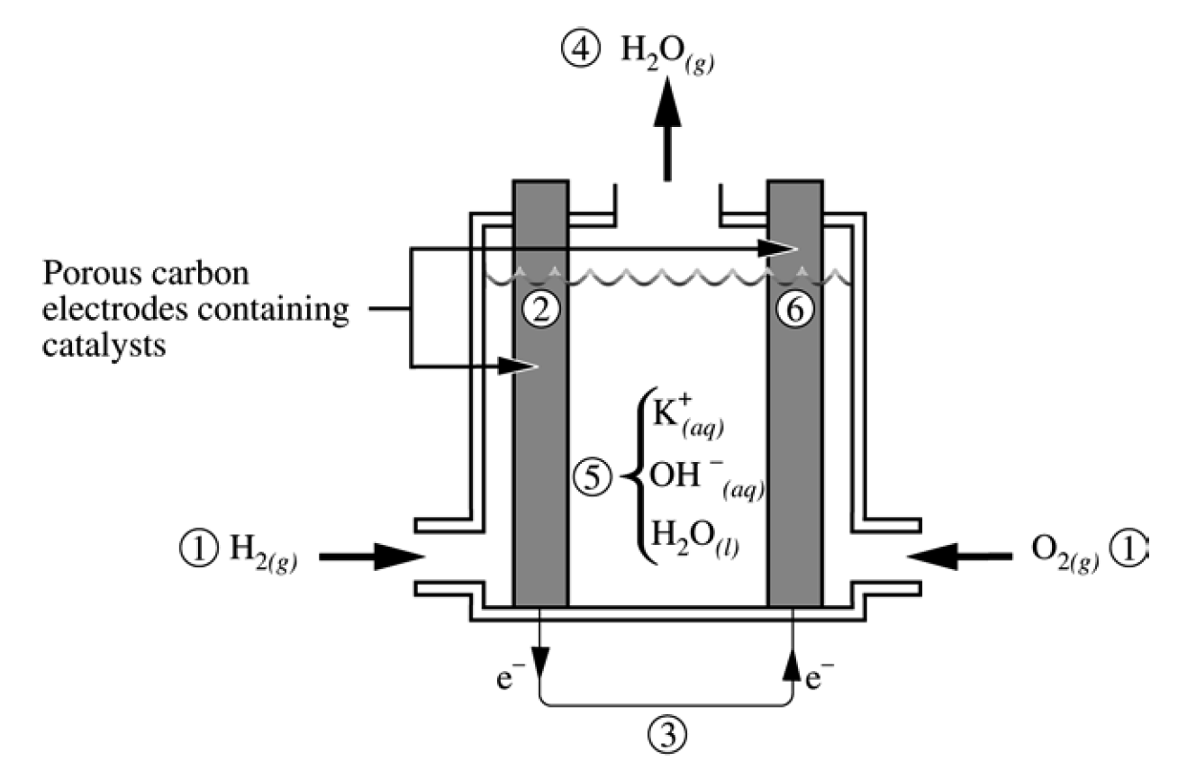

202. In the diagram above, the anode, the cathode, the electrolyte, and a product of the reaction are labelled, respectively, __, __, __, and __.
(Record your four digit answer in the numeric response section.)

Use the following information to answer the next question.
Copper can be refined (purified) using an apparatus like the one shown below, which is a small-scale version of an industrial apparatus.
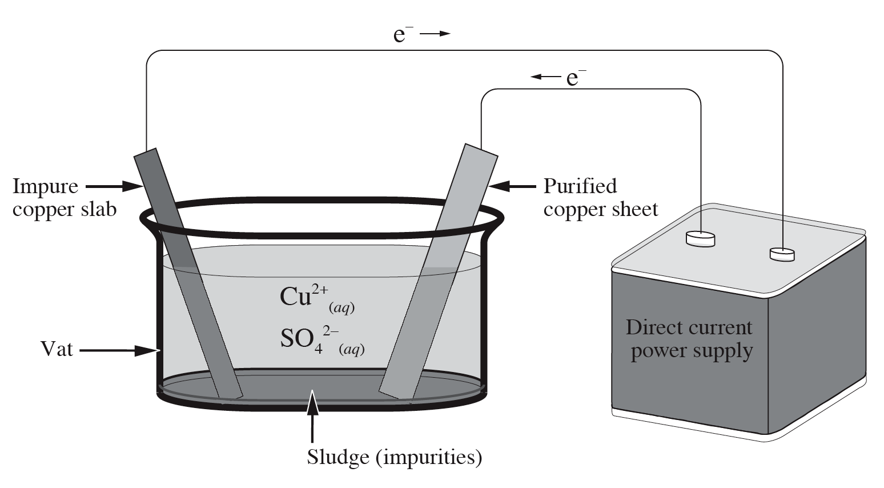

203. If the direct current power supply produces a steady 3.50 A current, then the time required to deposit 0.100 g of purified copper is _______ s.
(Record your three digit answer in the numeric response section.)

Use the following information to answer the next _ questions.
The silver oxide alkaline cell is a miniature power source used in watches, calculators, hearing aids, and cameras. The construction of this cell is shown in the following diagram.
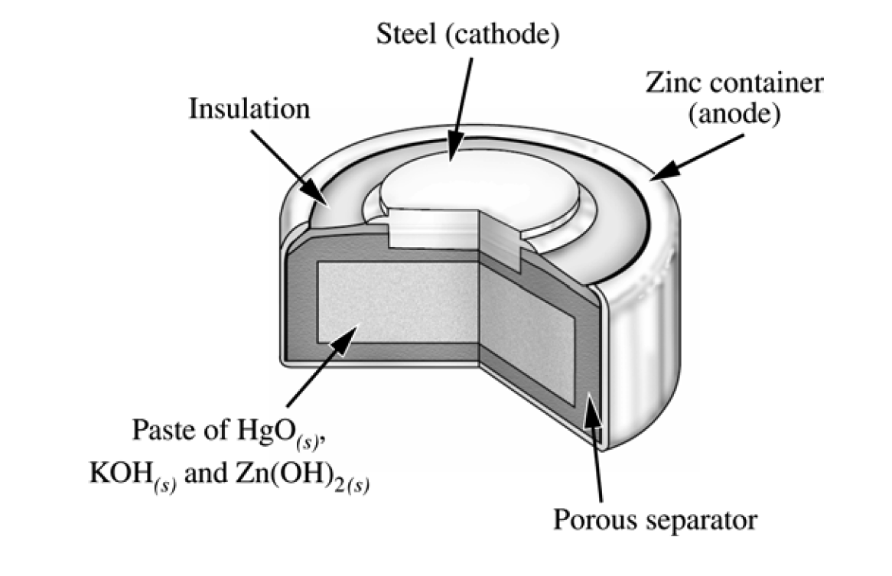
Half-Reactions
Zn(OH)₂(s) + 2 e⁻ → Zn(s) + 2 OH⁻(aq) E° = − 1.25 V
Ag₂O(s) + H₂O(l) + 2 e⁻ → 2 Ag(s) + 2 OH⁻(aq) E° = +0.34 V

204. During discharge, the voltage generated by the cell is +/- _____ V.
(Record your three digit answer in the numeric response section.)

205. The voltage generated by three silver oxide cells connected in series is _______ V.
(Record your three digit response in the numeric response section.)

Use the following information to answer the next _ questions.
Concern about increased air pollution and the increasing use of non-renewable resources has accelerated research into alternatives to the internal combustion engine. One alternative is a battery-powered electric motor. Several “new” efficient batteries are being tested. The diagram below represents one of these batteries.
Aluminium-Air Battery
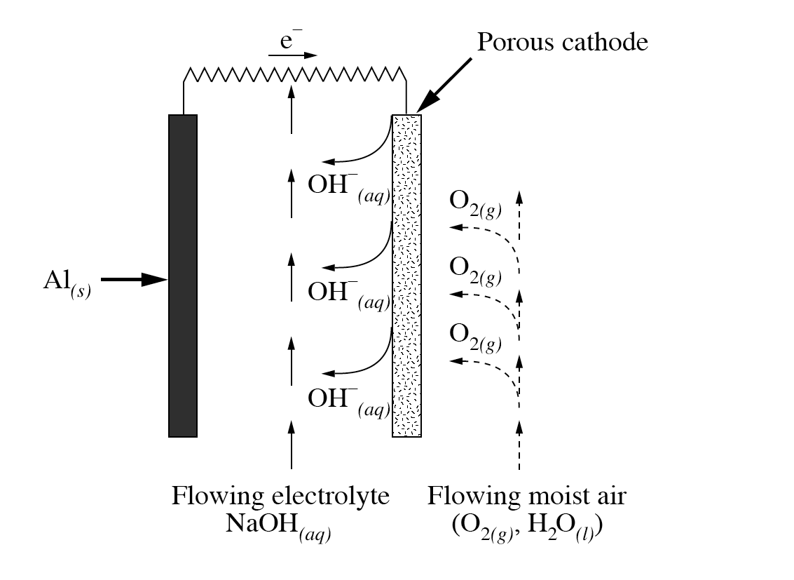

206. When three aluminium-air cells are connected in series, the net voltage generated by the battery +/- ________ V.
(Record your three digit answer in the numeric response section.)
Use the following information to answer the next question.
2 RhCl₆³⁻(aq) + 3 Zn(s) → 3 Zn²⁺(aq) + 2 Rh(s) + 12 Cl⁻(aq) E°_{net} = +1.20 V

207. The standard electrode potential for the half-reaction
RhCl₆³⁻(aq) + 3 e⁻ → Rh(s) + 6 Cl⁻(aq) is _______ V.
(Record your three digit answer in the numeric response section.)

Use the following information to answer the next _ questions.
A chemistry student constructs the cell shown below.
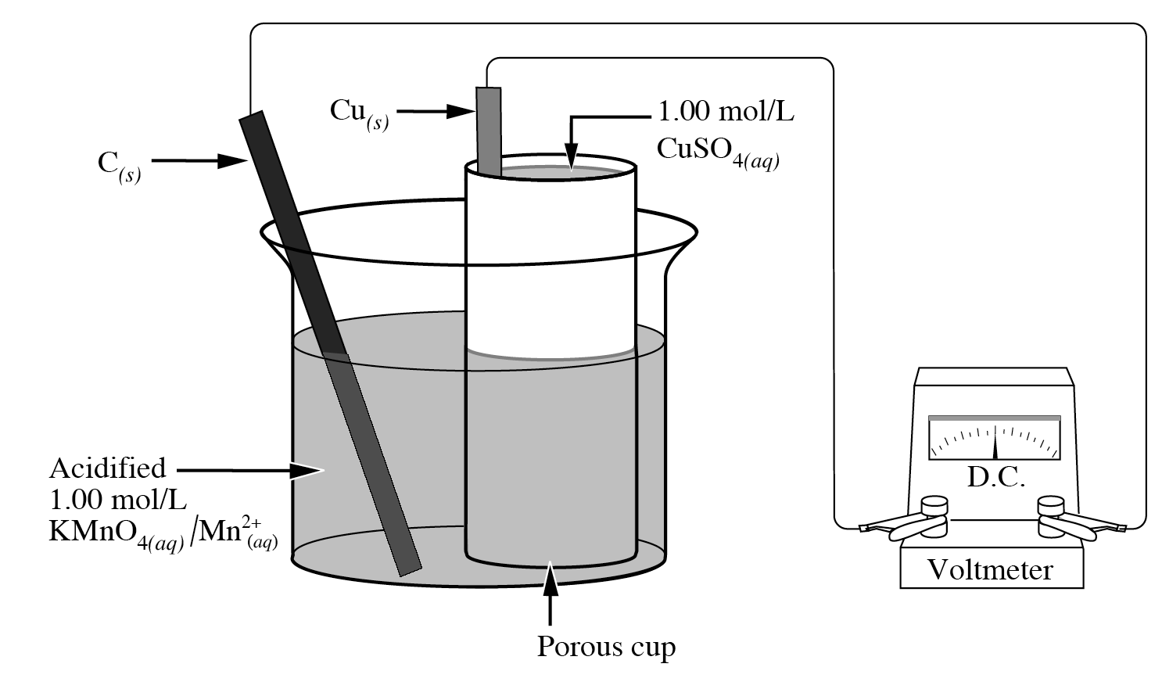

208. During the operation of this cell, if 0.354 mol of MnO₄⁻(aq) were consumed, then the mass of the copper electrode would decrease by _______ g.
(Record your three digit answer in the numeric response section.)

Use the following information to answer the next _ questions.
Chromium plating of objects, such as iron car bumpers, to prevent corrosion actually involves the plating of three different meals in three separate electrolytic cells. The first cell contains a solution of a copper salt, the second a solution of nickel salt, and the third a solution of chromium salt.

Use the following additional information to answer the next question.
Electroplating Cell
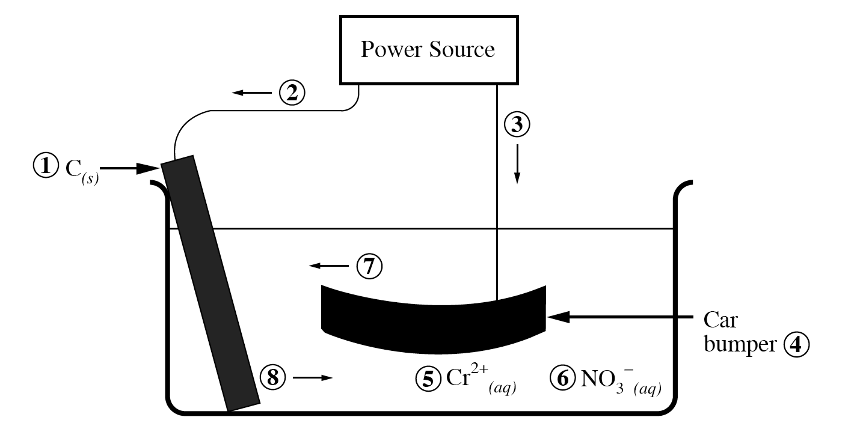
209. Use the numbers that identify the parts of the electroplating cell in the cell above to complete the statements below.
The cathode is identified by ____ (Record in the first column)
The electron movement is identified by ____ (Record in the second column)
The cation movement is identified by ____ (Record in the third column)
The anion is identified by ____ (Record in the fourth column)
(Record your four digit answer in the numeric response section.)

210. A chromium electroplating cell needs to operate at a current of 2000 A to plate 112 g of chromium onto a car bumper. In order to plate the bumper, the cell must operate for ___________min.
(Record your three digit answer in the numeric response section.)

Use the following information to answer the next question.
During the operation of a NiCad battery, the two half-reactions that occur are
I Cd(s) + 2 OH⁻(aq) → Cd(OH)₂(s) + 2 e⁻ E° = ? V
II NiO₂(s) + 2 H₂O(l) + 2 e⁻ → Ni(OH)₂(s) + 2 OH⁻(aq) E° = -0.49 V

211. On discharging, the electric potential of a NiCad battery is +1.40 V. The reduction potential for half-reaction I is - ________ V.
(Record your three digit answer in the numeric response section.)

Use the following diagram to answer the next question.
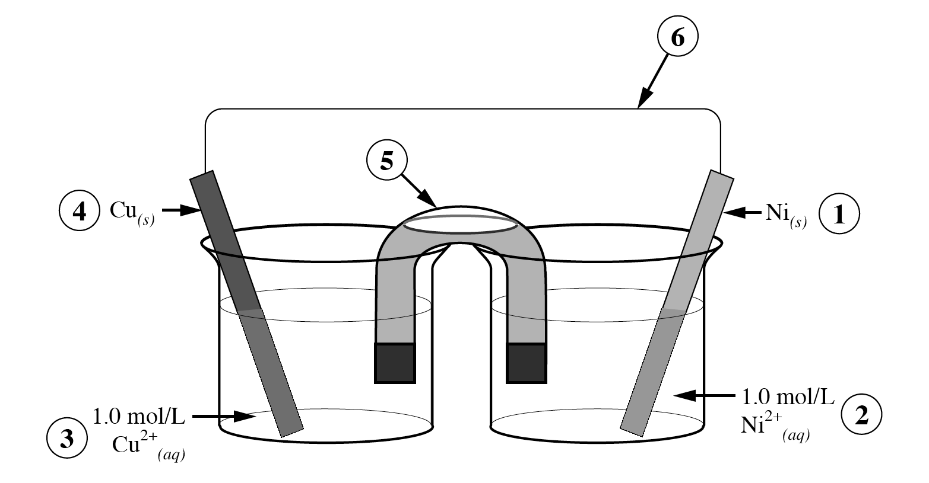

212. Identify the part of the electrochemical cell, as numbered above, that correponds to the term listed below.

Cathode _____ (Record in the first column)
External electron circuit _____ (Record in the second column)
Oxidizing agent _____ (Record in the third column)
Anode _____ (Record in the fourth column)
(Record your four digit answer in the numeric response section.)

Use the following information to answer the next _ questions.
In 1936, an object of unknown purpose was discovered near Baghdad. The object was determined to be approximately 2 000 years old. This object had several similarities to modern dry cells, and as a result, was named the “Battery of Baghdad.”
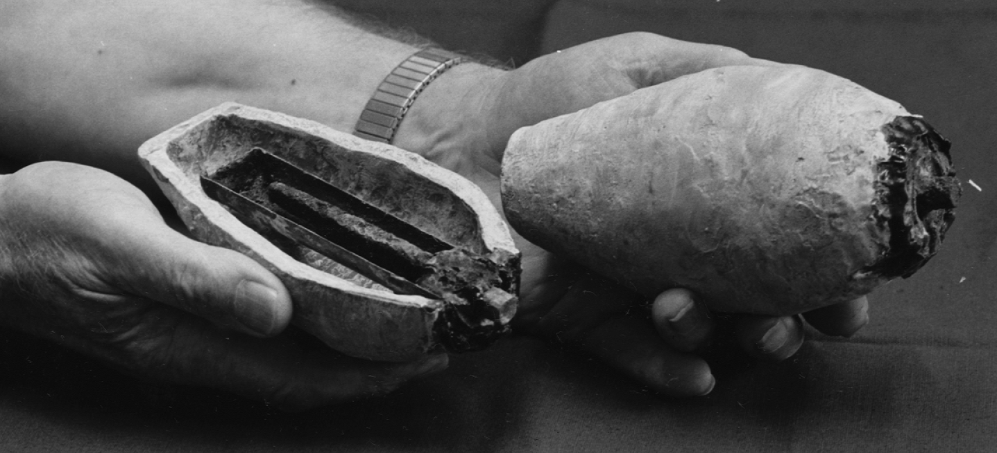

It is possible, using materials known to be available 2 000 years ago, to construct a model cell that produces a voltage.

The reaction that occurs in this model cell is
Fe(s) + OC₆H₄O(aq) + 2 H⁺(aq) → HOC₆H₄OH(aq) + Fe²⁺(aq) E°_{net} = +1.25 V

213. The time in hours that the model cell would have to operate at 10.0 A to consume 35.0 g of Fe(s) is ____________h.
(Record your three digit answer in the numeric response section.)

Use the following information to answer the next _ questions.
The chlor-alkali process used by Dow Chemical in Fort Saskatchewan uses sodium chloride from underground deposits. The sodium chloride is dissolved in water and then pumped into electrolytic cells where a current is passed through the solution to form yellow chlorine gas, colourless hydrogen gas, and aqueous sodium hydroxide.
The net ionic equation is 2 H₂O(l) + Cl⁻(aq) → Cl₂(g) + 2 OH⁻(aq) + H₂(g)

214. If the mass of the element formed at the anode is 78.1 g, the mass of element formed at the cathode is _________ g.
(Record your three digit answer in the numeric response section.)
Use the following equation to answer the next question.
Sn⁴⁺(aq) + 2 Cr²⁺(aq) → Sn²⁺(aq) + 2 Cr³⁺(aq)

215. At standard conditions, the net potential for the reaction represented by the equation above is ________V.
(Record your three digit answer in the numeric response section.)

Use the following diagram to answer the next question.
Voltaic Cell
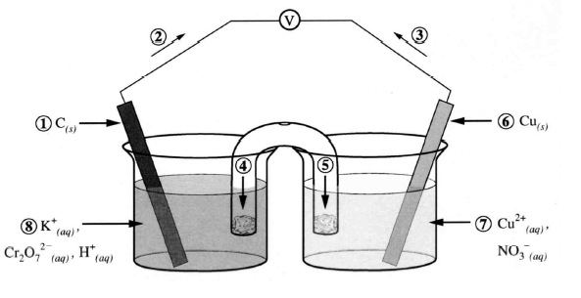

216. In the diagram above, the number that represents the

anode is _____ (Record in the first column)
cathode is _____ (Record in the second column)
cation flow is _____ (Record in the third column)
electron flow is _____ (Record in the fourth column)
(Record your four digit answer in the numeric response section.)
Short Answer

217. Use the following information to answer the next question.
Before fleeing Denmark in 1943, Niels Bohr prevented two Nobel prize gold medals from being seized by German authorities. The gold was reacted with aqua regia (a combination of concentrated nitric acid and hydrochloric acid). The unbalanced equation for the reaction that Bohr used is
Au(s) + H⁺(aq) + NO₃⁻(aq) + Cl⁻(aq) → AuCl₄⁻(aq) + NO₂(g) + H₂O(l)
After the Second World War, the gold was recovered, and then the medals were recast.

1a. Balance the equation above using oxidation-reduction methods. Identify the oxidizing and reducing agents and the number of electrons lost or gained by each. (3 marks)
1b. If the initial combined mass of the gold in the medals was 225 g and the total volume of aqueous solution was 4.00 L, then what was the final concentration of AuCl₄⁻(aq) after the medals were completely reacted? (3 marks)
1c. The reduction potential for the AuCl₄⁻(aq) half-reaction is 1.00V. Suggest a substance that could be used to convert the AuCl₄⁻(aq) back into Au(s). Justify your choice. (2 marks)
Communication (2 marks)

218.
Use the following information to answer the next question.
A student was given four solutions labelled A, B, C, and D. One contained Cl⁻(aq) ions, one contained Br⁻(aq) ions, one contained Sn²⁺(aq) ions, and one contained Fe²⁺(aq) ions.
In order to identify each solution, the student selected the following acidified reagents:
MnO₄⁻(aq), SO₄²⁻(aq), NO₃⁻(aq) and Cr₂O₇²⁻(aq)
The student combined some of each solution with the reagents and recorded the following results:

Reagents | Unknown Solutions
 | A | B | C | D
H⁺(aq), MnO₄⁻(aq) |  |  |  | 
H⁺(aq), SO₄²⁻(aq) |  |  |  | 
H⁺(aq), NO₃⁻(aq) |  |  |  | 
H⁺(aq), Cr₂O₇²⁻(aq) |  |  |  | 

If “” indicates a spontaneous reaction and “” indicates no reaction, identify what each unknown solution contained. Explain how you reached your conclusions.

219. Draw an electrolytic cell that could be used to plate an iron ring with gold.
Your answer should also include
• Labels for all of the necessary parts of your cell.
• The electrolyte(s) used and precise composition of the electrodes.
• A balanced net cell equation and cell potential

220.
Use the following information to answer the next question.
Electroless plating has been used for many decades. Electroless plating uses a redox reaction to deposit metal on an object without the need for an electric current. Electroless platings of silver on mirrors can be prepared, under basic conditions, according to the unbalanced reaction:
CH₃CHO(aq) + Ag(NH₃)₂OH(aq) → Ag(s) + CH₃COO⁻(aq) + H₂O(l) + NH₃(aq)

a. Balance the reaction equation using electrochemical methods. (3 marks)
b. Identify, clearly, the reducing agent and the oxidizing agent in the electroless
silver plating reaction. (2 marks)
c. Calculate the mass of silver deposited when 350 mL of a 0.250 mol/L aqueous
solution of ethanal, CH₃CHO(aq), is completely consumed. (3 marks)
Communication.(2 marks)

221. In the table below, the time, in hours, that each of three cells would operate four particular devices is given. The cost of each cell is also given.
 | Type of D Cell
 | LeClanché | Zinc Chloride | Alkaline
Motor Toy | 1.0 h | 3.0 h | 11.0 h
Cassette Player | 1.0 h | 2.5 h | 5.7 h
Flashlight | 1.0 h | 2.0 h | 4.6 h
Pocket Radio | 1.0 h | 1.8 h | 4.1 h
Voltage | 1.5 V | 1.5 V | 1.5 V
Operating Temperature Range | 5°C - 55°C | -20°C - 55°C | -30°C - 55°C
Cost of Cell | $0.75 | $0.95 | $2.25

Leclanché Cell (Zn(s)/MnO₂(s))
Overall Reaction
2 MnO₂(s) + 2 NH₄Cl(aq) + Zn(s) → ZnCl₂•2NH₃(s) + Mn₂O₃•H₂O(s)

Zinc Chloride Cell (Zn(s)/MnO₂(s))
Overall Reaction
8 MnO₂(s) + 4 Zn(s) + ZnCl₂(s) + 9 H₂O(l) → 8 MnOOH(s) + ZnCl₂•4ZnO•5H₂O(s)

Alkaline/Manganese Dioxide Cell (Zn(s)/MnO₂(s))
Overall Reaction 2 Zn(s) + 3 MnO₂(s) → 2 ZnO(s) + Mn₃O₄(s)

a. Identify the anode common to all of the D cells. Indicate the change in oxidation number for the anode. (2 marks)
b. For how many hours could a Leclanché cell operate at 0.300 A is the limiting reagent was a 10.0 g anode? (3 marks)
c. Which type of D cell battery would you use to operate a portable cassette player outside on a mild winter day when the temperature was -12°C? Justify your choice from two different perspectives. (3 marks)
Communication (2 marks)

222. Describe a working voltaic cell that incorporates a standard nickel half-cell and that has a net cell potential greater than 1.00 V.

Your response should include
• relevant balanced half-reaction equations and an E°net calculation
• a labelled diagram
• evidence that a reaction occurred in each half-cell

223. Use the following information to answer the next question.
Several factors affect the length of time a voltaic cell can produce energy. A student has the materials to construct several silver-zinc voltaic cells.
Design an experiment that would allow the student to test how one of these factors will affect the length of time that a silver-zinc voltaic cell can operate.
Your response should include
• a detailed procedure
• identification of the manipulated, responding, and controlled variables
• a balanced net ionic equation and E°net calculation

224. Use the following information to answer the next question.
Electric-powered vehicles produce less air pollution than gasoline-powered vehicles. A zinc-air battery can be used in electric vehicles because it is lightweight and rechargeable. The battery uses water and oxygen gas from the air, a solid zinc electrode, and an electrolyte.

a. Write the balanced equations that represent the half-reaction that occurs at the anode and the half-reaction that occurs at the cathode of the zinc-air battery, and label which reaction occurs at the anode and which reaction occurs at the cathode. (2 marks)
b. Write the balanced net ionic equation that represents the overall reaction for the zinc-air battery and calculate the E°net. (2 marks)
c. Determine the mass of oxygen from the air that would be required to produce a current of 1.5 x 103 A for 5.0 min. (2 marks)
d. Identify and explain a quantitative disadvantage of replacing the zinc electrode with a lead electrode. (2 marks)
Communication (2 marks)

225. Use the following information to answer the next question.
In an experiment, a student constructed a standard voltaic cell using cadmium nitrate and copper(II) nitrate, as represented by the cell notation belwo.
Cd(s)⎥ Cd²⁺(aq)⎥⎥ Cu²⁺(aq)⎥ Cu(s)
The student then measured the voltage of the cell at 25.0°C.

a. Draw and label the voltaic cell, including the anode, cathode and direction of movement of the ions and electrons. (4 marks)
b. Write the net balanced equation that represents the reaction occurring in the cell, and calculate the standard net cell potential. (2 marks)
c. Identify evidence that a reaction occurred in each half-cell. (2 marks)
Communication (2 marks)

226. Use the following information to answer the next question.
A student hypothesizes that if the concentration of copper(II) ions is increased in a copper-zinc voltaic cell, the potential difference of the cell will also increase.

Design an experiment that would allow you to test the student’s hypothesis using a copper-zinc voltaic cell.

Your response should include
• a detailed procedure
• a labelled diagram of the copper-zinc voltaic cell
• identification of the manipulated, controlled, and responding variables

227. Use the following information to answer the next question.
In some industrial processes sodium chromate is added to water coolants. When the coolant is drained, the chromate ions can be removed through an electrolysis process that uses an iron anode. The products of the electrolysis are aqueous iron(II) ions and solid chromium(III) hydroxide, a recoverable pollutant. The half-reaction involving the chromate ion is
CrO₄²⁻(aq) + 4 H₂O(l) + 3 e⁻ → Cr(OH)₃(s) + 5 OH⁻(aq)

a. Provide the half-reactions and a net redox reaction for this electrochemical process. (3 marks)
b. A current of 3.00 A is applied for 48.0 h to a cell containing a 400 g iron anode. What is the final mass of the iron anode? (3 marks)
c. Suggest an alternative anode material that would last longer than iron. Support your answer with relevant calculations and explanations. (2 marks)
Communication (2 marks)

228. Talon Tapes of Edmonton manufactures plastic tape containing small pieces of magnesium. This tape is completely wrapped around iron pipes that will be buried underground. Explain in chemical terms the purpose(s) of each component of the tape. Your response should include relevant half-reactions.

Electrochemistry review Answer Section
MULTIPLE CHOICE

105. ANS: A PTS: 1 REF: June 2000 Diploma
OBJ: 30-B2.3k TOP: standard cell notation KEY: predicting net ionic equation

106. ANS: A PTS: 1 REF: June 2000 Diploma
OBJ: 30-B2.3k TOP: voltaic cell KEY: identify the oxidation half-reaction

107. ANS: A PTS: 1 REF: June 2000 Diploma
OBJ: 30-B2.3k TOP: voltaic cell KEY: identify the SOA

108. ANS: B PTS: 1 REF: June 2000 Diploma
OBJ: 30-B2.1k TOP: voltaic cell KEY: electron flow and pH change

109. ANS: B PTS: 1 REF: June 2000 Diploma
OBJ: 30-B2.6k TOP: voltaic cell KEY: identify the anode from voltage

110. ANS: C PTS: 1 REF: 2007 Released Items
OBJ: 30-B2,6k TOP: battery chemistry
KEY: calculation of reduction potential for a half-reaction

111. ANS: A PTS: 1 REF: 2007 Released Items
OBJ: 30-B2.7k TOP: voltaic cells KEY: identify the SRA

112. ANS: D PTS: 1 REF: 2007 Released Items
OBJ: 30-B2.1s TOP: voltaic cell KEY: cation migration

113. ANS: D PTS: 1 REF: 2007 Released Items
OBJ: 30-B2.2sts TOP: corrosion KEY: sacrifical anode

114. ANS: B PTS: 1 REF: January 2002 Diploma
OBJ: 30-B2.2k TOP: electrolysis KEY: energy change

115. ANS: A PTS: 1 REF: January 2002 Diploma
OBJ: 30-B2.8k TOP: Electrolysis KEY: Faraday calculation

116. ANS: D PTS: 1 REF: January 2002 Diploma
OBJ: 30-B2.2sts TOP: corrosion KEY: prevention

117. ANS: D PTS: 1 REF: January 2002 Diploma
OBJ: 30-B2.1s TOP: voltaic cell KEY: anode selection

118. ANS: C PTS: 1 REF: January 2002 Diploma
OBJ: 30-B2.6k TOP: voltaic cells KEY: predicting E° cathode

119. ANS: C PTS: 1 REF: January 2002 Diploma
OBJ: 30-B2.8k TOP: cell stoich KEY: mol of e- transferred

120. ANS: D PTS: 1 REF: January 2002 Diploma
OBJ: 30-B2.6k TOP: voltaic cell KEY: predicting net cell equation and potential

121. ANS: A PTS: 1 REF: June 2001 Diploma
OBJ: 30-B2.3sts TOP: fuel cell KEY: ecological perspective

122. ANS: D PTS: 1 REF: June 2001 Diploma
OBJ: 30-B2.3k TOP: electrolytic cell KEY: predicting cathode reaction

123. ANS: A PTS: 1 REF: June 2001 Diploma
OBJ: 30-B2.3k TOP: battery KEY: predicting RA

124. ANS: A PTS: 1 REF: June 2001 Diploma
OBJ: 30-B2.1k TOP: battery KEY: definition of salt bridge

125. ANS: A PTS: 1 REF: January 1996 Diploma
OBJ: 30-B2.3k

126. ANS: C PTS: 1 REF: January 1996 Diploma
OBJ: 30-B2.3s

127. ANS: B PTS: 1 REF: June 2001 Diploma
OBJ: 30-B2.1s TOP: voltaic cell KEY: identifying an error in construction

128. ANS: C PTS: 1 REF: June 2001 Diploma
OBJ: 30-B2.3k TOP: electrolysis KEY: identification of cathode reaction

129. ANS: C PTS: 1 REF: January 2001 Diploma
OBJ: 30-B2.3k TOP: battery KEY: identification of the OA

130. ANS: D PTS: 1 REF: January 2001 Battery
OBJ: 30-B2.3k TOP: voltaic cell KEY: reduction half-reaction

131. ANS: B PTS: 1 REF: January 2001 Diploma
OBJ: 30-B2.6k TOP: voltaic cell KEY: calculation of potential

132. ANS: C PTS: 1 REF: January 2001 Diploma
OBJ: 30-B2.3k TOP: voltaic cell KEY: predict net equation and potential

133. ANS: A PTS: 1 REF: January 2001 Diploma
OBJ: 30-B2.1k TOP: voltaic cell KEY: cell details

134. ANS: D PTS: 1 REF: January 2001 Diploma
OBJ: 30-B2.2k TOP: voltaic cell KEY: details

135. ANS: C PTS: 1 REF: June 1999 Diploma
OBJ: 30-B2.6k TOP: identifying an oxidation half-reaction
KEY: given cell potential and reduction half

136. ANS: A PTS: 1 REF: June 1999 Diploma
OBJ: 30-B2.2sts TOP: corrosion protection KEY: sacrificial anode

137. ANS: C PTS: 1 REF: June 1999 Diploma
OBJ: 30-B2.7k TOP: electrolysis KEY: predicting products

138. ANS: B PTS: 1 REF: June 1999 Diploma
OBJ: 30-B2.5s TOP: reference half cell KEY: change to copper half-reaction

139. ANS: A PTS: 1 REF: June 1999 Diploma
OBJ: 30-B2.6k TOP: voltaic cell KEY: predicting cell potential

140. ANS: B PTS: 1 REF: June 1999 Diploma
OBJ: 30-B2.3s TOP: electrolysis KEY: identifying products

141. ANS: D PTS: 1 REF: January 1999 Diploma
OBJ: 30-B2.3s TOP: electroplating KEY: site of reduction

142. ANS: C PTS: 1 REF: January 1999 Diploma
OBJ: 30-B2.3s TOP: electrolysis KEY: products of cell

143. ANS: A PTS: 1 REF: January 1999 Diploma
OBJ: 30-B2.7k TOP: spontaneous reaction KEY: given OA

144. ANS: A PTS: 1 REF: January 1999 Diploma
OBJ: 30-B2.8k TOP: Faraday calculation
KEY: mass change at anode given current and time

145. ANS: B PTS: 1 REF: January 1999 Diploma
OBJ: 30-B2.3k TOP: reduction potential KEY: selecting from the table

146. ANS: A PTS: 1 REF: January 1999 Diploma
OBJ: 30-B2.1s TOP: voltaic cells KEY: identifying variables

147. ANS: B PTS: 1 REF: January 1998 Diploma
OBJ: 30-B2.3s

148. ANS: B PTS: 1 REF: January 1998 Diploma
OBJ: 30-B2.2k

149. ANS: D PTS: 1 REF: January 1998 Diploma
OBJ: 30-B2.5k

150. ANS: C PTS: 1 REF: January 1998
OBJ: 30-B2.3k

151. ANS: D PTS: 1 REF: January 1998 Diploma
OBJ: 30-B2.1k

152. ANS: B PTS: 1 REF: January 1998 Diploma
OBJ: 30-B2.3s

153. ANS: A PTS: 1 REF: January 1998 Diploma
OBJ: 30-B2.6k

154. ANS: A PTS: 1 REF: January 1998 Diploma
OBJ: 30-B2.2k

155. ANS: D PTS: 1 REF: January 1998 Diploma
OBJ: 30-B2.4k

156. ANS: D PTS: 1 REF: January 1996 Diploma
OBJ: 30-B2.3k

157. ANS: C PTS: 1 REF: January 1996 Diploma
OBJ: 30-B2.3s

158. ANS: D PTS: 1 REF: 2005 Released items
OBJ: 30-B1.2sts TOP: corrosion KEY: econmic and ecological

159. ANS: D PTS: 1 REF: 2005 Released items
OBJ: 30-B2.3s TOP: voltaic cells KEY: characteristics

160. ANS: B PTS: 1 REF: 2005 Released items
OBJ: 30-B2.6k TOP: identity of anode KEY: given cathode and potential

161. ANS: D PTS: 1 REF: 2005 Released items
OBJ: 30-B2.3s TOP: electrolysis KEY: identifying products

162. ANS: A PTS: 1 REF: 2005 Released items
OBJ: 30-B2.3k TOP: electrolytic cell KEY: reaction at the anode

163. ANS: C PTS: 1 REF: 2005 Released items
OBJ: 30-B2.8k TOP: calculating time KEY: given current and mass

NUMERIC RESPONSE

164. ANS: 4646 PTS: 1 REF: June 1997 Diploma OBJ: 30-B1.3k
TOP: electrochemistry KEY: oxidation numbers

165. ANS: 2143 PTS: 1 REF: June 1997 OBJ: 30-B1.5k
TOP: electrochemistry KEY: strength of OA

166. ANS: 4746 PTS: 1 REF: June 1998 Diploma OBJ: 30-B1.7k
TOP: redox equations KEY: balancing equations

167. ANS: 8.58 PTS: 1 REF: June 1998 Diploma OBJ: 30-B1.2s
TOP: redox titration KEY: calculating an average volume

168. ANS: 6.65 PTS: 1 REF: June 1998 Diploma OBJ: 30-B1.8k
TOP: redox titration KEY: calculating a concentration

169. ANS: 2121 PTS: 1 REF: June 2000 Diploma OBJ: 30-B1.7k
TOP: redox equations KEY: balancing equations

170. ANS: 2431 PTS: 1 REF: June 2000 Diploma OBJ: 30-B1.6k
TOP: redox reaction KEY: order of reaction

171. ANS: 1356 PTS: 1 REF: January 2000 Diploma OBJ: 30-B1.3k
TOP: redox reactions KEY: identifying redox reactions

172. ANS: xxx PTS: 1 REF: January 2000 Diploma OBJ: 30-B1.2s
TOP: redox titration KEY: calculation of an average volume

173. ANS: xxx PTS: 1 REF: January 2000 Diploma OBJ: 30-B1.8k
TOP: redox titration KEY: calculation of concentration

174. ANS: 1.79 PTS: 1 REF: 2004 Released Items OBJ: 30-B1.8k
TOP: redox reaction KEY: solution stoich

175. ANS: 2112 PTS: 1 REF: January 2002 Diploma OBJ: 30-B1.7k
TOP: redox reactions KEY: balancing in an acid

176. ANS: 3.29 PTS: 1 REF: January 2002 Diploma OBJ: 30-B1.8k
TOP: redox reactions KEY: titration calculations

177. ANS: 37.0 PTS: 1 REF: June 2001 Diploma OBJ: 30-B1.8k
TOP: redox reactions KEY: mass calculation

178. ANS: 2314 PTS: 1 REF: January 2001 Diploma OBJ: 30-B1.7k
TOP: predicting reactions KEY: from the table

179. ANS: 5234 PTS: 1 REF: June 1999 Diploma OBJ: 30-B1.4k
TOP: reactions KEY: identifying redox reactions

180. ANS: 2323 PTS: 1 REF: June 1999 Diploma OBJ: 30-B1.7k
TOP: equations KEY: balancing using ON

181. ANS: 2415 PTS: 1 REF: June 1999 Diploma OBJ: 30-B1.7k
TOP: oxidation numbers KEY: assigning in compounds

182. ANS: 3.04 PTS: 1 REF: January 1999 Diploma OBJ: 30-B1.8k
TOP: stoichiometry KEY: mass of metal reacted

183. ANS: 16.5 PTS: 1 REF: January 1998 Diploma OBJ: 30-B1.8k

184. ANS: 2042 PTS: 1 REF: January 1998 Diploma OBJ: 30-B1.3k

185. ANS: 6.00 PTS: 1 REF: January 1993 Diploma OBJ: 30-B1.3k

186. ANS: 0330 PTS: 1 REF: 2005 Released items OBJ: 30-B1.7k
TOP: oxidation numbers KEY: assigning in substances

187. ANS: 5876 PTS: 1 REF: 2005 Released items OBJ: 30-B1.3s
TOP: ranking OA KEY: from reaction data

188. ANS: 3.24 PTS: 1 REF: June 1992 Diploma OBJ: 30-B2.8k
TOP: voltaic cells KEY: Faraday calculation

189. ANS: 0.00 PTS: 1 REF: June 1992 Diploma OBJ: 30-B2.6k, 30-B2.1s
TOP: voltaic cells KEY: predicting potentials

190. ANS: 2.32 PTS: 1 REF: June 1997 Diploma OBJ: 30-B2.8k
TOP: cells KEY: corrosion

191. ANS: 32.3 PTS: 1 REF: June 1997 Diploma OBJ: 30-B2.8k
TOP: cells KEY: calculation of mass

192. ANS: 2461 PTS: 1 REF: June 1998 Diploma OBJ: 30-B2.1k
TOP: voltaic cells KEY: labelling diagram

193. ANS: 1845 or 4518 PTS: 1 REF: June 1998 Diploma OBJ: 30-B2.6k
TOP: voltaic cells KEY: predict materials given voltage

194. ANS: 1.50 PTS: 1 REF: January 2000 Diploma OBJ: 30-B2.6k
TOP: voltaic cell KEY: calculation of potential

195. ANS: 8.05 PTS: 1 REF: June 2000 Diploma OBJ: 30-B2.8k
TOP: Faraday calculation KEY: calculate mass when given n electrons

196. ANS: 1.10 PTS: 1 REF: June 2000 Diploma OBJ: 30-B2.6k
TOP: cell potential KEY: calculation E°net

197. ANS: 6143 PTS: 1 REF: 2003 Released Items OBJ: 30-B2.1k
TOP: voltaic cell KEY: labelling a cell

198. ANS: 1534 PTS: 1 REF: 2006 Released items OBJ: 30-B2.1k
TOP: electrolysis KEY: label diagram

199. ANS: 10.7 PTS: 1 REF: 2007 Released Items OBJ: 30-B2.8k
TOP: voltaic cell KEY: calculation of mass consumed given time and current

200. ANS: 2145
PTS: 1 REF: January 2002 Diploma OBJ: 30-B2.1k
TOP: voltaic cells KEY: identifying parts of a cell

201. ANS: 4.59 PTS: 1 REF: January 2002 Diploma OBJ: 30-B2.8k
TOP: cell stoich KEY: mol of metal electroplated

202. ANS: 2654 PTS: 1 REF: June 2001 Diploma OBJ: 30-B2.1k
TOP: fuel cell KEY: labelling a diagram

203. ANS: 86.8 PTS: 1 REF: June 2001 Diploma OBJ: 30-B2.8k
TOP: electrolysis calculation KEY: calculating time to deposit a specific mass

204. ANS: 1.59 PTS: 1 REF: June 2001 Diploma OBJ: 30-B2.6k
TOP: battery KEY: calculate potential given half-reaction potentials

205. ANS: 3.18 PTS: 1 REF: January 1996 Diploma OBJ: 30-B2.6k

206. ANS: 6.18 PTS: 1 REF: January 2001 Diploma OBJ: 30-B2.6k
TOP: voltaic cell KEY: voltage in series

207. ANS: 0.44 PTS: 1 REF: January 2001 Diploma OBJ: 30-B2.6k
TOP: voltaic cell KEY: calculate a E° from a net potential

208. ANS: 56.2 PTS: 1 REF: January 2001 Diploma OBJ: 30-B2.8k
TOP: voltaic cell KEY: mass change of anode

209. ANS: 4386 PTS: 1 REF: June 1999 Diploma OBJ: 30-B2.1k
TOP: electrolytic cell KEY: identifying components

210. ANS: 3.46 PTS: 1 REF: June 1999 Diploma OBJ: 30-B2.8k
TOP: Faraday law KEY: min calculation

211. ANS: 1.89 PTS: 1 REF: January 1999 Diploma OBJ: 30-B2.6k

212. ANS: 4631 PTS: 1 REF: January 1999 Diploma OBJ: 30-B2.3s

213. ANS: 3.36 PTS: 1 REF: January 1998 Diploma OBJ: 30-B2.8k

214. ANS: 2.23 PTS: 1 REF: January 1996 Diploma OBJ: 30-B2.8k

215. ANS: 0.56 PTS: 1 REF: 2005 Released items OBJ: 30-B2.6k
TOP: electrochemical cell KEY: net potential

216. ANS: 6143 PTS: 1 REF: 2005 Released items OBJ: 30-B2.1s
TOP: voltaic cell KEY: identify components

SHORT ANSWER

217. ANS: 1a. 1 mark - balanced equation
1 mark - identify the OA and RA
1 mark - identify the #e lost and gained
1b. 1 mark - correct method
1 mark - correct substitution
1 mark - correct answer
1c. 1 mark - choice of RA
1 mark - justification of choice

PTS: 1 REF: 2003 Released Items OBJ: 30-B1.7k, 30-B1.8k
TOP: redox KEY: predicting, balancing, calculation of amounts

218. ANS:
Unknown A is
Unknown B is
Unknown C is
Unknown D is

PTS: 1 REF: June 1992 Diploma OBJ: 30B1.5k
TOP: spontaneity KEY: identification of compounds from a table

219. ANS: Key (2 marks) - a working electrolytic cell
Support marks - 1 mark - labelled anode, cathode, electrolyte, power source
1 mark - an aqueous gold(III) solution, and identity of an inert anode
and the iron ring as the cathode
1 mark - a net cell equation showing the reduction of gold(III) and the
oxidation of water (or the SOA) and the correct potential for
the cell described

PTS: 1 OBJ: 30-B TOP: electrolysis KEY: describing an electrolytic cell

220. ANS: xxx PTS: 1

221. ANS: 1a. Zinc (1 mark) 0 to +2 (1 mark)
1b. correct method (1 mark)
correct substitution (1 mark)
correct answer - 27.3 h (or an answer consistent with their choice in a) (1 mark)
1c. Choice (1 mark)
Perspectives (1 mark each)
PTS: 1 REF: January 2000 Diploma OBJ: 30-B2.3s
TOP: batteries KEY: ID anode, Faraday's calculation, STS issue

222. ANS: Key - a working voltaic cell (has electrolytes, salt bridge, electrodes, connecting wire) 2 marks
Support half-reactions and potential calculation - 1 mark
labelled diagram (identify of electrodes and electrolytes, salt bridge) - 1 mark
evidence at the cathode and evidence at the anode - 1 mark
PTS: 1 REF: June 2004 Diploma OBJ: 30-B2.1k
TOP: voltaic cell KEY: diagram, half-reactions, potential, evidence

223. ANS: Key a design that manipulates a factor and measures time of operation - 2 marks
Support details in procedure (steps, amounts, concentrations) 1 mark
identification of variables - 1 mark
balanced net ionic and potential - 1 mark

PTS: 1 REF: June 2005 Diploma OBJ: 30-B2.1s
TOP: voltaic cell KEY: experiment, equations and potential, variables

224. ANS:
1a. 1 mark - labeled anode reaction (oxidation of zinc)
1 mark - labeled cathode reaction (reduction of oxygen)
1b. 1 mark - net ionic equation
1 mark - potential
1c. 1 mark - correct method
1 mark - correct value
1d. 1 mark - disadvantage
1 mark - explanation

PTS: 1 REF: June 2006 Diploma OBJ: 30-B2.3s
TOP: zinc-air battery KEY: reactions, electrodes, E°net, Faradays

225. ANS: 1a. 1 mark - electrodes
1 mark - electrolytes/salt bridge
1 mark - movement of cations and anions
1 mark - movement of electrons
1b. 1 mark - balanced equation
1 mark - potential
1c. 1 mark - evidence at anode
1 mark - evidence at cathode
PTS: 1 REF: January 2007 OBJ: 30-B2.3s
TOP: voltaic cell KEY: diagram and labels, half-reactions, E°net, evidence

226. ANS: Key 2 marks - an experiment in which copper(II) ions is manipulated and voltage measured.
Support 1 mark - details (ie. steps, concentrations, amounts)
1 mark - diagram with electrodes, electrolytes, salt bridge and voltmeter
1 mark - identification of variables

PTS: 1 REF: June 2007 Diploma OBJ: 30-B2.1s
TOP: voltaic cell KEY: design, diagram, variables

227. ANS: xx PTS: 1

228. ANS: Key 2 marks -prevention of oxidation of iron pipe by oxygen and water
Support 1 mark - corrosion reaction
1 mark - Mg is sacrificial anode
1 mark - purpose of plastic to prevent oxygen and water contact
PTS: 1 REF: January 1998 Diploma OBJ: 30-B2.2sts

