Name:____________________________________

Chemistry 30
Electrochemistry Review

Use the following information to answer the next question.
At the Wascana Gas Plant in Balzac, Alberta, environmental and economic concerns have resulted in the development of an efficient process for the removal of sulphur from sour gas, which is a mixture of hydrocarbons and H₂S_{(g)}. In the first step of the process, one-third of the H₂S_{(g)} reacts with O_{2(g)} to produce SO_{2(g)}. In the second step of the process, the SO_{2(g)} produced reacts with the remaining H₂S_{(g)} to form elemental sulphur and water.

Step I 2 H₂S(g) + 3 O₂(g) → 2 H₂O(g) + 2 SO₂(g)
Step II 2 H₂S(g) + 2 SO₂(g) → 2 H₂O(g) + 3 S(s)

Overall Equation: 2 H₂S(g) + O₂(g) → 2 H₂O(g) + 2 S(s)

- As H₂S(g) forms S(s), the oxidation number of sulphur
  - changes from 0 to −2 and sulphur is reduced
  - changes from −2 to 0 and sulphur is oxidized
  - decreases by 2 and hydrogen sulphide acts as the reducing agent
  - stays the same because the sulphur is neither oxidized nor reduced

Use the following information to answer the next question.
U³⁺(aq) + La(s) → La³⁺(aq) + U(s)
Y³⁺(aq) + U(s) → no reaction
Y³⁺(aq) + La(s) → La³⁺(aq) + Y(s)

- The oxidizing agents above, listed from strongest to weakest, are
  - U³⁺(aq), La³⁺(aq), Y³⁺(aq)
  - U³⁺(aq), Y³⁺(aq), La³⁺(aq)
  - Y³⁺(aq), U³⁺(aq), La³⁺(aq)
  - U(s), Y(s), La(s)
Use the following information to answer the next question.
A farmer noticed a white substance around the scratches on his zinc-coated steel grain bins. His daughter, who had just completed Chemistry 30, correctly told him that the zinc was being oxidized.

- In the process of being oxidized, the zinc
  - gained electrons to produce more Zn(s)
  - lost electrons and became Zn²⁺(aq)
  - gained protons to produce Zn²⁺(aq)
  - lost protons and became Zn(s)

- The oxidation number of chromium in Na₂Cr₃O₁₀(s) is
  - +6
  - +18
  - +1

+3

Use the following information to answer the next question.
A student used an acidified 6.31×10⁻² mol/L KMnO₄(aq) solution to titrate 25.0 mL samples of Fe²⁺(aq) solution of unknown concentration. In the reactions, the Fe²⁺(aq) ion was oxidized to the Fe³⁺(aq) ion. The student completed five trials and summarized the data in a table.

Trial Number | 1 | 2 | 3 | 4 | 5
Final Buret Reading (mL) | 17.55 | 35.65 | 26.40 | 42.65 | 16.85
Initial Buret Reading (mL) | 0.30 | 17.55 | 10.05 | 26.40 | 0.55
Final Colour | purple | purple | pink | pink | pink

- According to the student’s data, the concentration of Fe²⁺(aq) is
  - 0.206 mol/L
  - 0.218 mol/L
  - 0.213 mol/L
  - 0.223 mol/L

Use the following information to answer the next question.
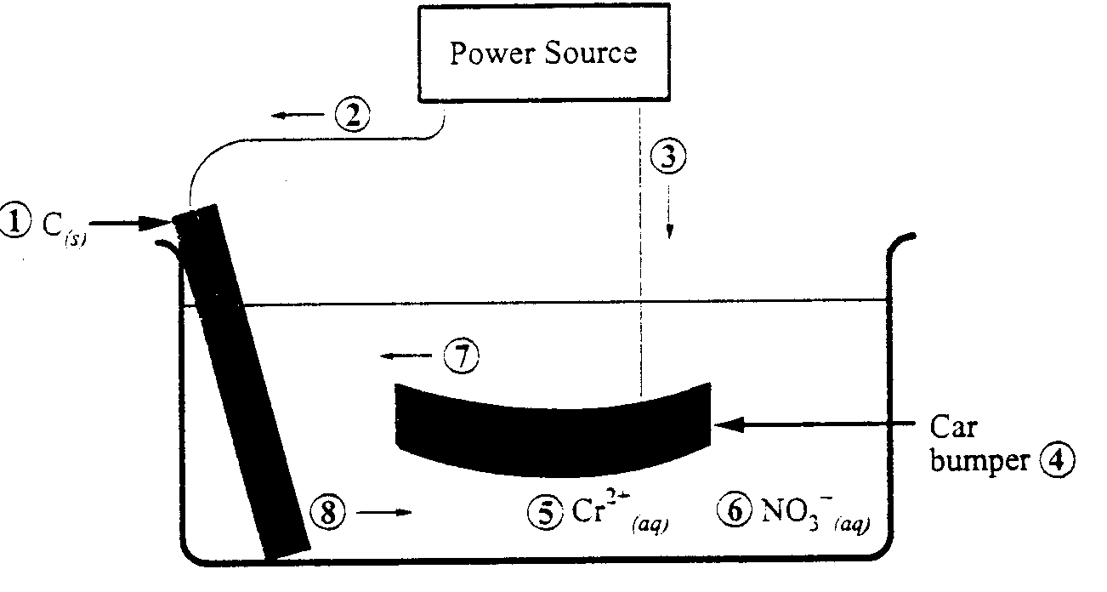
Electroplating Cell

Numerical Response
1. Use the numbers that identify the parts of the electroplating cell in the diagram above to complete the statements below.

The cathode is identified by ____________ (Record in the first column)
The electron movement is identified by ____________(Record in the second column)
The cation movement is identified by ____________(Record in the third column)
The anion is identified by ____________(Record in the fourth column)

(Record your answer in the numerical-response section on the answer sheet)

Use the following information to answer the next question.
The following are materials used by Chemistry 30 students in laboratory work.

1 electrodes 5 thermometer
2 insulated containers 6 electrolytes
3 pH paper 7 external circuit
4 porous boundary 8 buret

Numerical Response
2. The materials necessary to construct and operational voltaic cell are, in numerical order, ______, ______, ______, and ______.

(Record your four-digit answer in the numerical-response section on the answer sheet)

Use the following information to answer the next three questions.
Restorers of antique cars often refinish chrome-plated parts by electroplating them. The part is attached to one electrode of an electrolytic cell in which the other electrode is lead. The electrolyte is a solution of dichromic acid, H₂Cr₂O₇(aq).

- The plating of chromium metal will take place at the
  - anode where oxidation occurs
  - anode where reduction occurs
  - cathode where oxidation occurs
  - cathode where reduction occurs

- During the operation of this cell,
  - Pb(s) is reduced
  - H₂Cr₂O₇(aq) is oxidized
  - the pH of the solution increases
  - the total energy of the system decreases

- A metal that will react spontaneously with Cr³⁺(aq) in a chromium-plating solution is
  - aluminum
  - cadmium
  - lead
  - tin

- The voltage of an electrochemical cell is +0.20 V. If one of the half-reactions is the reduction of Cu²⁺(aq), then the other half-reaction that occurs could be

  - 2 I⁻(aq) → I₂(s) + 2 e⁻
  - S(s) + 2 H⁺(aq) + 2 e⁻ → H₂S(aq)
  - H₂S(aq) → S(s) + 2 H⁺(aq) + 2 e⁻
  - I₂(s) + 2 e⁻ → 2 I⁻(aq)

Use the following information to answer the next question.
A chromium electroplating cell needs to operate at a current of 2000 A to plate 112 g of chromium onto a car bumper.

Numerical Response
3. In order to plate the bumper, the number of moles of chromium(II) ions that must react in the cell is _________________ mol.

(Record your three-digit answer in the numerical-response section on the answer sheet)

Use your recorded answer for Numerical Response 3 to answer Numerical Response 4*.
Numerical Response
4. In order to plate the bumper, the cell must operate for ______________ min.

(Record your three-digit answer in the numerical-response section on the answer sheet)
*You can still receive marks for this question even if the previous question was answered incorrectly.

Use the following information to answer the next question.
Some car manufacturers have designed an anticorrosion system that sends a weak electric current from the battery to the frame of the car. The current provides a source of electrons, which reduces corrosion of the steel frame.

- Which of the following methods could not be used as an alternative to the method of corrosion prevention described above?

  - Galvanize the steel frame with zinc.
  - Coat the steel frame with inert plastic polymers.
  - Use a paint that prevents contact of the steel frame with the environment.
  - Bolt sacrificial anodes made of copper to the steel frame.

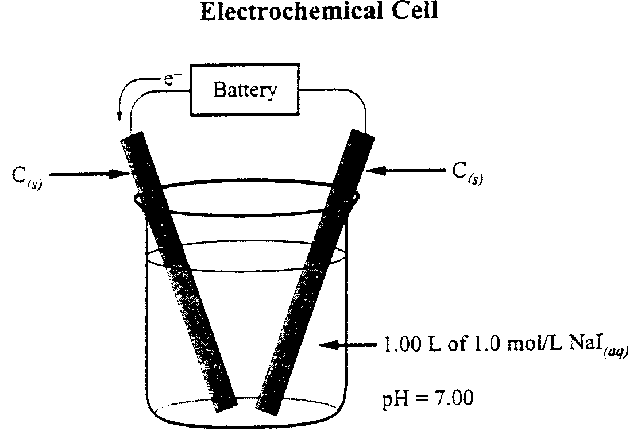
Use the following information to answer the next question.

The diagram above provides a representation of the process of electrolysis.

- Which of the following statements describes what happens during the operation of this cell?

  - Chemical energy is converted to electrical energy.
  - Electrical energy is converted to chemical energy.
  - Electrons flow toward the anode.
  - Plating takes place at the anode.

Use the following information to answer the next question.

2 RhCl₆³⁺(aq) + 3 Zn(s) → 3 Zn²⁺(aq) + 2 Rh(s) + 12 Cl⁻(aq) E°_{net} = +1.20 V

Numerical Response
5. The standard electrode potential for the half-reaction
RhCl₆³⁺(aq) + 3 e⁻ → Rh(s) + 6 Cl⁻(aq) is +/−_________ V.

(Record your three-digit answer in the numerical-response section on the answer sheet)
Use the following information to answer the next four questions.
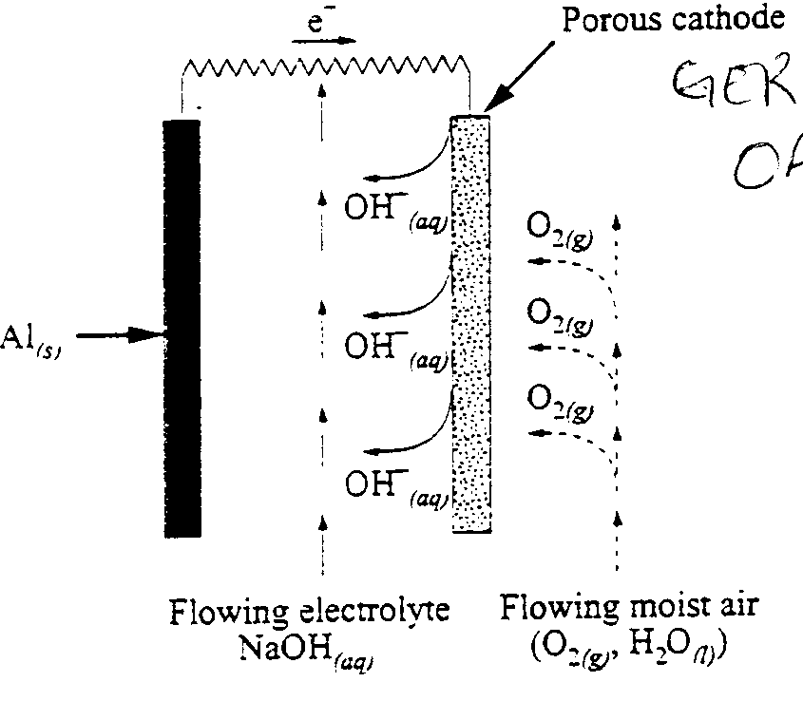
Concern about increased air pollution and the increasing use of non-renewable resources has accelerated research into alternatives to the internal combustion engine. One alternative is a battery-powered electric motor. Several “new” efficient batteries are being tested. The diagram below represents one of these batteries.

Aluminum-Air Battery

- In this aluminum-air battery, the O₂(g) acts as the
  - reducing agent and gains electrons
  - reducing agent and loses electrons
  - oxidizing agent and gains electrons
  - oxidizing agent and loses electrons

- The reduction half-reaction for this aluminum-air battery is
  - 2 H₂O(l) + 2 e⁻ → H₂(g) + 2 OH⁻(aq)
  - Na⁺(aq) + e⁻ → Na(s)
  - O₂(g) + 4 H⁺(aq) + 4 e⁻ → 2 H₂O(l)
  - O₂(g) + 2 H₂O(l) + 4 e⁻ → 4 OH⁻(aq)

Use the answer selected for Multiple Choice 15 to answer Multiple Choice 16.*
- The standard voltage produced by this aluminum-air cell is
  - +2.36 V
  - +2.06 V
  - +0.83 V
  - −1.05 V
*You can receive marks for this question even if the previous question was answered incorrectly.

Use your recorded answer for Multiple Choice 14 to answer Numerical Response 6.*
Numerical Response
6. When three aluminum-air cells are connected in series, the net voltage generated by the battery is +/− _______________ V.

(Record your three-digit answer in the numerical-response section on the answer sheet)
*You can receive marks for this question even if the previous question was answered incorrectly.

Use the following information to answer the next three questions.
At the Banff Wastewater Treatment plant, bacteria are used to treat organic “sludge” (CH₂O)_{n(s)} in a process called autothermal thermophilic aerobic digestion (ATAD). The digestion of the sludge can be represented by the equation

(CH₂O)_{n}(s) + n O₂(g) n CO₂(g) + n H₂O(l) + energy
bacteria

- At the treatment plant, the enzymes in the bacteria act as
  - buffers
  - reducing agents
  - oxidizing agents
  - biological catalysts

- The ATAD process is
  - a reduction
  - exothermic
  - endothermic
  - an acid-base reaction

- During the digestion process, the carbon in the sludge is
  - reduced
  - oxidized
  - amphoteric
  - precipitated

Use the following information to answer the next two questions.
Electronic hobbyists often “etch” circuit boards. In this process, unwanted copper foil is removed from a copper-clad plastic circuit board by immersing the board in a bath of iron(III) chloride solution. The equation for the net reaction is

Cu(s) + 2 Fe³⁺(aq) → Cu²⁺(aq) + 2 Fe²⁺(aq)

- In the reaction above, in which the unwanted copper foil is removed,
  - copper ions are reduced
  - copper atoms are oxidized
  - iron(II) ions act as the oxidizing agent
  - iron(III) ions act as the reducing agent

- Which of the following statements and corresponding net voltages are correct for this reaction?
  - It is a spontaneous reaction with an E°_{net} = +0.43 V.
  - It is a spontaneous reaction with an E°_{net} = +1.11 V.
  - A power supply is required because the E°_{net} = −0.43 V.
  - A power supply is required because the E°_{net} = −1.11 V.

Use the following information to answer the next question.
ICCP (Impressed Current Cathodic Protection) is a corrosion prevention technique that is used to protect buried metal structures. A low-voltage current (electron flow) is applied to the buried metal structure such that only reduction reactions can occur at its surface.

Numerical Response
7. The ground water surrounding the buried metal structure may contain the following ions.

- Pb²⁺(aq)
- Fe²⁺(aq)
- Fe³⁺(aq)
- Cd²⁺(aq)

The order in which these ions are reduced on the surface of the metal structure is ______, ______, ______ and ______.

(Record your four-digit answer in the numerical-response section on the answer sheet)

Use the following information to answer the next three questions.
A student dipped 12.50 g strips of four different metals, Ag(s), Cu(s), Pb(s), and Mg(s), into a beaker containing 250 mL of 1.00 mol/L HCl(aq) in order to determine an activity series. One of the metals reacted immediately and vigorously with the acid.

- The balanced net-ionic equation for the first reaction that occurred is
  - 2 Ag(s) + 2 H⁺(aq) → H₂(g) + 2 Ag⁺(aq)
  - Cu(s) + 2 H⁺(aq) → H₂(g) + Cu²⁺(aq)
  - Pb(s) + 2 H⁺(aq) → H₂(g) + Pb²⁺(aq)
  - Mg(s) + 2 H⁺(aq) → H₂(g) + Mg²⁺(aq)

Use your recorded answer for Multiple Choice 20 to answer Numerical Response 8.*
Numerical Response
8. The electrical potential for this reaction is +/− ___________ V.

(Record your three-digit answer in the numerical-response section on the answer sheet)
*You can receive marks for this question even if the previous question was answered incorrectly.

Use your recorded answer for Multiple Choice 20 to answer Numerical Response 9.*
Numerical Response
9. The mass of metal that reacted with the hydrochloric acid is _________ g.

(Record your three-digit answer in the numerical-response section on the answer sheet)
*You can receive marks for this question even if the previous question was answered incorrectly.

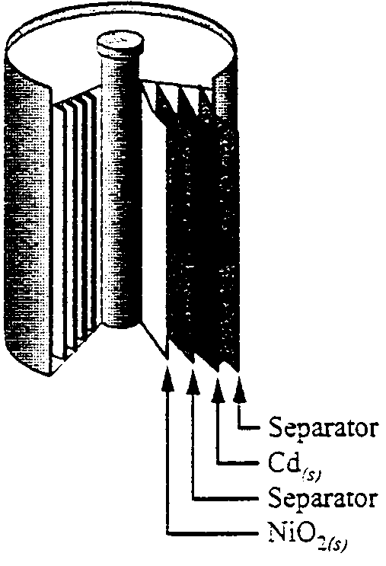
Use the following information to answer the next two questions.
Voltaic cells are used as portable sources of electrical energy. One common cell is the rechargeable nickel-cadmium cell.

The equation representing the discharge of this cell is
NiO₂(s) + Cd(s) + 2 H₂O(l) → Cd(OH)₂(s) + Ni(OH)₂(s)

- The oxidation half-reaction for the discharge of this cell is
  - Cd(s) + 2 OH⁻(aq) → Cd(OH)₂(s) + 2 e⁻
  - NiO₂(s) + 2 H₂O(l) + 2 e⁻ → Ni(OH)₂(s) + 2 OH⁻(aq)
  - NiO₂(s) + 2 H₂O(l) → Ni(OH)₂(s) + 2 OH⁻(aq) + 2 e⁻
  - Cd(s) + 2 OH⁻(aq) + 2 e⁻ → Cd(OH)₂(s)

- In this system, the strongest oxidizing agent is
  - NiO₂(s)
  - Cd(s)
  - Cd(OH)₂(s)
  - H₂O(l)

- If the electrochemical cell Cd(s) / Cd²⁺(aq)//Ag⁺(s) /Ag(s) produces a 6.00 A current for 2.00 h, the mass change of the anode will be a
  - 25.2 g decrease
  - 2.25 g increase
  - 48.3 g decrease
  - 48.3 g increase
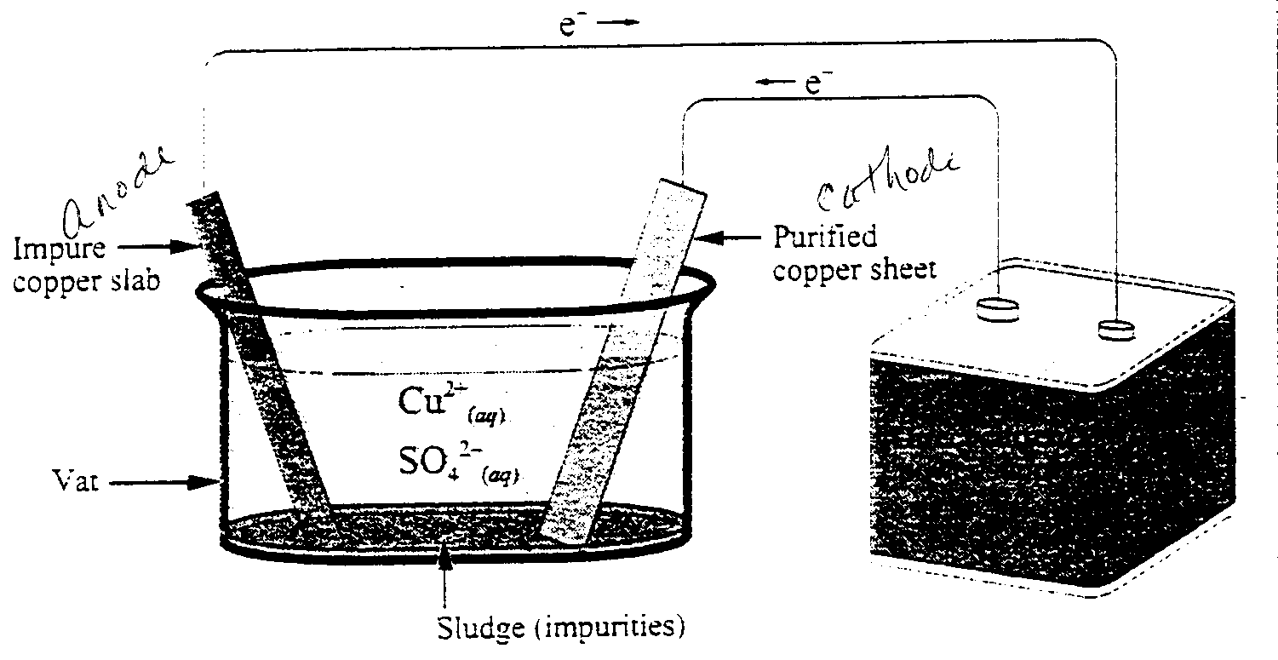
Use the following information to answer the next question.
Copper can be refined (purified) using an apparatus like the one shown below, which is a small-scale version of an industrial apparatus.

- In this electrochemical cell, the purified copper sheet acts at the
  - anode and is the site where SO₄²⁻(aq) ions are oxidized
  - cathode and is the site where SO₄²⁻(aq) ions are reduced
  - anode and is the site where Cu²⁺(aq) ions are oxidized
  - cathode and is the site where Cu²⁺(aq) ions are reduced

Numerical Response
10. If the direct current power supply produces a steady 3.50 A current, then the time required to deposit 0.100 g of purified copper is ________ s.

(Record your three-digit answer in the numerical-response section on the answer sheet)

Use the following information to answer the next question.
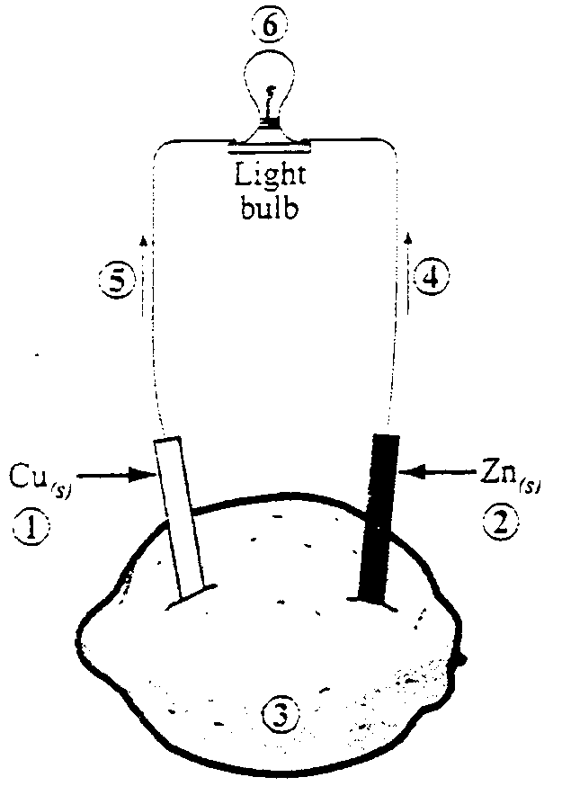
A voltaic cell capable of lighting a small light bulb can be made by placing copper and zinc strips in a lemon.

Numerical Response
11. Identify the part of the voltaic cell, as numbered above, that corresponds to each of the descriptors listed below.
Anode ______________ (Record in the first column)
Cathode ______________ (Record in the second column)
Electron flow ______________ (Record in the third column)
Electrolyte ______________ (Record in the fourth column)

(Record your four-digit answer in the numerical-response section on the answer sheet)

Use the following information to answer the next question.
A particular voltaic cell is represented by
Ag(s) / Ag⁺(aq) // Cr₂O₇²⁻(aq), Cr³⁺(aq), H⁺(aq) / C(s)

- The net ionic equation for this voltaic cell is
  - 6 Ag(s) + Cr₂O₇²⁻(aq) + 14 H⁺(aq) → 6 Ag⁺(aq) + 2 Cr³⁺(aq) + 7 H₂O(l)
  - 6 Ag⁺(aq) + Cr₂O₇²⁻(aq) + 14 H⁺(aq) → 6 Ag(s) + 2 Cr³⁺(aq) + 7 H₂O(l)
  - Ag(s) + Cr₂O₇²⁻(aq) + 14 H⁺(aq) → Ag⁺(aq) + 2 Cr³⁺(aq) + 7 H₂O(l)
  - Ag⁺(aq) + Cr₂O₇²⁻(aq) + 14 H⁺(aq) → Ag(s) + 2 Cr³⁺(aq) + 7 H₂O(l)

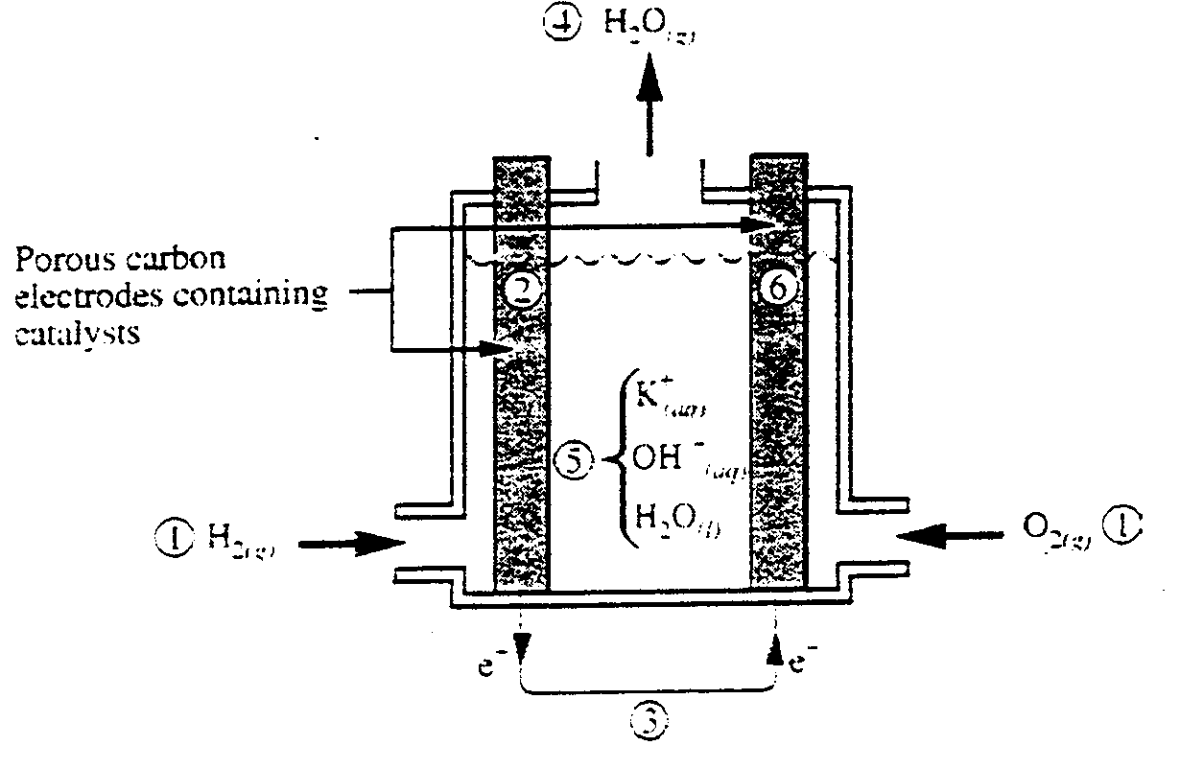
Use the following information to answer the next two questions.
Hydrogen-oxygen fuel cells have been used for years in spacecraft and more recently in small-scale power plants to generate electricity. Now, some governments and companies are working together to perfect this type of fuel cell for automobile use, and experiments are currently being conducted with operational prototypes. A diagram of a hydrogen-oxygen fuel cell is shown below.

Numerical Response
12. In the diagram above, the anode, the cathode, the electrolyte, and a product of the reaction are labelled, respectively, _______, _______, _______, and ______.

(Record your four-digit answer in the numerical-response section on the answer sheet)

Use the following information to answer the next question.
The sodium metal in television picture tubes reacts with oxygen that would otherwise oxidize the tungsten and phosphorus found in the tubes. Tungsten and phosphorus are vital to the function of picture tubes.

Numerical Response
13. The mass of sodium that will react when 0.350 mol of electrons is transferred is ________ g.

(Record your three-digit answer in the numerical-response section on the answer sheet)

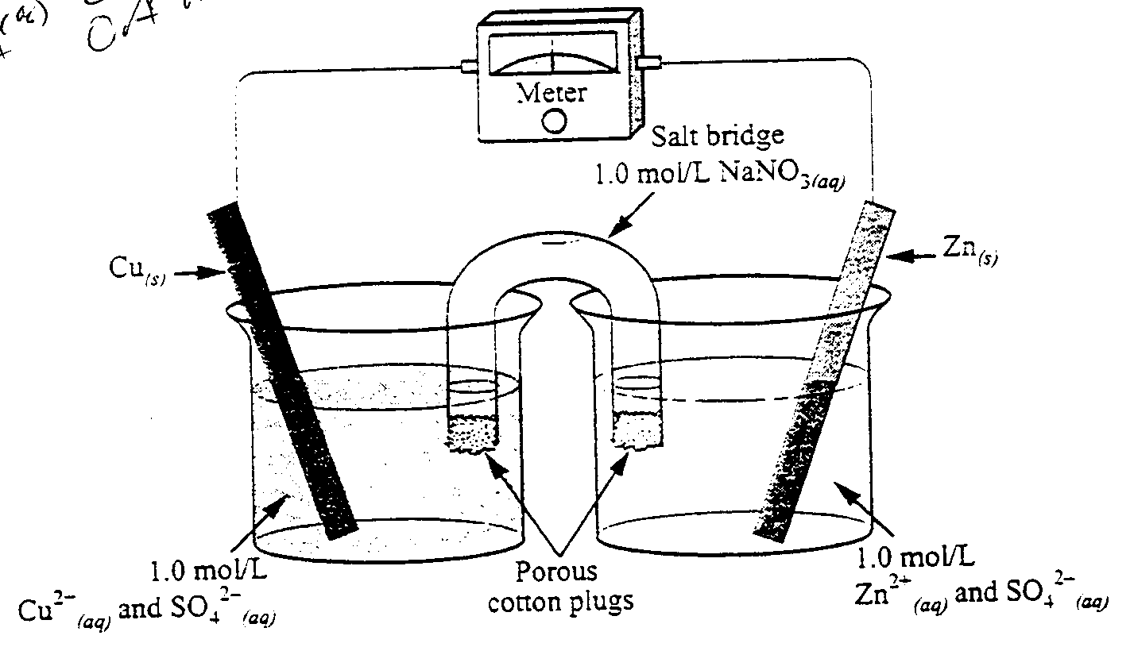
Use the following information to answer the next question.
An Electrochemical Cell

Numerical Response
14. A student attempted to replicate a traditional Daniell Cell by setting up the electrochemical cell shown above. Under standard conditions, the electrical potential of the cell should be +/− __________ V.

(Record your three-digit answer in the numerical-response section on the answer sheet)

Numerical Response
15. Under standard conditions, hydrogen gas reacts with Au³⁺(aq) ions to produce Au(s). The net cell potential for the reaction is +/− __________ V.

(Record your three-digit answer in the numerical-response section on the answer sheet)
Use the following information to answer the next question.
In a laboratory, a student obtained the following results when testing, under standard conditions, reactions between various metals and their corresponding ions.

 | Ga(s) | Fe(s) | Zn(s) | Mg(s)
Ga³⁺(aq) | − | × | ✓ | ✓
Fe²⁺(aq) | ✓ | − | ✓ | ✓
Zn²⁺(aq) | × | × | − | ✓
Mg²⁺(aq) | × | × | × | −
× denotes no reaction
✓ denotes a reaction
− denotes not tested

- The reduction potential of Ga³⁺(aq) could be
  - −0.53 V
  - −1.41 V
  - +1.21 V
  - +1.92 V

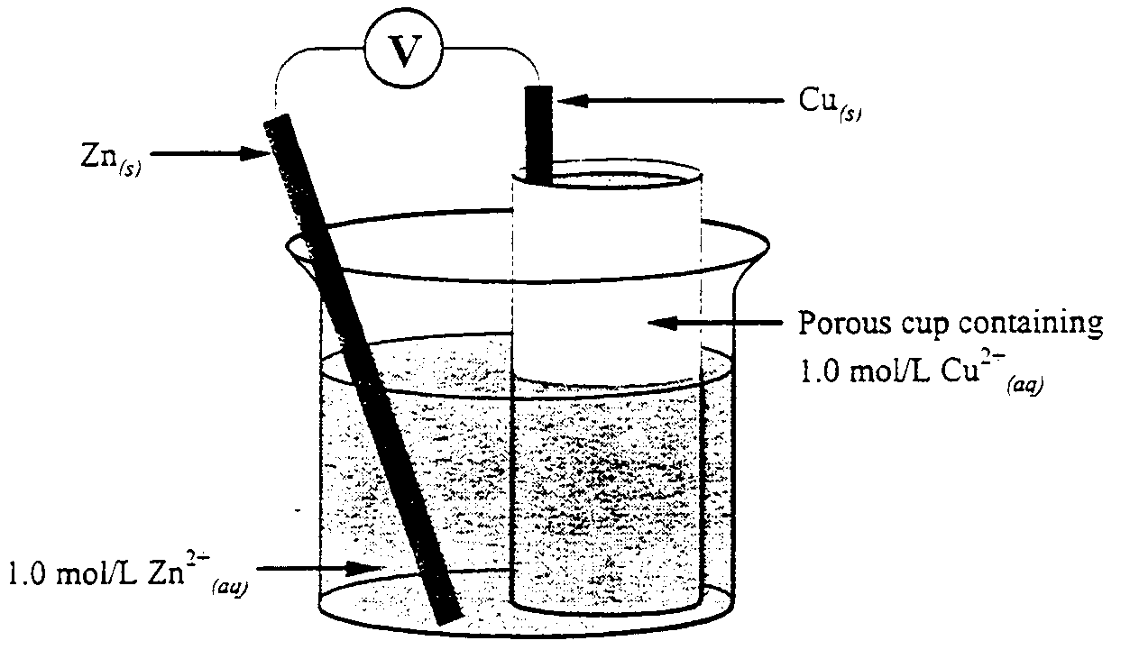
Use the following information to answer the next question.

Electrochemical Cell

- For this cell, the potential is
  - +1.10 V
  - +0.42 V
  - −0.42 V
  - −1.10 V

