Chemistry 30
Equilibrium, Acids & Bases
Unit Review

Use the following information to answer the next four questions.
Prairie Chem Inc. in Edmonton is a bulk manufacturer of concentrated bleach (NaOCl_{(aq)}). The bleach reacts with water to form a solution with a pH of 10.87.

OCl⁻_{(aq)} + H₂O_{(l)} ⇌ HOCl_{(aq)} + OH⁻_{(aq)}

- In this reaction, the substances that act as Brønsted-Lowry acids are

  - OCl⁻_{(aq)} and H₂O_{(l)}
  - OCl⁻_{(aq)} and HOCl_{(aq)}
  - OCl⁻_{(aq)} and OH⁻_{(aq)}
  - H₂O_{(l)} and HOCl_{(aq)}

- The substance in the equation above that may act as an amphiprotic species is

  - OCl⁻_{(aq)}
  - H₂O_{(l)}
  - HOCl_{(aq)}
  - OH⁻_{(aq)}

- The two species in equimolar amounts that could act as a buffer in this bleach solution are

  - OCl⁻_{(aq)} and HOCl_{(aq)}
  - HOCl_{(aq)} and OH⁻_{(aq)}
  - OCl⁻_{(aq)} and H₂O_{(l)}
  - H₂O_{(l)} and OH⁻_{(aq)}

- In this bleach solution, the acid-base indicator

  - phenolphthalein would be colourless
  - alizarin yellow R would be orange
  - indigo carmine would be green
  - methyl orange would be red

Use the following information to answer the next question.
A source of hydrogen for the Haber process is “syngas”, which is produced by a reaction of methane and water at 1 000°C.

CH_{4(g)} + H₂O_{(g)} ⇌ CO_{(g)} + 3 H_{2(g)}

nickel
catalyst

Numerical Response
1. If, at equilibrium, the [CH_{4(g)}] = 2.97 mol/L, [H₂O_{(g)}] = 7.94 mol/L, [CO_{(g)}] = 5.45 mol/L, and [H_{2(g)}] = 2.10 mol/L, then the K_{eq} is __________.

(Record your three-digit answer in the numerical-response section on the answer sheet)

Use the following information to answer the next question.
Some of the SO_{2(g)} produced from the burning of coal and natural gas can react with NO_{2(g)} in the atmosphere according to the equation

SO_{2(g)} + NO_{2(g)} ⇌ NO_{(g)} + SO_{3(g)} ΔH = −41.9 kJ

- The equilibrium concentration of SO_{3(g)} in the reaction could be increased by

  - raising the temperature
  - adding a catalyst
  - removing SO_{2(g)}
  - adding NO_{2(g)}

- Which of the following acid solutions has the lowest pH?

  - 300 mL of 1.00 × 10⁻² mol/L H₂S_{(aq)}
  - 100 mL of 1.00 × 10⁻¹ mol/L H₂CO_{3(aq)}
  - 100 mL of 1.00 × 10⁻³ mol/L H₂SO_{4(aq)}
  - 10.0 mL of 1.00 × 10⁻⁴ mol/L H₂SO_{4(aq)}

Use the following information to answer the next question.
Antibiotics formed by different species of the genus of bacteria Penicillium are among the most widely prescribed drugs in the world today.

One of these antibiotics is penicillin G (benzylpenicillinic acid), which is represented as HPn_{(s)}. This acid is only slightly soluble in water. The saturated aqueous solution is represented by the equilibrium

H₂O_{(l)} + HPn_{(s)} ⇌ H₃O⁺_{(aq)} + Pn⁻_{(aq)}

- This system is at equilibrium when the rate of formation of Pn⁻_{(aq)} in the forward reaction is

  - favoured over the rate of the formation of HPn_{(s)} in the reverse reaction
  - slower than the rate of the formation of HPn_{(s)} in the reverse reaction
  - faster than the rate of the formation of HPn_{(s)} in the reverse reaction
  - equal to the rate of the formation of HPn_{(s)} in the reverse reaction

Numerical Response
2. The concentration of H₃O⁺_{(aq)} ions in a particular bottle of wine is 3.2 × 10⁻⁴ mol/L. The pH of this wine is __________.

(Record your three-digit answer in the numerical-response section on the answer sheet)

Use the following information to answer the next question.
Rainwater is acidic because it contains dissolved atmospheric CO_{2(g)} that occurs naturally. It may also contain air pollutants, NO_{x(g)}, and SO_{x(g)} from industrial sources.

- If each of the following components of acid rain is of equal concentration, then which of them would have the lowest pH?

  - HNO_{3(aq)}
  - HNO_{2(aq)}
  - H₂SO_{3(aq)}
  - H₂SO_{4(aq)}

Use the following information to answer the next two questions.
If H₂S_{(g)} is released into the atmosphere, it dissolves in atmosphere water to form hydrosulphuric acid. The ionization of H₂S_{(aq)} can be represented by the equilibrium

H₂S_{(aq)} + H₂O_{(l)} ⇌ HS⁻_{(aq)} + H₃O⁺_{(aq)}

- The K_{a} expression for this ionization is

  - K_{a} = [H₂S_{(aq)}] B. K_{a} = [H₂S_{(aq)}][ H₂O_{(l)}]
[HS⁻_{(aq)}][ H₃O⁺_{(aq)}] [HS⁻_{(aq)}][ H₃O⁺_{(aq)}]

C. K_{a} = [HS⁻_{(aq)}][ H₃O⁺_{(aq)}] D. K_{a} = [HS⁻_{(aq)}][ H₃O⁺_{(aq)}]
[H₂S_{(aq)}][ H₂O_{(l)}] [H₂S_{(aq)}]

- The [ H₃O⁺_{(aq)}] in a 0.050 mol/L H₂S_{(aq)} solution is

  - 4.5 × 10⁻⁹ mol/L
  - 6.7 × 10⁻⁵ mol/L
  - 1.3 × 10⁻⁴ mol/L
  - 0.10 mol/L

- An equilibrium that would favour the products is

  - NH₄⁺_{(aq)} + H₂PO₄⁻_{(aq)} ⇌ NH_{3(aq)} + H₃PO_{4(aq)}
  - HCN_{(aq)} + HS⁻_{(aq)} ⇌ CN⁻_{(aq)} + H₂S_{(aq)}
  - HCO₃⁻_{(aq)} + PO₄³⁻_{(aq)} ⇌ HPO₄²⁻_{(aq)} + CO₃²⁻_{(aq)}
  - HSO₄⁻_{(aq)} + HSO₃⁻_{(aq)} ⇌ H₂SO_{3(aq)} + SO₄²⁻_{(aq)}

Numerical Response
3. The K_{b} for the conjugate base of the ammonium ion, expressed in scientific notation, is ____________ × 10⁻⁵.

(Record your three-digit answer in the numerical-response section on the answer sheet)

- If the [H⁺_{(aq)}] in a reaction is 0.020 mol/L, then the pH and pOH are, respectively,

  - 1.05 and 12.95
  - 1.40 and 12.60
  - 1.70 and 12.30
  - 2.00 and 12.00

- When ammonium nitrate dissolves in water, the resulting solution will be

  - basic
  - acidic
  - neutral
  - a non-electrolyte

Use the following information to answer the next question.
Blood pH is influenced by the concentration of buffers and gas solutes, such as carbon dioxide, which is formed during cellular respiration. In red blood cells, the enzyme carbonic anhydrase catalyzes the equilibrium

CO_{2(g)} + H₂O_{(l)} ⇌ HCO₃⁻_{(g)} + H⁺_{(g)}

carbonic anhydrase

- In this equilibrium, carbonic anhydrase

  - increases the concentration of HCO₃⁻_{(aq)} formed at equilibrium
  - decreases the concentration of HCO₃⁻_{(aq)} formed at equilibrium
  - increases the concentration of CO_{2(g)} formed at equilibrium
  - increases the speed at which equilibrium is reached

Use the following information to answer the next question.
When equally concentrated solutions of HNO_{3(aq)}, CH₃COOH_{(aq)}, HOOCCOOH_{(aq)}, and Na₂S_{(aq)} were titrated with either a strong acid or strong base, the following curves were obtained.

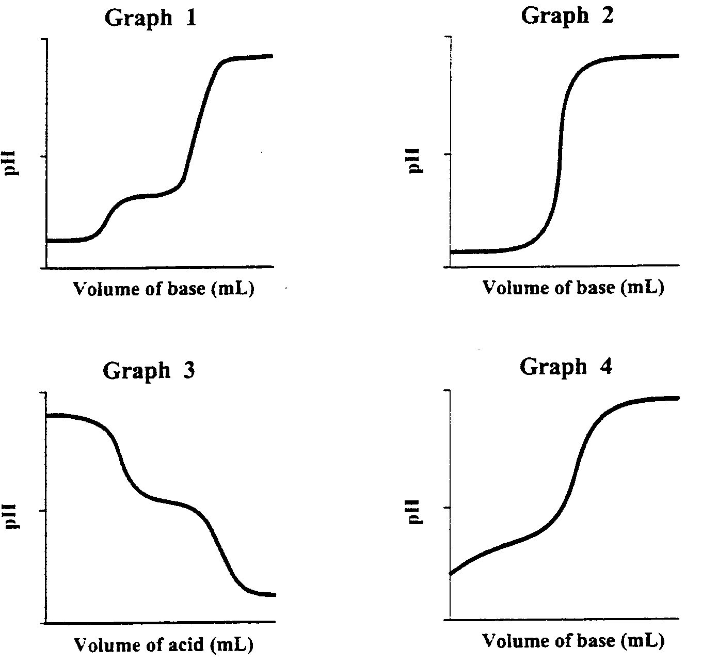

Numerical Response
4. Match each of the graphs, as numbered above, with the corresponding titration species listed below.

HNO_{3(aq)} ___________ (Record in the first column)
CH₃COOH_{(aq)} ___________ (Record in the second column)
HOOCCOOH_{(aq)} ___________ (Record in the third column)
Na₂S_{(aq)} ___________ (Record in the fourth column)

(Record your four-digit answer in the numerical-response section on the answer sheet)

Use the following information to answer the next question.

Oxoacids of Chlorine

Acid | K_{a}
HClO_{4(aq)} | very large
HClO_{3(aq)} | 5.1 × 10²
HClO_{2(aq)} | 1.1 × 10⁻²
HClO_{(aq)} | 2.9 × 10⁻⁸

- Acids are classified as either strong or weak. Of the acids listed above, only

  - HClO_{(aq)} is a strong acid
  - HClO_{4(aq)} is a strong acid
  - HClO_{4(aq)} and HClO_{3(aq)} are strong acids
  - HClO_{4(aq)}, HClO_{3(aq)}, and HClO_{2(aq)} are strong acids

- In the equation HNO_{3(aq)} + N₂H_{4(aq)} ⇌ NO₃⁻_{(aq)} + N₂H₅⁺_{(aq)} , one conjugate acid-base pair is

  - HNO_{3(aq)} and N₂H₅⁺_{(aq)}
  - HNO_{3(aq)} and N₂H_{4(aq)}
  - N₂H_{4(aq)} and N₂H₅⁺_{(aq)}
  - N₂H_{4(aq)} and NO₃⁻_{(aq)}

Use the following information to answer the next question.
0.10 mol/L Solutions

1 NaNO_{2(aq)} 3 HNO_{3(aq)}
2 NaHCO_{3(aq)} 4 Ba(OH)_{2(aq)}

Numerical Response
5. When the solutions above are ordered from most basic to least basic, the order is _______, ________, ________, and ________.

(Record your four-digit answer in the numerical-response section on the answer sheet)

Use the following information to answer the next question.
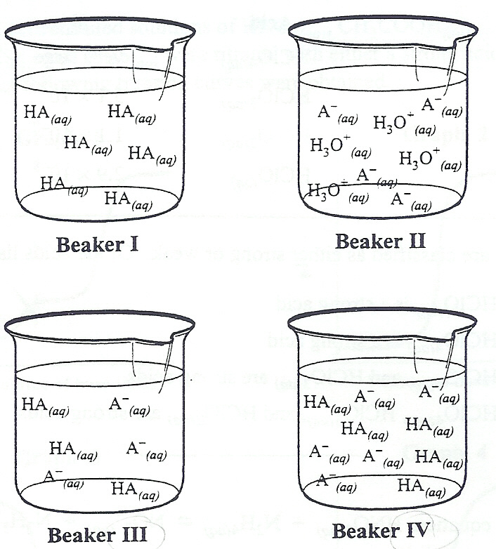

- The beakers that best represent a buffer solution in which HA_{(aq)} is a weak acid are those labelled

  - I and II
  - I and III
  - II and III
  - III and IV

- Which of the following mixtures could act as a buffer solution?

  - HF_{(aq)} and H₂S_{(aq)}
  - NaOH_{(aq)} and HCl_{(aq)}
  - Na₂CO_{3(aq)} and NH_{3(aq)}
  - NaH₂BO_{3(aq)} and Na₂HBO_{3(aq)}

Use the following information to answer the next question.
A 0.500 mol/L solution of hydrazine (N₂H_{4(aq)}) contains the following equilibrium concentrations.

[N₂H_{4(aq)}] = 0.498 mol/L
[OH⁻_{(aq)}] = 2.14 × 10⁻³ mol/L
[N₂H₅⁺_{(aq)}] = 2.14 × 10⁻³ mol/L

Numerical Response
6. The K_{b} for hydrazine, in scientific notation, is a.bc × 10^{-d}. The values of a, b, c, and d are, respectively, _______, _______, _______, and _______.

(Record your four-digit answer in the numerical-response section on the answer sheet)

- Acid rain is linked to the leaching of heavy metals and their ions in lakes and rivers. Biomagnification of these metals and ions increases levels of disease in fish and wildlife. Based on this information, a decision to reduce sulphur dioxide emissions would be

  - political
  - scientific
  - technological
  - environmental

- A drop of thymol blue indicator in its blue form added to 10.0 mL of 0.10 mol/L H₂SO_{4(aq)} would become

  - yellow because the indicator would gain one proton
  - yellow because the indicator would lose one proton
  - red because the indicator would gain two protons
  - red because the indicator would lose two protons

Use the following information to answer the next question.

The labels came off four cleaning solution containers found under a kitchen sink. Each of the cleaning solutions was tested with two available indicators, and the following results ere recorded.

Cleaning Solution | Bromothymol Blue | Phenolphthalein
1 | blue | pink
2 | blue | colourless
3 | green | colourless
4 | blue | light pink

Numerical Response
7. Listed in order from lowest to highest pH, the cleaning solutions are, respectively, _______, _______, _______, and _______.

(Record your four-digit answer in the numerical-response section on the answer sheet)

Use the following information to answer the next question.
Apple growers in British Columbia’s Okanagan Valley are coping with trees that are stunted and have blistered bark as a result of a dramatic increase in the acidity of the region’s soil. Nitrogen fertilizers are one of the main causes of the high acidity level of the soil.

- To solve this problem, Agriculture Canada has suggested that apple growers work lime into the soil in their orchards because lime is

  - a base
  - an acid
  - a neutral ionic compound
  - a neutral molecular compound

Use the following information to answer the next three questions.
Methanoic (formic) acid is the irritant secreted during an ant bite. The irritation is partially due to the ionization of methanoic acid. The equilibrium equation for the ionization can be represented as

HCOOH_{(aq)} + H₂O_{(l)} ⇌ H₃O⁺_{(aq)} + HCOO⁻_{(aq)}

- Which of the substances in the equation above could function as an amphiprotic species?

  - H₂O_{(l)} and H₃O⁺_{(aq)}
  - H₂O_{(l)}
  - H₃O⁺_{(aq)} and HCOO⁻_{(aq)}
  - H₂O_{(l)}, H₃O⁺_{(aq)}, and HCOO⁻_{(aq)}

- In a comparison of the species present in HCOOH_{(aq)}, the

  - [H₃O⁺_{(aq)}] is greater than [HCOOH_{(aq)}]
  - [H₃O⁺_{(aq)}] is equal to [HCOOH_{(aq)}]
  - [HCOOH_{(aq)}] is greater than [HCOO⁻_{(aq)}]
  - [HCOOH_{(aq)}] is equal to [HCOO⁻_{(aq)}]

- When a 0.100 mol/L HCOOH_{(aq)} is titrated with 0.100 mol/L NaOH_{(aq)}, an appropriate choice of indicator for this titration is

  - orange IV
  - cresol red
  - methyl red
  - indigo carmine

Use the following information to answer the next three questions.
Sodium hydrogen carbonate, NaHCO_{3(s)} (baking soda), is used in baking. When lactic acid, HC₃H₅O_{3(aq)}, and baking soda are present, they cause doughs and batters to rise. Lactic acid, a component of buttermilk, has a K_{a} = 1.4 × 10⁻⁴.

- The net ionic equation that best illustrates the reaction responsible for the dough rising is

  - H₃O⁺_{(aq)} + HCO₃⁻_{(aq)} → CO_{2(g)} + 2 H₂O_{(l)}
  - HCO₃⁻_{(aq)} + C₃H₅O₃⁻_{(aq)} → HC₃H₅O_{3(aq)} + CO₃²⁻_{(aq)}
  - NaHCO_{3(aq)} + H₃O⁺_{(aq)} → H₂CO_{3(aq)} + H₂O_{(l)} + Na⁺_{(aq)}
  - HCO₃⁻_{(aq)} + HC₃H₅O_{3(aq)} → H₂O_{(l)} + CO_{2(g)} + C₃H₅O₃⁻_{(aq)}

- The [H₃O⁺_{(aq)}] in 0.20 mol/L HC₃H₅O_{3(aq)} is

  - 2.8 × 10⁻³ mol/L
  - 5.3 × 10⁻³ mol/L
  - 2.6 × 10⁻² mol/L
  - 7.0 × 10⁻⁴ mol/L

Use your recorded answer from Multiple choice 26 to answer Numerical Response 8*.
Numerical Response
8. The pH of the HC₃H₅O_{3(aq)} is ______________.

(Record your three-digit answer in the numerical-response section on the answer sheet)
°You can receive marks for this question even if the previous question was answered incorrectly.

- To completely react 50 mL of 0.10 mol/L acid, 150 mL of 0.10 mol/L KOH_{(aq)} was required. The number of protons donated by each acid molecule was

  - 1
  - 2
  - 3
  - 4

Use the following information to answer the next three questions.
Titration of 20.0 mL Samples of Acidified H₂O_{2(l)}
with 0.15 mol/L KMnO_{4(aq)}

Trial | I | II | III | IV
Final Buret Volume (mL) | 18.3 | 34.6 | 17.4 | 33.8
Initial Buret Volume (mL) | 0.4 | 18.3 | 0.9 | 17.4
Colour at endpoint | purple | pink | pink | pink

- The balanced equation for the titration is

  - 2 MnO₄⁻_{(aq)} + 16 H⁺_{(aq)} + 5 H₂O_{2(l)} → 2 Mn²⁺_{(aq)} + 8 H₂O_{(l)} + 5 O_{2(g)}
  - 2 MnO₄⁻_{(aq)} + 6 H⁺_{(aq)} + 5 H₂O_{2(l)} → 2 Mn²⁺_{(aq)} + 4 H₂O_{(l)} + O_{2(g)}
  - 2 MnO₄⁻_{(aq)} + 6 H⁺_{(aq)} + 5 H₂O_{2(l)} → 2 Mn²⁺_{(aq)} + 3 H₂O_{(l)} + 5 O_{2(g)}
  - 2 MnO₄⁻_{(aq)} + 6 H⁺_{(aq)} + 5 H₂O_{2(l)} → 2 Mn²⁺_{(aq)} + 8 H₂O_{(l)} + 5 O_{2(g)}

Numerical Response
9. The volume of potassium permanganate that should be used in subsequent calculations is __________ mL.

(Record your three-digit answer in the numerical-response section on the answer sheet)

Use your recorded answer from Numerical Response 9 to answer Numerical Response 10*.
Numerical Response
10. The hydrogen peroxide concentration is __________ mol/L.

(Record your three-digit answer in the numerical-response section on the answer sheet)
°You can receive marks for this question even if the previous question was answered incorrectly.

Use the following information to answer the next four questions.
Sodium azide, NaN_{3(s)}, which is found in automobile air bags, reacts readily with acids to form the highly toxic and explosive hydroazoic acid HN_{3(aq)}. The K_{a} for hydroazoic acid is 1.9 × 10⁻⁵.

- The K_{a} expression for hydroazoic acid is

  - K_{a} = [HN_{3(aq)}] B. K_{a} = [ H₃O⁺_{(aq)}] [ N₃⁻ _{(aq)}]
[N₃⁻_{(aq)}][ H₃O⁺_{(aq)}] [HN_{3(aq)}]

C. K_{a} = [HN_{3(aq)}]³ D. K_{a} = [N₃⁻_{(aq)}]³[ H₃O⁺_{(aq)}]
[N₃⁻_{(aq)}][ H₃O⁺_{(aq)}] [HN_{3(aq)}]³

- In a solution of hydroazoic acid, the

  - [HN_{3(aq)}] < [N₃⁻_{(aq)}]
  - [HN_{3(aq)}] > [H₃O⁺_{(aq)}]
  - [HN_{3(aq)}] > [H₂O_{(l)}]
  - [HN_{3(aq)}] = [H₃O⁺_{(aq)}]

Numerical Response
11. The pH of a 0.28 mol/L HN_{3(aq)} solution is _________.

(Record your three-digit answer in the numerical-response section on the answer sheet)

Numerical Response
12. The volume of 6.00 mol/L NaOH_{(aq)} required to neutralize 2.20 kg of HN_{3(aq)} is __________ L.

(Record your three-digit answer in the numerical-response section on the answer sheet)

Use the following information to answer the next two questions.
Body chemistry involves a number of chemical systems that are critically dependent of pH, buffering action, and concentration of gas solutes such as CO_{2(g)} and O_{2(g)}.

- The function of chemical buffers in the blood is to

  - control all reactions
  - act as catalysts to increase the rate of reaction
  - withstand the continual addition of acid or base
  - maintain a constant pH when a small amount of acid or base is added

- One of the buffers present in blood is

  - HSO₃⁻_{(aq)} − H₂SO_{3(aq)}
  - HCO₃⁻_{(aq)} − H₂CO_{3(aq)}
  - NO₃⁻_{(aq)} − HNO_{3(aq)}
  - Cl⁻_{(aq)} − HCl_{(aq)}

Use the following information to answer the next question.
HSO₄⁻_{(aq)} + HCOO⁻_{(aq)} ⇌ HCOOH_{(aq)} + SO₄²⁻_{(aq)}
1 2 3 4

Numerical Response
13. Match each acid or base in the forward reaction, as numbered above, with the corresponding term below.

acid ___________ (Record in the first column)
conjugate base ___________ (Record in the second column)
base ___________ (Record in the third column)
conjugate acid ___________ (Record in the fourth column)

(Record your four-digit answer in the numerical-response section on the answer sheet)

Use the following information to answer the next two questions.
HNO_{2(aq)} + H₂BO₃⁻_{(aq)} ⇌ NO₂⁻_{(aq)} + H₃BO_{3(aq)}

- A conjugate acid-base pair in the reaction is

  - H₂BO₃⁻_{(aq)} and NO₂⁻_{(aq)}
  - H₃BO_{3(aq)} and H₂BO₃⁻_{(aq)}
  - HNO_{2(aq)} and H₂BO₃⁻_{(aq)}
  - H₃BO_{3(aq)} and NO₂⁻_{(aq)}

- The amphiprotic species in the reaction is

  - H₂BO₃⁻_{(aq)}
  - HNO_{2(aq)}
  - NO₂⁻_{(aq)}
  - H₃BO_{3(aq)}

Use the following information to answer the next question.
A sample of rainwater is poured into five test tubes. A different indicator is added to each test tube. Four of the observations are recorded in the table below.

Indicator | Colour
methyl red | yellow
phenol red | yellow
bromocresol green | blue
phenolphthalein | colourless
bromothymol blue | ?

- The pH of the rainwater and the predicted colour of the sample containing bromothymol blue are

  - 6.0 and blue
  - 7.6 and blue
  - 6.0 and yellow
  - 7.6 and yellow
Use the following information to answer the next question.

Titration Plot for 25.0 mL of 0.100 mol/L NH_{3(aq)} with 0.100 mol/L HCl_{(aq)}

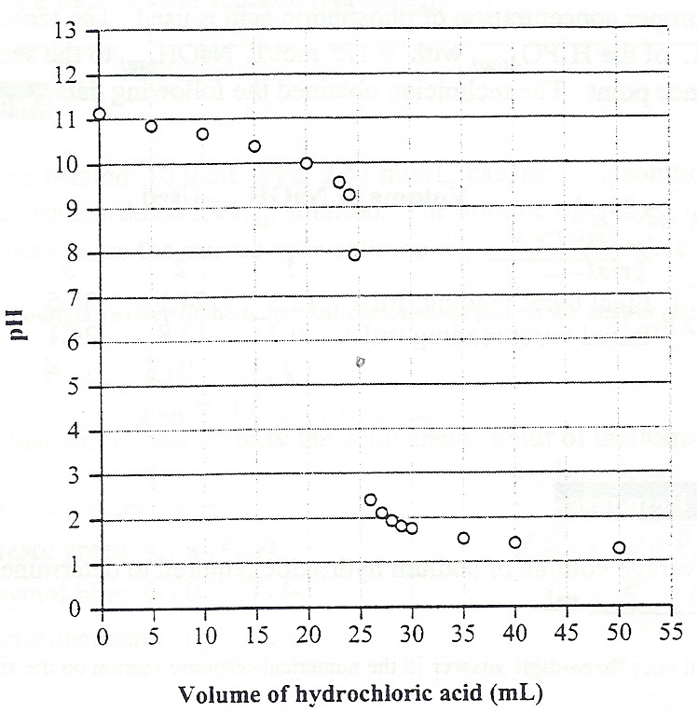

- The most suitable indicator for the titration is

  - phenolphthalein
  - methyl violet
  - chlorophenol red
  - methyl orange

- A solution was tested and found to have a pOH of 3.2. This solution would most likely

  - be a proton donor
  - react violently with zinc
  - cause thymolphthalein to be blue
  - cause bromocresol green to be yellow

Use the following information to answer the next two questions.
The Stelco Plant in Camrose, Alberta, uses phosphoric acid to remove rust from steel pipes before they are welded. A technician is responsible for ensuring that the proper concentration of phosphoric acid is used. The technician titrated 10.00 mL of the H₃PO_{4(aq)} with 0.125 mol/L NaOH_{(aq)} to the second equivalence point. The technician obtained the following data.

Volume of NaOH_{(aq)} used

Trial | I | II | III | IV
Final Buret Volume (mL) | 12.8 | 24.1 | 35.5 | 46.7
Initial Buret Volume (mL) | 0.7 | 12.8 | 24.1 | 35.5

Numerical Response
14. The average volume of sodium hydroxide required to determine the [H₃PO_{4(aq)}] is ___________ mL.

(Record your three-digit answer in the numerical-response section on the answer sheet)

- Based on the data gathered at the second equivalence point, the concentration of the phosphoric acid was

  - 47.1 mmol/L
  - 70.6 mmol/L
  - 141 mmol/L
  - 283 mmol/L

- A glass of orange juice contains enough hydronium ions to kill you if your blood is not buffered to a pH of about 7.35. One of the several buffer systems that your blood contains is H₂PO₄⁻_{(aq)} − HPO₄²⁻_{(aq)}. This system initially buffers the addition of hydronium ions from orange juice by the reaction

  - H₃O⁺_{(aq)} + H₂PO₄⁻_{(aq)} ⇌ H₃PO_{4(aq)} + H₂O_{(l)}
  - H₃O⁺_{(aq)} + HPO₄²⁻_{(aq)} ⇌ H₂PO₄⁻_{(aq)} + H₂O_{(l)}
  - 2 H₃O⁺_{(aq)} + PO₄³⁻_{(aq)} ⇌ H₂PO₄⁻_{(aq)} + H₂O_{(l)}
  - 2 H₃O⁺_{(aq)} + 2 H₂PO₄⁻_{(aq)} ⇌ PO₄³⁻_{(aq)} + 2 H₂O_{(l)}
Use the following information to answer the next two questions.
After the ethene is separated from the byproducts of the cracking process, it is washed with a caustic soda solution (NaOH_{(aq)}).

Numerical Response
15. A lab technician titrated 10.0 mL of a 2.57 mol/L caustic soda solution with a 0.860 mol/L standardized HCl_{(aq)} solution. The volume of HCl_{(aq)} needed to completely neutralize the caustic soda solution is __________ mL.

(Record your three-digit answer in the numerical-response section on the answer sheet)

- The indicator that would best identify the equivalence point of this titration is

  - methyl violet
  - bromocresol green
  - bromothymol blue
  - 1,3,5−trinitrobenzene

Use the following information to answer the next question.
A student was asked to determine the concentration of an aqueous HCl_{(aq)} solution by titrating it with 1.13 mol/L NaOH_{(aq)} in the presence of bromothymol blue indicator. Since burets were not available, the student used droppers for each solution and assumed that each drop was of equal volume. It took 26 drops of NaOH_{(aq)} to neutralize 20 drops of the HCl_{(aq)} solution and to reach the bromothymol blue endpoint.

Numerical Response
16. The concentration of the HCl_{(aq)} solution was ______________ mol/L.

(Record your three-digit answer in the numerical-response section on the answer sheet)

Use the following information to answer the next question.
At the Wascana Gas Plant in Balzac, Alberta, environmental and economic concerns have resulted in the development of an efficient process for the removal of sulphur from sour gas, which is a mixture of hydrocarbons and H₂S_{(g)}. In the first step of the process, one-third of the H₂S_{(g)} reacts with O_{2(g)} to produce SO_{2(g)}. In the second step of the process, the SO_{2(g)} produced reacts with the remaining H₂S_{(g)} to form elemental sulphur and water.

Step I 2 H₂S_{(g)} + 3 O_{2(g)} ⇌ 2 H₂O_{(g)} + 2 SO_{2(g)}
Step II 2 H₂S_{(g)} + SO_{2(g)} ⇌ 2 H₂O_{(g)} + 3 S_{(s)}

Overall Equation 2 H₂S_{(g)} + O_{2(g)} ⇌ 2 H₂O_{(g)} + 2 S_{(s)}

To maximize the amount of sulphur removed from the sour gas, the gas plant engineers apply Le Chatelier’s Principle.

- According to the overall equilibrium equation above, the amount of sulphur removed may be increased by

  - adding a catalyst
  - removing water vapour
  - increasing the volume of the system
  - increasing the temperature of the system

- The indicator that would most accurately identify a solution with a pH between 4.00 and 4.30 is

  - thymol blue
  - methyl orange
  - litmus
  - methyl red

Use the following information to answer the next two questions.
A student titrated a 10.0 mL sample of nitric acid with sodium hydroxide solution in the presence of an indicator.

Volume of 5.00 mmol/L NaOH_{(aq)} Used

Trial | I | II | III | IV
Final Buret Volume (mL) | 7.99 | 14.51 | 21.02 | 27.53
Initial Buret Volume (mL) | 1.00 | 7.99 | 14.51 | 21.02

Numerical Response
17. The average volume of titrant used is _________ mL.

(Record your three-digit answer in the numerical-response section on the answer sheet)

Use your recorded answer from Numerical Response 17 to answer Numerical Response 18*.
Numerical Response
18. The concentration of the nitric acid is ___________ mmol/L.

(Record your three-digit answer in the numerical-response section on the answer sheet)
°You can receive marks for this question even if the previous question was answered incorrectly.

- The addition of NaOH_{(aq)} would cause the equilibrium system
HBb_{(aq)} + H₂O_{(l)} ⇌ H₃O⁺_{(aq)} + Bb⁻_{(aq)} to turn

  - blue and the pH to decrease
  - blue and the pH to increase
  - yellow and the pH to decrease
  - yellow and the pH to increase

Use the following information to answer the next question.
Thermometric Titration of 20.0 mL of 0.20 mol/L HCl_{(aq)}
with NaOH_{(aq)}

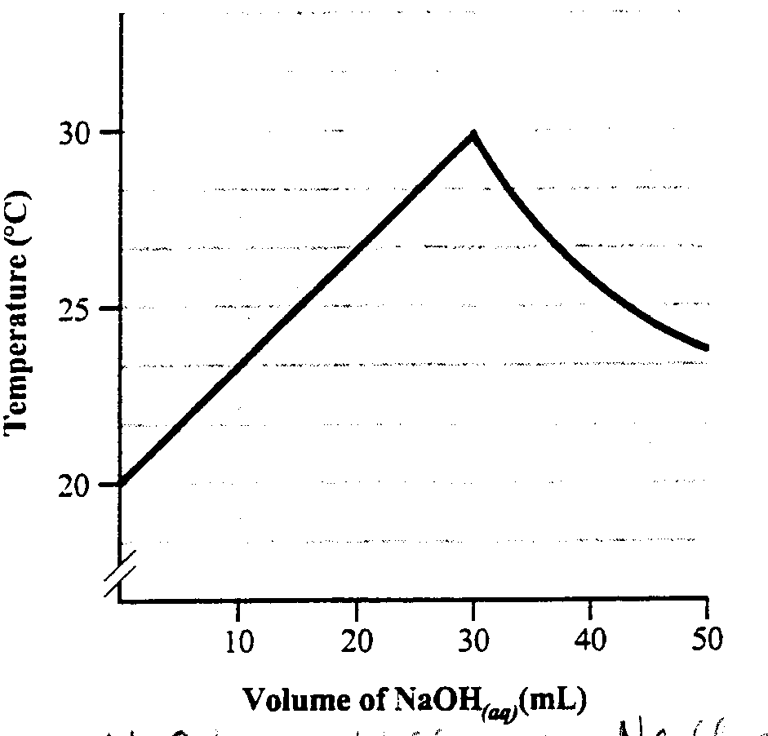

Numerical Response
19. This experiment is an example of a thermometric titration in which a change in temperature occurs as the reagents react. The [NaOH_{(aq)}] for this titration is ___________ mol/L.

(Record your three-digit answer in the numerical-response section on the answer sheet)

- The main buffer solution of plasma and tissue fluid found in our bodies is H₂CO_{3(aq)} − HCO₃⁻_{(aq)}. When excess hydronium ions enter our blood, the equation that represents the reaction that occurs is

  - H₃O⁺_{(aq)} + OH⁻_{(aq)} → 2 H₂O_{(l)}
  - H₂CO_{3(aq)} + OH⁻_{(aq)} → HCO₃⁻_{(aq)} + H₂O_{(l)}
  - H₂CO_{3(aq)} + H₂O_{(l)} → H₃O⁺_{(aq)} + HCO₃⁻_{(aq)}
  - H₃O⁺_{(aq)} + HCO₃⁻_{(aq)} → H₂CO_{3(aq)} + H₂O_{(l)}

Use the following information to answer the next question.
A student was asked to rank the relative strength of the following four acids.
- Formic acid (HCOOH_{(aq)})
- Hydroazoic acid (HN_{3(aq)})
- Hypobromous acid (HOBr_{(aq)})
- Nitrous acid (HNO_{2(aq)})

The student was given the following information.
HNO_{2(aq)} + HCOO⁻_{(aq)} ⇌ NO₂⁻_{(aq)} + HCOOH_{(aq)} (Products favoured)
HN_{3(aq)} + OBr⁻_{(aq)} ⇌ N₃⁻_{(aq)} + HOBr_{(aq)} (Products favoured)
HN_{3(aq)} + HCOO⁻_{(aq)} ⇌ N₃⁻_{(aq)} + HCOOH_{(aq)} (Reactants favoured)

Numerical Response
20. Based on the reaction evidence, the four acids, ranked from strongest to weakest, are _______, _______, _______, and _______.

(Record your four-digit answer in the numerical-response section on the answer sheet)

Use the following information to answer the next question.
A student sketched a titration curve based on data collected during a reaction between 0.050 mol/L NaOH_{(aq)} and a 25.0 mL sample of a soft drink.

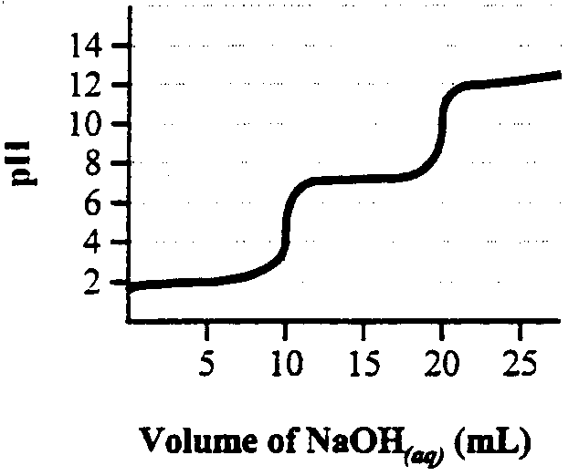

- The most suitable indicator to identify the equivalence point of the second reaction is

  - phenolphthalein
  - bromothymol blue
  - methyl red
  - methyl orange

Equilibrium, Acids & Bases Review

Multiple Choice Key
- D
- B
- A
- B
- D
- C
- D
- D
- D
- B
- C
- C
- B
- D
- C
- C
- D
- D
- D
- C
- A
- B
- C
- B
- D
- B
- C
- D
- B
- B
- D
- B
- B
- A
- C
- C
- C
- B
- B
- C
- B
- B
- B
- D
- A

Numerical Response Key
1. 2.14
2. 3.49
3. 1.79
4. 2413
5. 4213
6. 9206
7. 3241
8. 2.28
9. 16.4
10. 0.31
11. 2.64
12. 8.52
13. 1423
14. 11.3
15. 29.9
16. 1.47
17. 6.51 or 6.63
18. 3.26
19. 0.13
20. 4123

