Name:____________________________________

Chemistry 30
Thermochemistry Review

- Which of the following statements is true for an endothermic reaction?

  - ΔH_{r} for the reaction is negative.
  - Energy is a product in the chemical equation.
  - The temperature of the surroundings increases.
  - The potential energy of the products is greater than the potential energy of the reactants.

Use the following information to answer the next question.
4 Q(s) + Z₂(g) + 100 kJ → 2 Q₂Z(g)

- The ΔH_{r} value for the reverse reaction would be

  - +100 kJ
  - +50.0 kJ
  - –50.0 kJ
  - –100 kJ

Numerical Response
1. Benzene is a gasoline additive. The heat of formation for 1.00 mol of C₆H₆(l) is __________________ kJ.

(Record your three-digit answer in the numerical-response section on the answer sheet)

Numerical Response
2. An outdoor mercury thermometer contains 1.02 g of mercury. On a winter day, the thermometer records a change in temperature from –38.0°C to –13.0°C. The mercury absorbed ________________ J of energy. The heat capacity of mercury is 0.140 J/g°C.

(Record your three-digit answer in the numerical-response section on the answer sheet)

- In the reaction C₂₅H₅₂(s) + 38 O₂(g) → 25 CO₂(g) + 26 H₂O(g) + energy, the energy released by the reaction of the paraffin fuel is called the molar enthalpy of

  - formation
  - vaporization
  - combustion

decomposition

Use the following information to answer the next two questions.
Limestone, mined near Exshaw, Alberta, is used as a raw material in the production of lime, which has a wide range of industrial applications. Lime, CaO_{(s)}, in the plant is produced by roasting crushed limestone, CaCO_{3(s)}, in kilns. The process of removing carbon dioxide from the limestone is referred to as calcination. The lime can be used to produce slaked lime, Ca(OH)_{2(s)}, through the careful addition of liquid water.

The demand for lime and slaked lime has increased in the last few years because it can be used in the treatment of industrial wastes and raw sewage, and in the purification of water.

- The molar heat of reaction for the production of lime from limestone is

  - –634.9 kJ/mol
  - +634.9 kJ/mol
  - +179.2 kJ/mol
  - –179.2 kJ/mol

- The production of slaked lime can be classified as an

  - exothermic phase change
  - endothermic phase change
  - exothermic chemical change
  - endothermic chemical change

- The Euglena is an organism that can produce glucose by photosynthesis when light is present. The major energy conversion in the Euglena, in the presence of light is best described as

  - endothermic, with an increase in potential energy
  - exothermic, with a decrease in potential energy
  - endothermic, with an increase in kinetic energy
  - exothermic, with a decrease in kinetic energy

Use the following information to answer the next question.

Molar Heats of Formation for Silicon Halides

SiF₄(g) −1 617 kJ/mol
SiCl₄(g) −688 kJ/mol
SiBr₄(g) −458 kJ/mol
SiI₄(g) −190 kJ/mol

- The silicon halide that is most stable is

  - SiF₄(g)
  - SiCl₄(g)
  - SiBr₄(g)
  - SiI₄(g)

- For which fossil fuel was the Sun the original source of energy?

  - O₂(g)
  - CH₄(g)
  - H₂(g)
  - UF₆(s)

Numerical Response
3. The amount of energy released by the formation of 0.100 mol of propane under standard conditions is ________________ kJ.

(Record your three-digit answer in the numerical-response section on the answer sheet)
Use the following information for the next question.
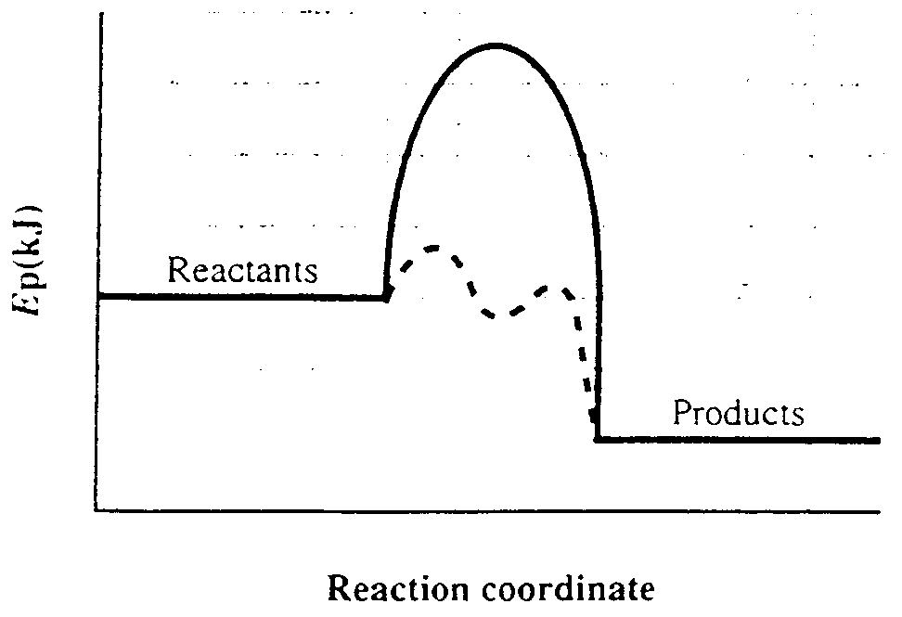

- The broken line on the energy diagram indicates that

  - the temperature of the reaction has increased
  - the pressure of the system has decreased
  - more reactants have been added
  - a catalyst has been added

- Compound X has a molar mass of 75.0 g/mol. The combustion of 300.0 g of compound X causes the temperature of 1000 g of water to rise 3.00°C. The molar heat of combustion for compound X is

  - −3.14 kJ/mol
  - −3.77 kJ/mol
  - −12.6 kJ/mol
  - −50.3 kJ/mol

- Pure copper can be obtained by roasting copper ore with carbon monoxide. The heat of reaction for CuO(s) + CO(g) → Cu(s) + CO₂(g) is

  - −125.7 kJ
  - −236.2 kJ
  - −504.0 kJ
  - −661.3 kJ

Use the following information to answer the next question.
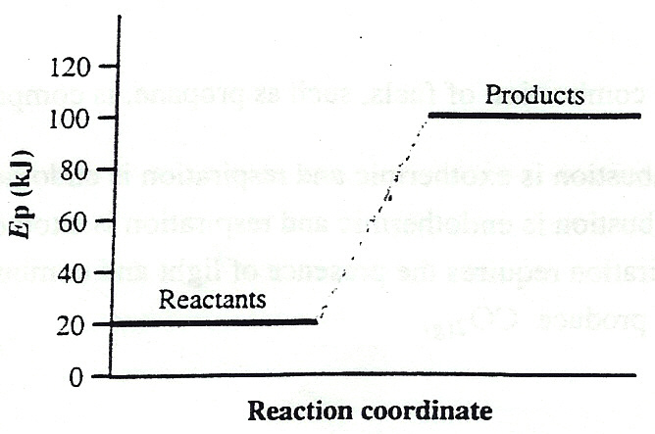

- The heat of reaction is

  - −100 kJ
  - −80 kJ
  - +80 kJ
  - +100 kJ

Use the following information to answer the next question.
- 3 B + X₂ + 31.1 kJ → B₃X₂
- A₂ + 4 B → 2 AB₂ + 42.5 kJ
- X₂ + Y₂ → 2 XY ΔH = −40.9 kJ
- C₄ + 5 G₂ → 2 C₂G₅ ΔH = +22.6 kJ

- Which of the above reactions is/are exothermic?

  - II only
  - III only
  - I and IV only
  - II and III only
Use the following information to answer the next four questions.
The combustion of fossil fuels such as propane, plays and important role in our daily lives and affects the economic and environmental climate in Alberta. The balanced chemical reaction for this combustion is
C₃H₈(g) + 5 O₂(g) → 3 CO₂(g) + 4 H₂O(g)

- The original source of the energy stored in fossil fuels such as propane was

  - protozoa
  - plants
  - animals
  - the Sun

- When propane is burned in a barbeque, the molar heat of reaction is

  - −103.8 kJ/mol
  - +103.8 kJ/mol
  - +2 043.9 kJ/mol
  - −2 043.9 kJ/mol

Use the value selected in Multiple Choice 15 to answer Numerical Response 4.

Numerical Response
4. If 449 g of propane are burned in a barbeque, the amount of energy released is ___________________ MJ.

(Record your three-digit answer in the numerical-response section on the answer sheet)

- When the combustion of fuels, such as propane, is compared to cellular respiration,

  - combustion is exothermic and respiration is endothermic
  - combustion is endothermic and respiration is exothermic
  - respiration requires the presence of light and combustion does not
  - both produce carbon dioxide gas

Use the following information to answer the next question.
K(s) + ½ Br₂(l) → KBr(s) Δ_{f}H° = −393.8 kJ/mol

- Using only the information given above, which valid interpretation can be made?

  - The equation represents a phase change.
  - The dissolving of KBr(s) is an exothermic process.
  - The decomposition of KBr(s) is an endothermic process.
  - KBr(s) is less stable than its constituent elements.

Use the following information to answer the next question.
A student was asked to determine the molar enthalpy of neutralization of KOH(aq). She recorded the average initial temperature of the KOH(aq) and the H₂SO₄(aq), then poured 50.0 mL of sulphuric acid into an insulated cup. She then added 100 mL of KOH(aq) to the acid, stirred the solution, and recorded the highest temperature reached. Her analysis of the data resulted in an answer of −46 kJ/mol.

- If the student had used 100 mL of H₂SO₄(aq) and 200 mL of KOH(aq), then

  - temperature change would double and the molar heat of reaction would double
  - heat released would be the same but the moles of KOH would double
  - heat released would double but the molar heat of reaction would remain the same
  - temperature would double and, because the volume of KOH had doubled, the molar heat of reaction would be four times as great

- Hydrogen peroxide slowly decomposes to water and oxygen. A small amount, 0.010 g, of black MnO₂(s) is added to a test tube containing hydrogen peroxide. As a result, the rate of bubble formation increases, the temperature increases more rapidly, a glowing splint relights above the liquid, and 0.010 g of black residue remains. These results indicate that MnO₂(s)

  - reacts with peroxide to form O₂(g)
  - decomposes to produce O₂(g)
  - reacts with peroxide to form H₂(g)
  - acts as a catalyst in the reaction

- Coal is composed mainly of carbon. The thermochemical equation that correctly represents the complete combustion of carbon is

  - C(s) + O₂(g) → CO₂(g) ΔH = +393.5 kJ
  - C(s) + O₂(g) → CO₂(g) ΔH = −393.5 kJ
  - 2 C(s) + O₂(g) → 2 CO(g) ΔH = −221.0 kJ
  - 2 C(s) + O₂(g) → 2 CO(g) ΔH = +221.0 kJ

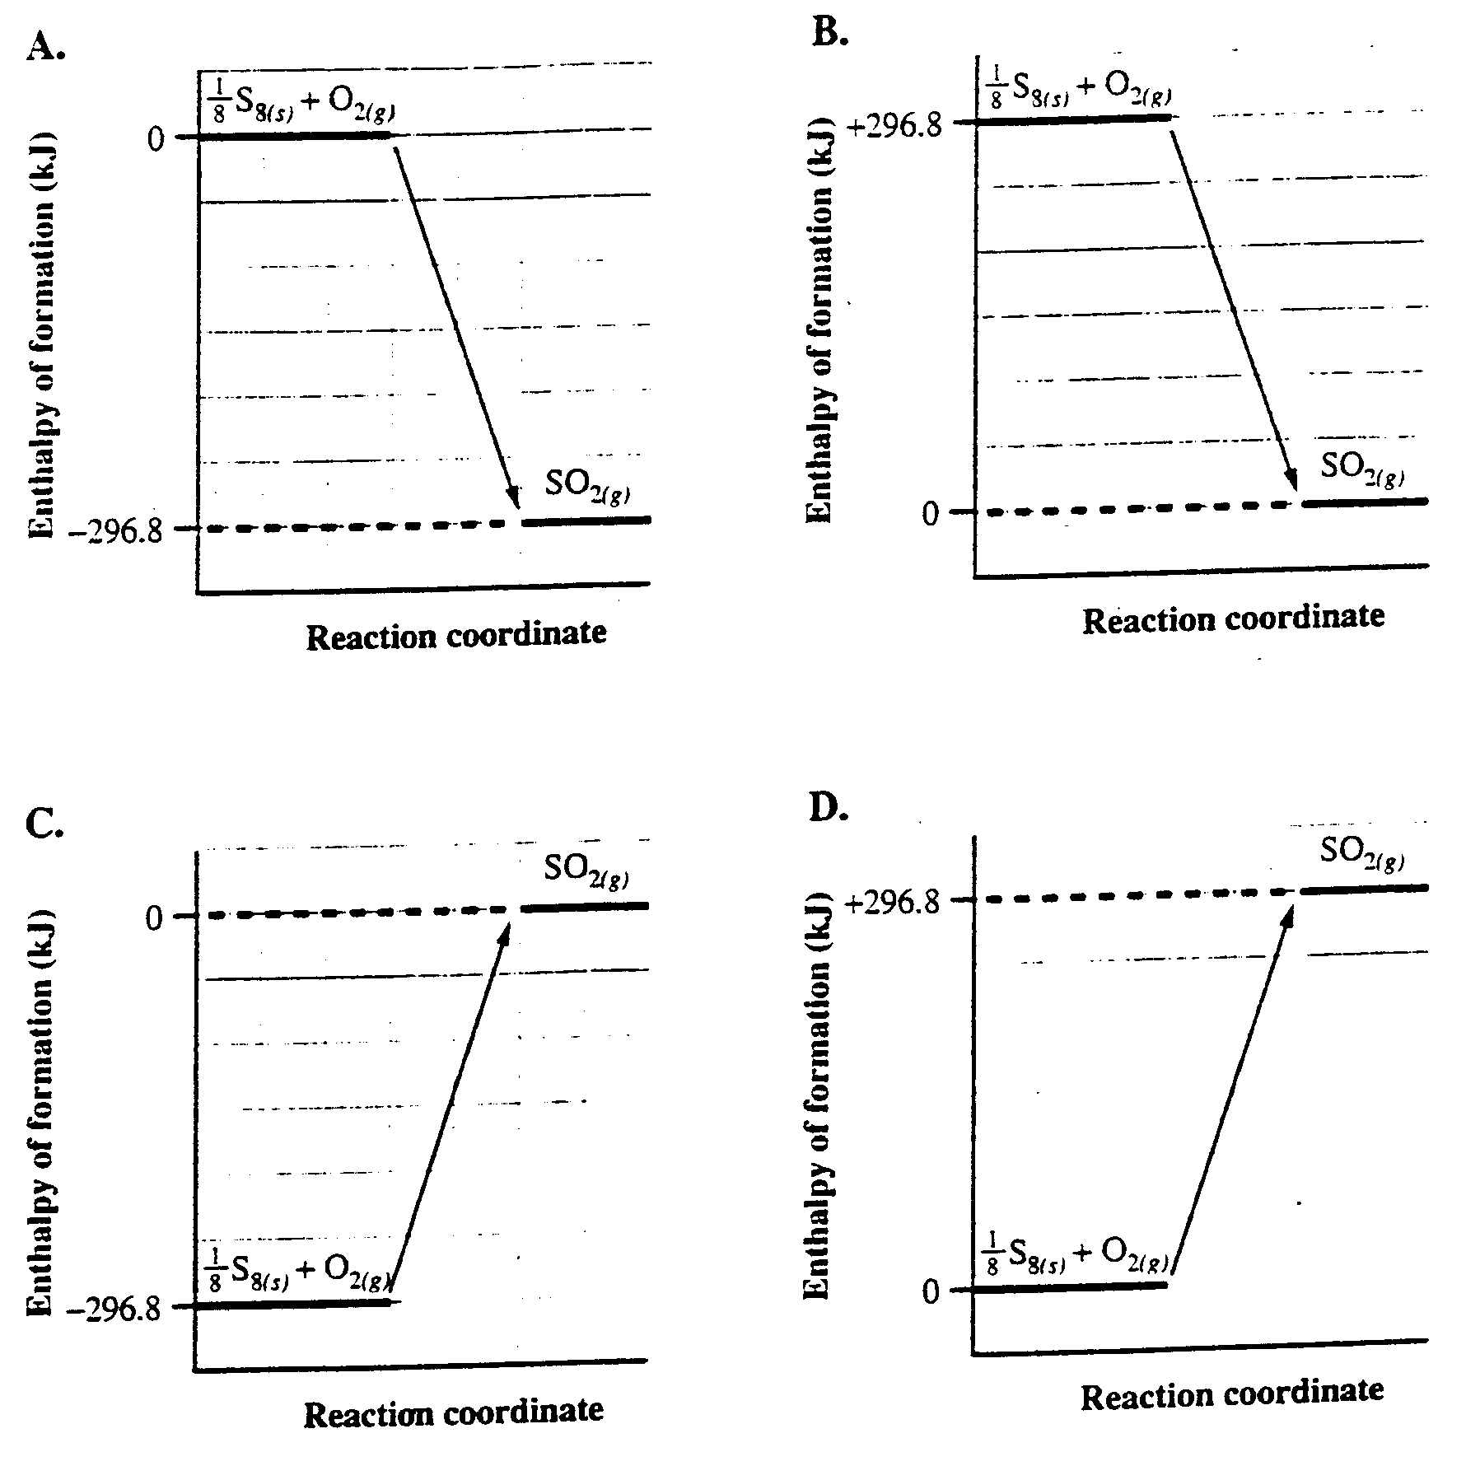
- Sulphur, S₈(s), is present in coal. When coal is burned, SO₂(g) is formed. The potential energy diagram that best represents this reaction is

Use the following information to answer the next question
Al₄C₃(s) + 12 H₂O(l) → 4 Al(OH)₃(s) + 3 CH₄(g) ΔH = −1 763.0 kJ

- If this equation is rewritten to show the production of one mole of CH₄(g) and the energy is expressed as a term in the equation, then the energy will be

  - 587.7 kJ on the reactant side
  - 1763.0 kJ on the reactant side
  - 587.7 kJ on the product side
  - 1763.0 kJ on the product side

- When a 25.0 g sample of a metal is heated from 20.0°C to 50.0°C, 178 J of energy is absorbed from the surroundings. The specific heat capacity of the metal is

  - 7.12 J/g°C
  - 0.356 J/g°C
  - 0.237 J/g°C
  - 0.142 J/g°C

Use the following information to answer the next question.
Cold packs are used to treat sprains and bruises. A chemical commonly used in cold packs is ammonium nitrate, NH₄NO_{3(s)}, which can produce a cooling effect.

- The change that occurs in this cold pack is an

  - endothermic change, which results in an increase in temperature
  - exothermic change, which results in an increase in temperature
  - endothermic change, which results in a decrease in temperature
  - exothermic change, which results in a decrease in temperature

Use the following information to answer the next two questions
A student designed a calorimetry experiment to determine the molar enthalpy of reaction of hydrochloric acid when it reacts with ammonium hydroxide. The following results were recorded:
heat capacity of calorimeter and water 228 J/°C
initial temperature of water 21.6°C
final temperature of water 16.4°C
concentration of HCl(aq) 0.0500 mol/L
volume of HCl(aq) 50.0 mL
concentration of NH₄OH(aq) 0.0500 mol/L
volume of NH₄OH(aq) 75.0 mL

Numerical Response
5. The molar enthalpy of reaction of the hydrochloric acid is

If + record 1
If − record 2 ________ ________ ________kJ/mol
first second third fourth
column column column column

(Record your four-digit answer in the numerical-response section on the answer sheet)

- The calculated energy change represents the enthalpy of

  - decomposition
  - combustion
  - neutralization
  - formation

Numerical Response
6. In organisms, the reaction of sucrose and oxygen produces carbon dioxide, water and energy. The energy available may be estimated using the reaction for the combustion of sucrose:
C₁₂H₂₂O_{11(aq)} + 12 O_{2(g)} → 12 CO_{2(g)} + 11 H₂O_{(l)} + 5 640.3 kJ

The quantity of energy available when 1.00 g of sucrose reacts is ________________kJ.

(Record your three-digit answer in the numerical-response section on the answer sheet)

Use the following information to answer the next question.
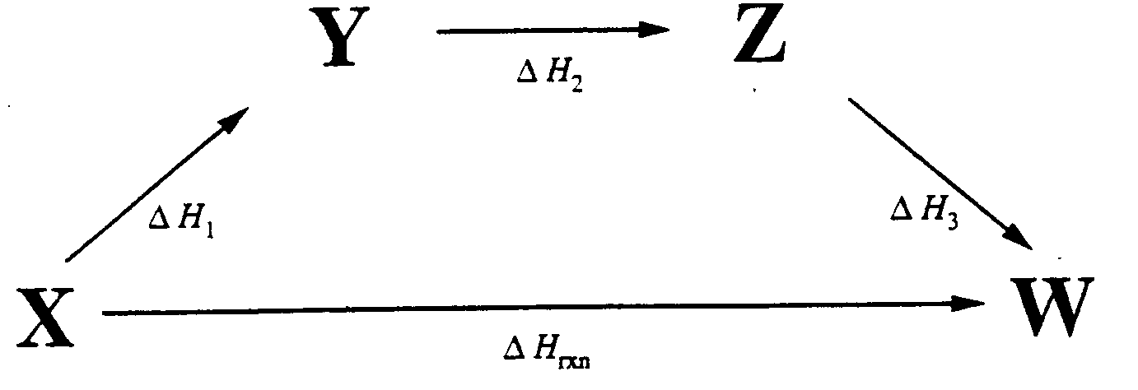

- This diagram illustrates

  - the Law of Conservation of Mass
  - an exothermic reaction
  - an endothermic reaction
  - Hess’s Law

- When phosphorus, P_{4(s)}, is exposed to air, it ignites spontaneously and rapidly releases 2 940 kJ/mol. Which of the following potential energy diagrams best represents this reaction?
